

**VIVEKANANDA INSTITUTE OF PROFESSIONAL STUDIES - TECHNICAL CAMPUS**

**Grade A++ Accredited Institution by NAAC**

NBA Accredited for MCA Programme; Recognized under Section 2(f) by UGC;

Affiliated to GGSIP University, Delhi; Recognized by Bar Council of India and AICTE

An ISO 9001:2015 Certified Institution

**SCHOOL OF ENGINEERING & TECHNOLOGY**

**B. Tech Programme: AI-ML (A) (4th Semester)**

**Course Title: Database Management Systems Lab**

**Course Code: AIML-254**

**Submitted To: Submitted By:**

**Dr. Deepika Bhatia Name: Kunsh Sabharwal**

**Enrolment No: 01117711623**

**VIVEKANANDA INSTITUTE OF PROFESSIONAL STUDIES - TECHNICAL CAMPUS**

**Grade A++ Accredited Institution by NAAC**

NBA Accredited for MCA Programme; Recognized under Section 2(f) by UGC;

Affiliated to GGSIP University, Delhi; Recognized by Bar Council of India and AICTE

An ISO 9001:2015 Certified Institution

**SCHOOL OF ENGINEERING & TECHNOLOGY**

**VISION OF INSTITUTE**

To be an educational institute that empowers the field of engineering to build a sustainable future by providing quality education with innovative practices that supports people, planet and profit.

**MISSION OF INSTITUTE**

To groom the future engineers by providing value-based education and awakening students' curiosity, nurturing creativity and building  
capabilities to enable them to make significant contributions to the world.

**VIVEKANANDA INSTITUTE OF PROFESSIONAL STUDIES - TECHNICAL CAMPUS**

**Grade A++ Accredited Institution by NAAC**

NBA Accredited for MCA Programme; Recognized under Section 2(f) by UGC;

Affiliated to GGSIP University, Delhi; Recognized by Bar Council of India and AICTE

An ISO 9001:2015 Certified Institution

**SCHOOL OF ENGINEERING & TECHNOLOGY**

**INDEX**

|  |  |  |  |  |  |  |  |  |
| --- | --- | --- | --- | --- | --- | --- | --- | --- |
| S.No. | Experiment | Date | Marks | | | Remarks | Updated Marks | Faculty Signature |
| Laboratory Assessment (15 Marks) | Class Participation (5 Marks) | Viva (5 Marks) |  |  |  |
| 1. | Study and practice various database management systems like MySQL/Oracle/PostgreSQL/SQL Server and others. |  |  |  |  |  |  |  |
| 2. | Implement simple queries of DDL and DML. |  |  |  |  |  |  |  |
| 3. | Implement basic queries to Create, Insert, Update, Delete and Select Statements for two different scenarios (For instance: Bank, College etc.) |  |  |  |  |  |  |  |
| 4. | Implement queries including various functions- mathematical, string, date etc. |  |  |  |  |  |  |  |

**VIVEKANANDA INSTITUTE OF PROFESSIONAL STUDIES - TECHNICAL CAMPUS**

**Grade A++ Accredited Institution by NAAC**

NBA Accredited for MCA Programme; Recognized under Section 2(f) by UGC;

Affiliated to GGSIP University, Delhi; Recognized by Bar Council of India and AICTE

An ISO 9001:2015 Certified Institution

**SCHOOL OF ENGINEERING & TECHNOLOGY**

|  |  |  |  |  |  |  |  |  |
| --- | --- | --- | --- | --- | --- | --- | --- | --- |
| 5. | Implement queries including Sorting, Grouping and Subqueries- like any, all, exists, not exists. |  |  |  |  |  |  |  |
| 6. | Implement queries including various Set operations (Union, Intersection, Except etc.). |  |  |  |  |  |  |  |
| 7. | Implement various JOIN operations- (Inner, Outer). |  |  |  |  |  |  |  |
| 8. | Write a PL/SQL program using FOR loop to insert ten rows into a database table. |  |  |  |  |  |  |  |
| 9. | Given the table EMPLOYEE (Emp No, Name, Salary, Designation, DeptID), write a cursor to select the five highest-paid employees from the table. |  |  |  |  |  |  |  |
| 10. | Illustrate how you can embed PL/SQL in a high-level host language such as C/Java And demonstrates how a banking debit transaction might be done. |  |  |  |  |  |  |  |

**VIVEKANANDA INSTITUTE OF PROFESSIONAL STUDIES - TECHNICAL CAMPUS**

**Grade A++ Accredited Institution by NAAC**

NBA Accredited for MCA Programme; Recognized under Section 2(f) by UGC;

Affiliated to GGSIP University, Delhi; Recognized by Bar Council of India and AICTE

An ISO 9001:2015 Certified Institution

**SCHOOL OF ENGINEERING & TECHNOLOGY**

|  |  |  |  |
| --- | --- | --- | --- |
| **Sr. No.** | **EXPERIMENT TITLE**  **(Beyond Curriculum)** | **Date** | **Faculty Signature** |
| 1 | Write the steps to install and implement NOSQL databases-MongoDB |  |  |
| 2 | Study and implement basic commands of MongoDB |  |  |
| 3 | Implement any one real-time project using MySQL/MongoDB such as Library Database Management System etc.. |  |  |

SECTION 1

Database Management System Lab

GGSIPU

**EXPERIMENT 1**

**Problem statement:** Study and practice various database management systems like MySQL/Oracle/PostgreSQL/SQL Server and others.

**Theory:**











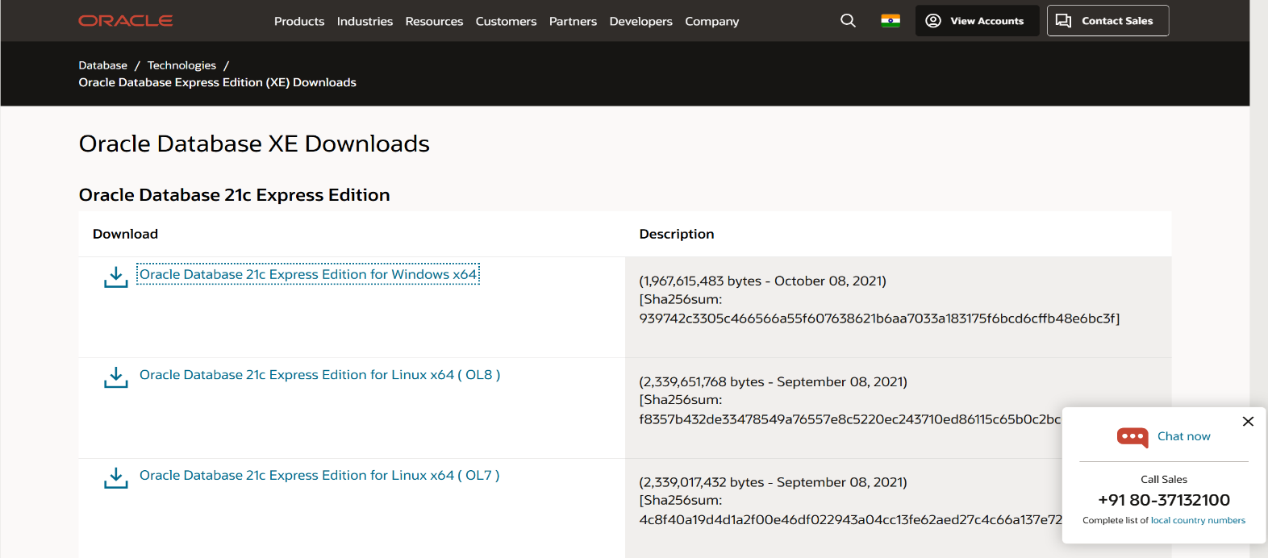**Installation screenshots of SQL:**

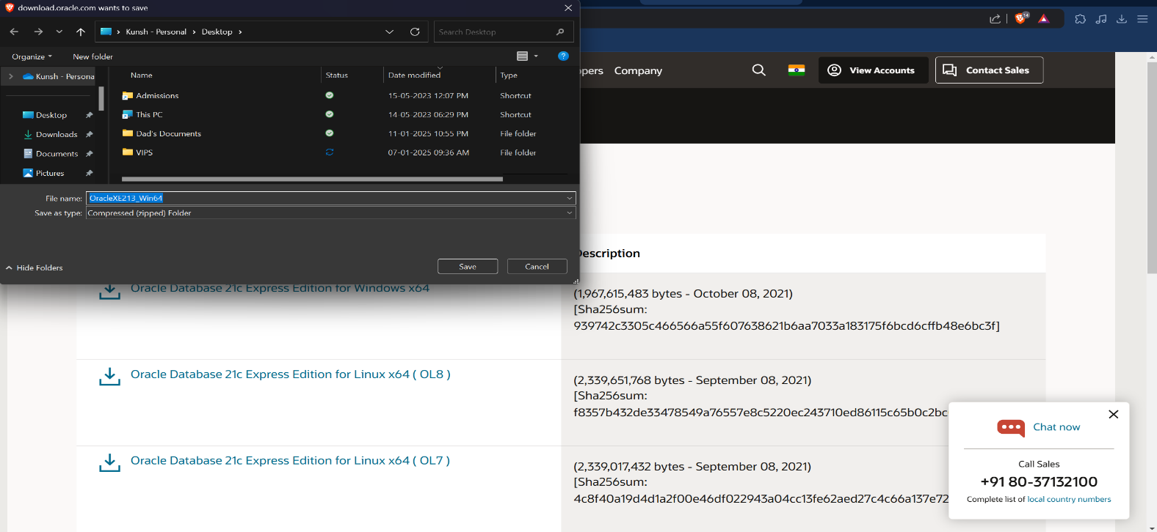

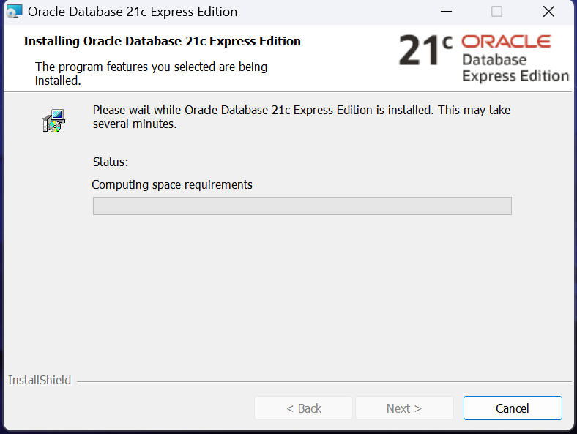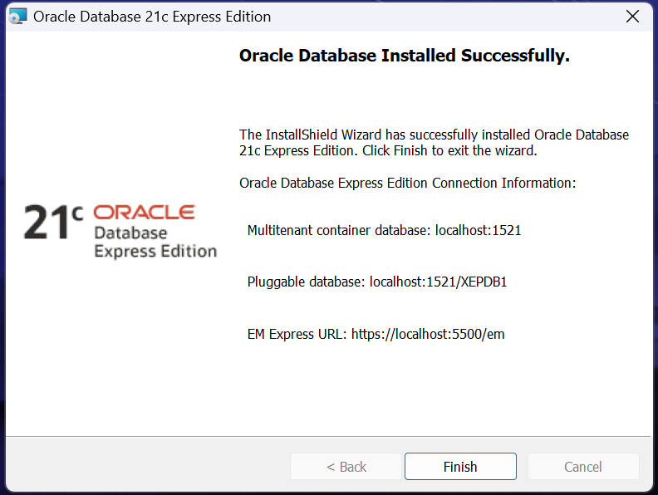

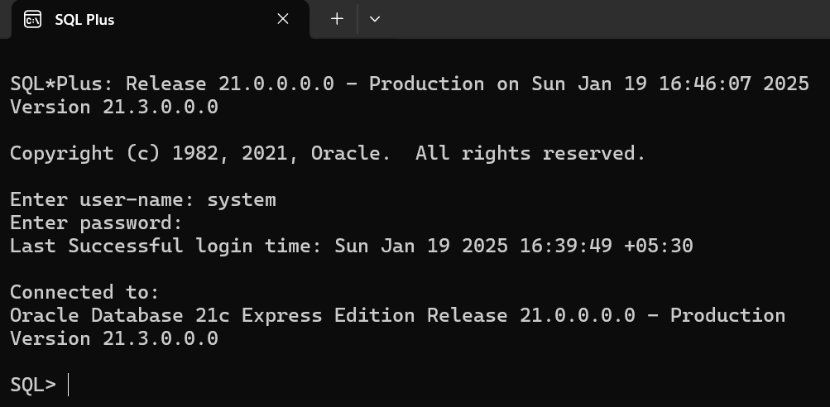

**Learning Outcome:**

**EXPERIMENT 2**

**Problem statement:** Implement simple queries of DDL and DML.

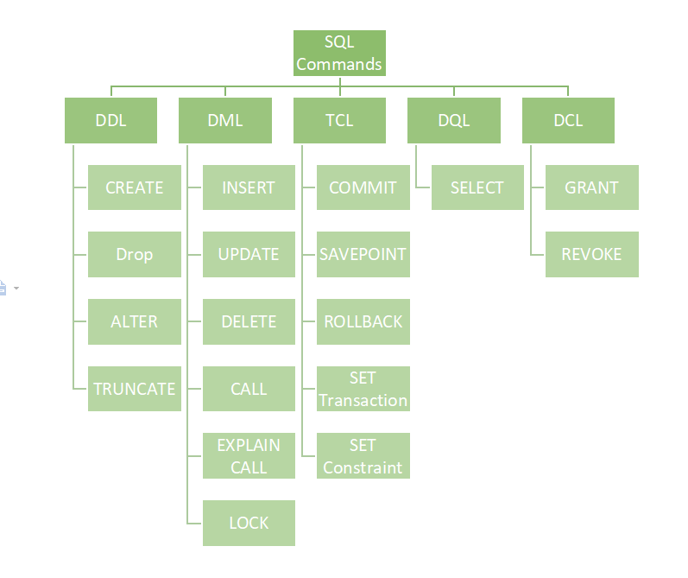**Theory:**

**SQL Commands: - (DDL Commands)**

1. Create a table VIPS1 (ID, NAME, STATE, SAL, Dno). (Add Constraints)

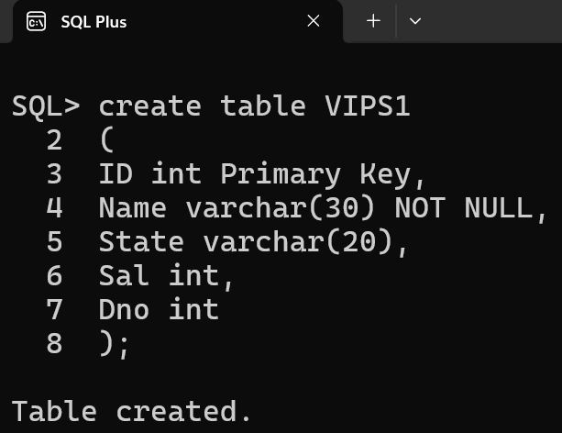

1. 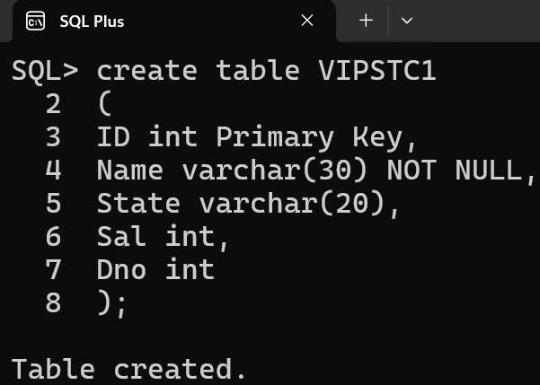Create a table VIPSTC1(ID, NAME, STATE, SAL, Dno). (Add Constraints)

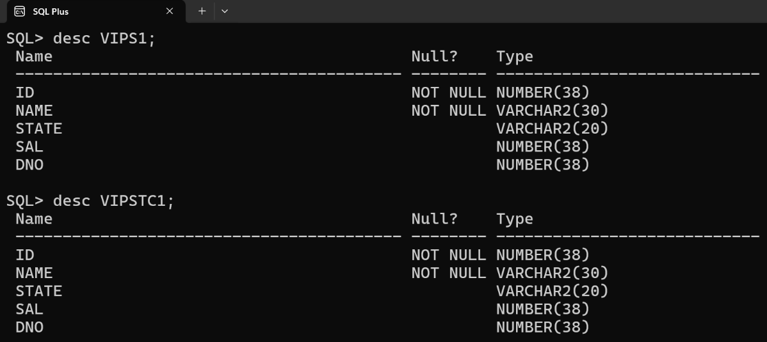

1. Add column Commission and Phone to table.
   1. Drop Column Phone
   2. 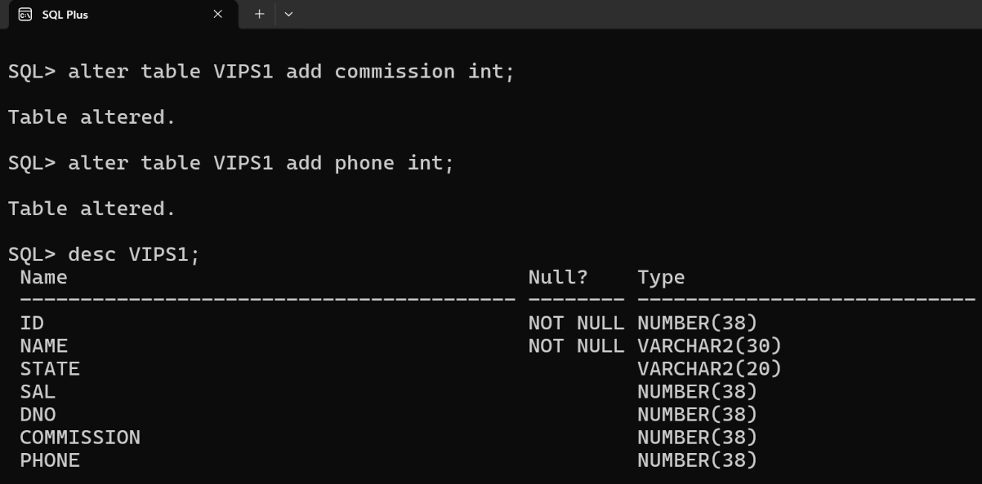Change the datatype of any of the column.

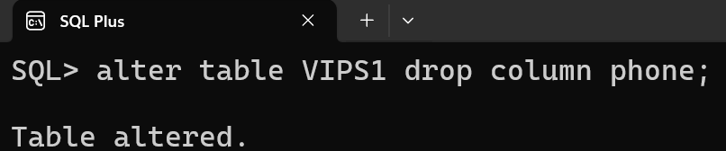

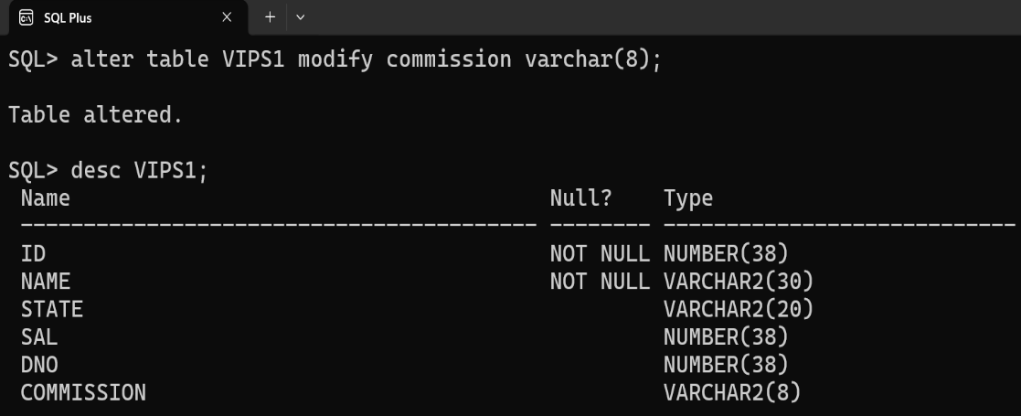

1. 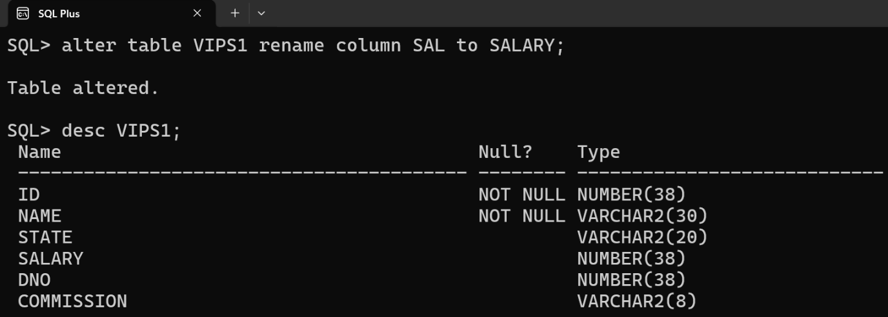Rename one of the columns of the table.
2. 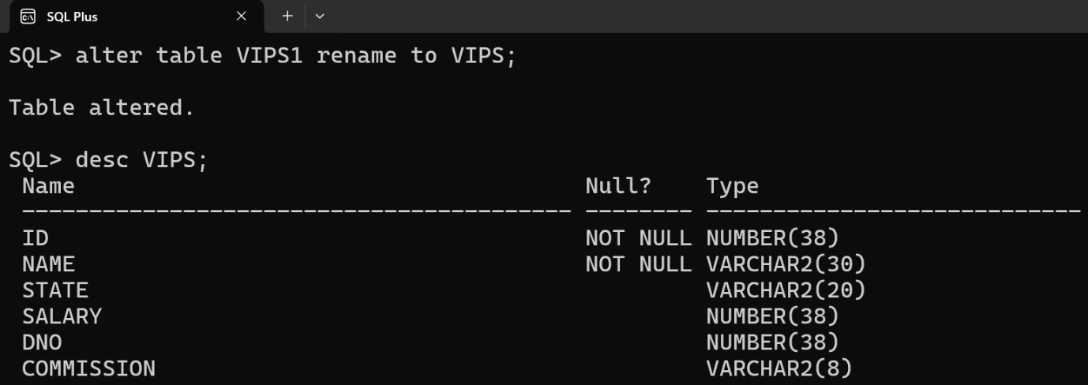Rename the table name.
3. 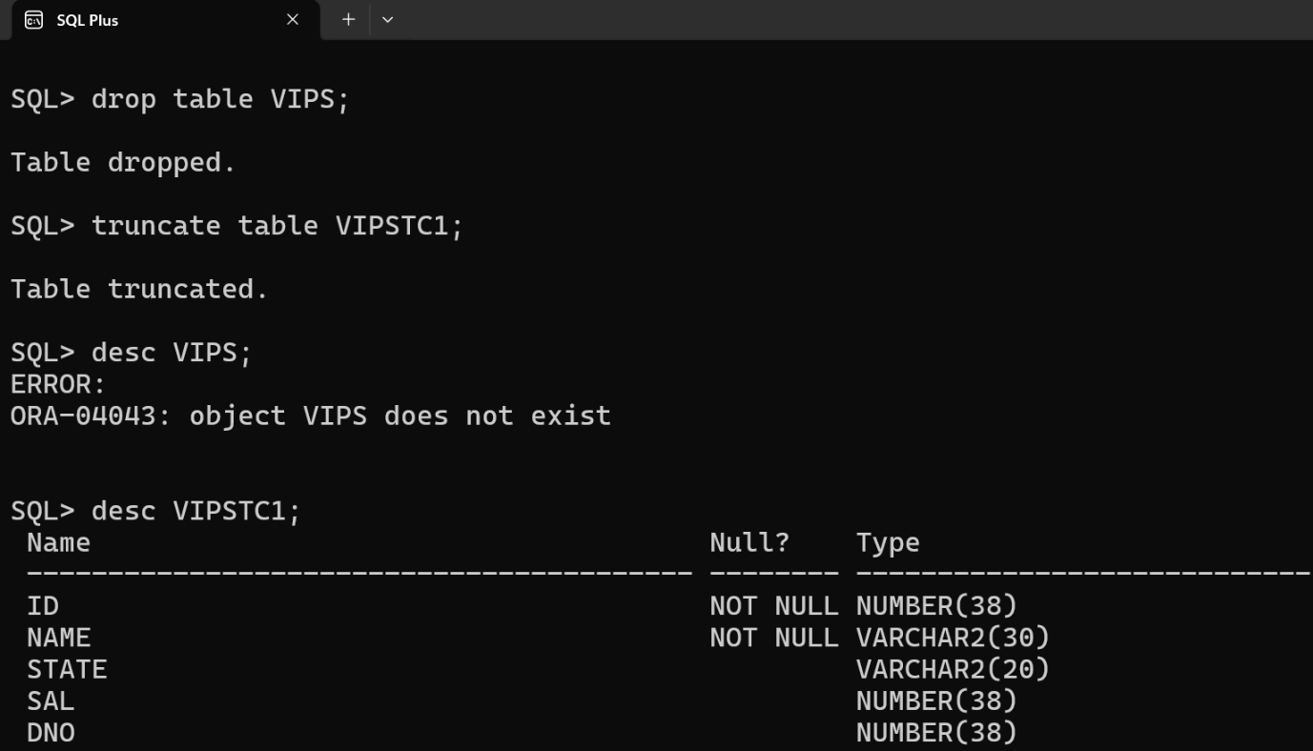Drop the table VIPS1 and Truncate VIPSTC1 and show the difference.

**DML Commands: -**

1. Insert Values in both tables. (at least 7 rows)

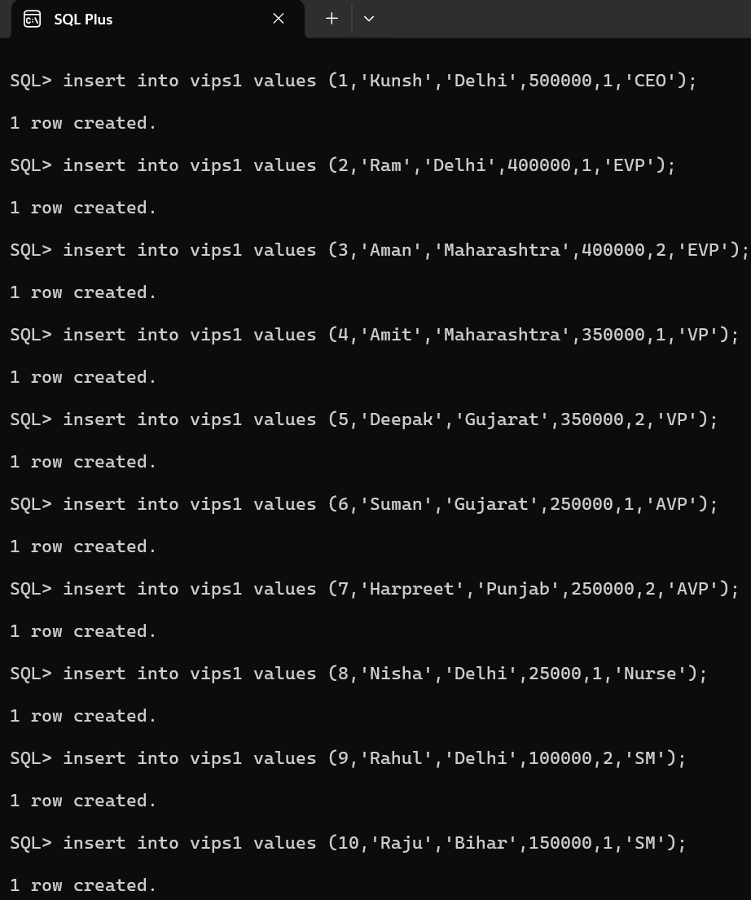

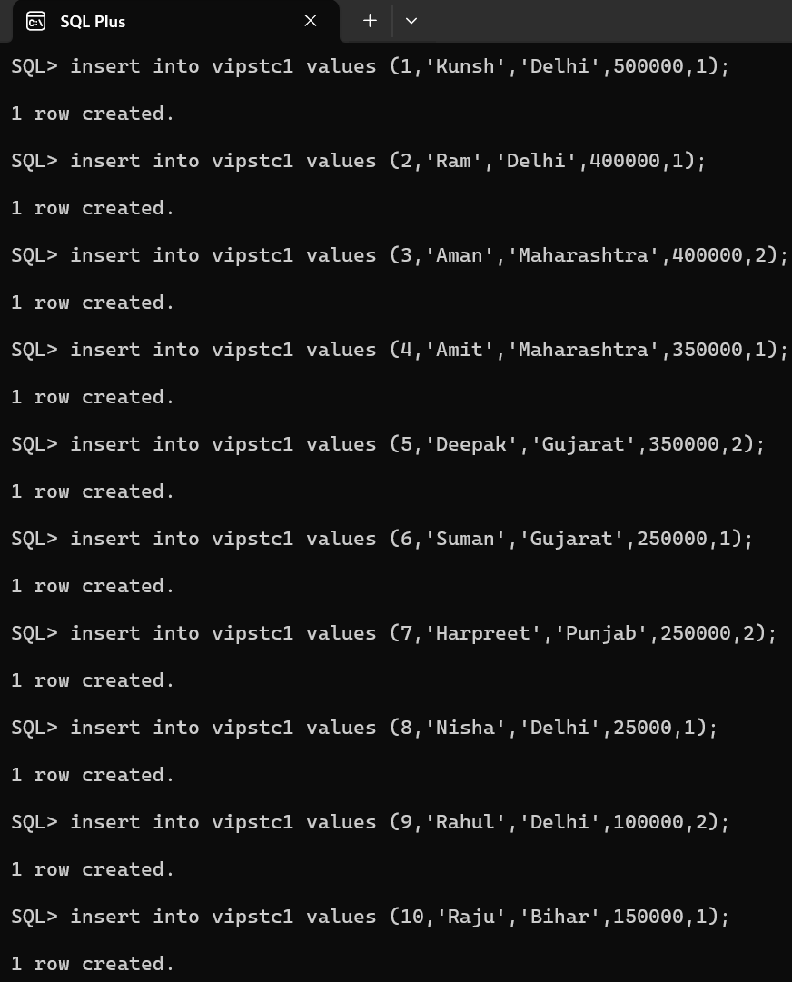

1. 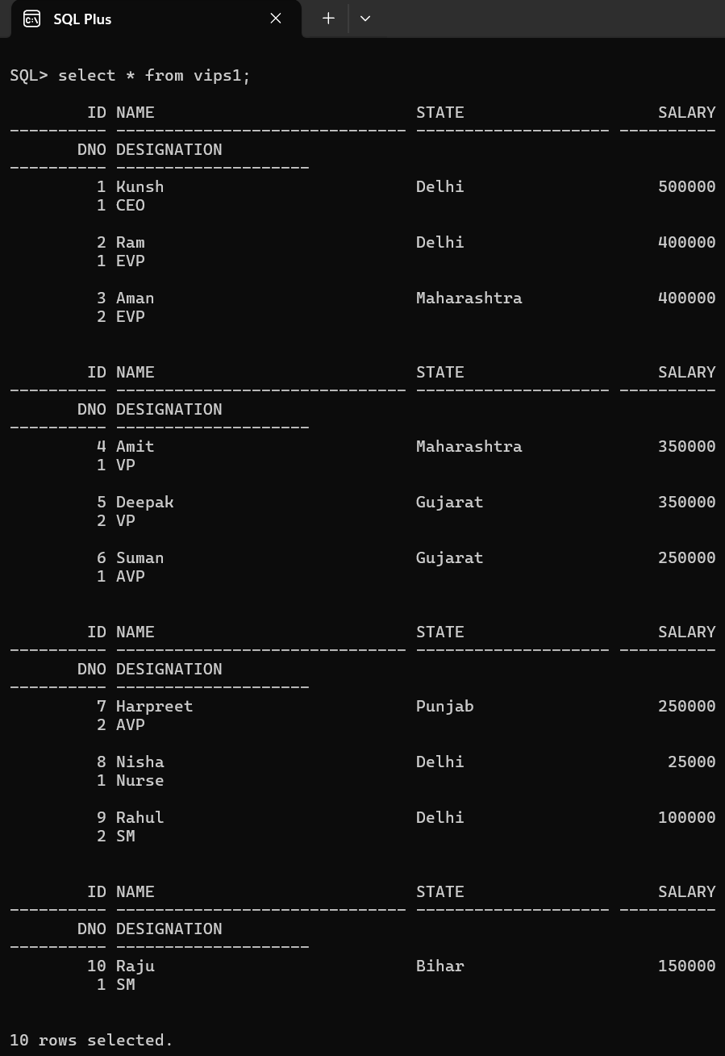Show the entire tables.

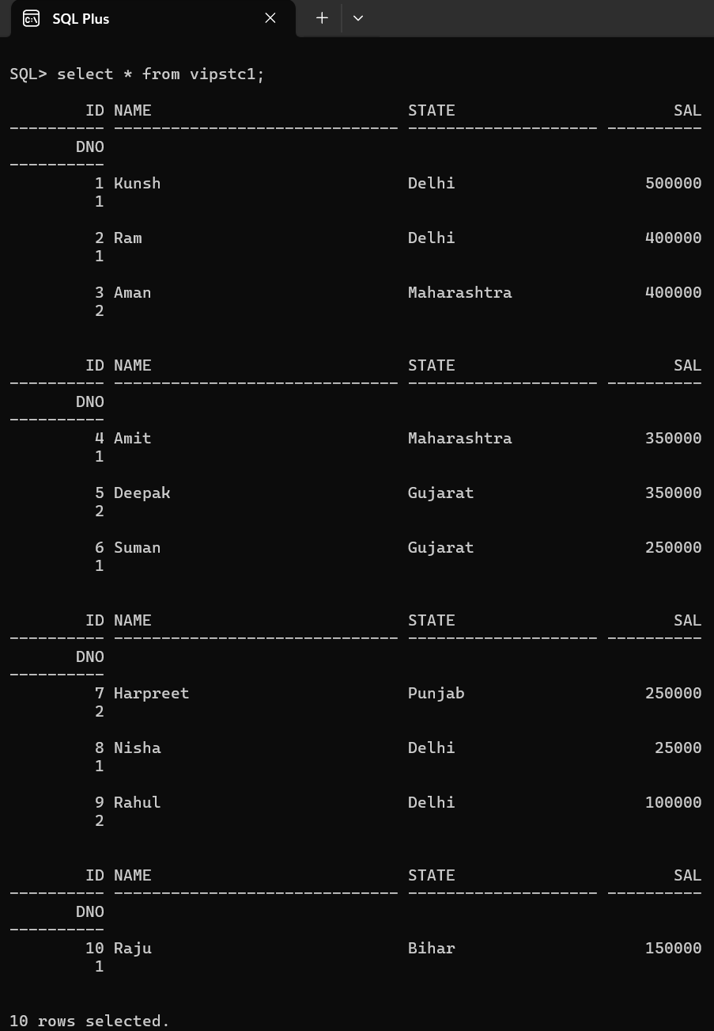

1. 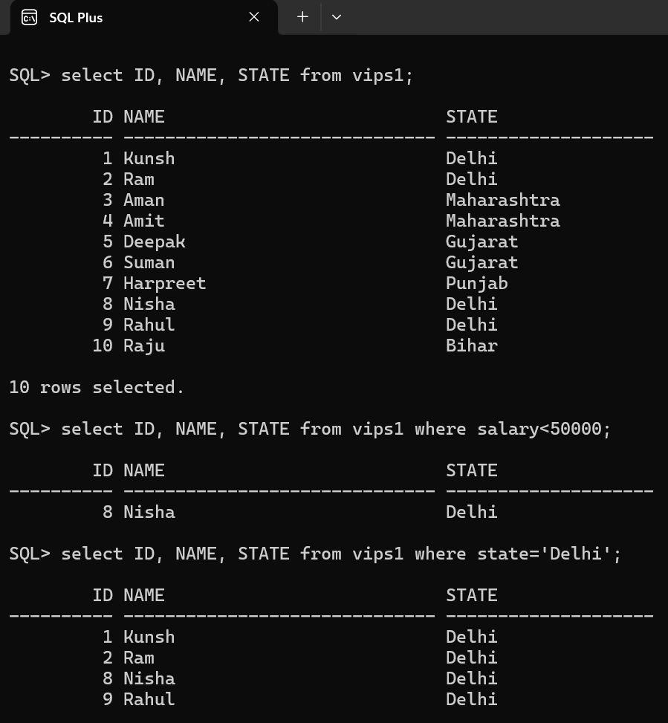Select only 3 columns from the table (With and without where clause)
2. 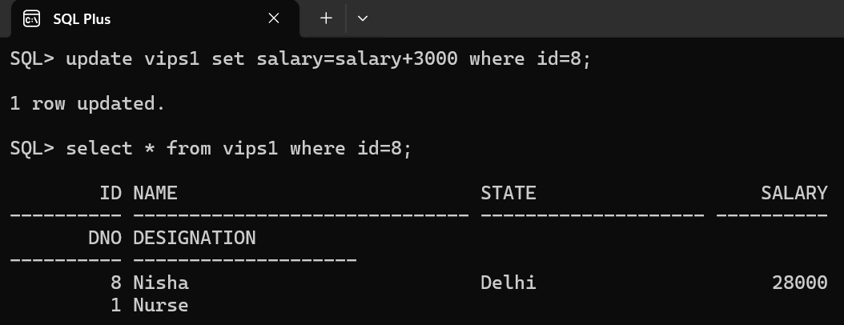Update the salary of any one of the employees by 3000.
3. 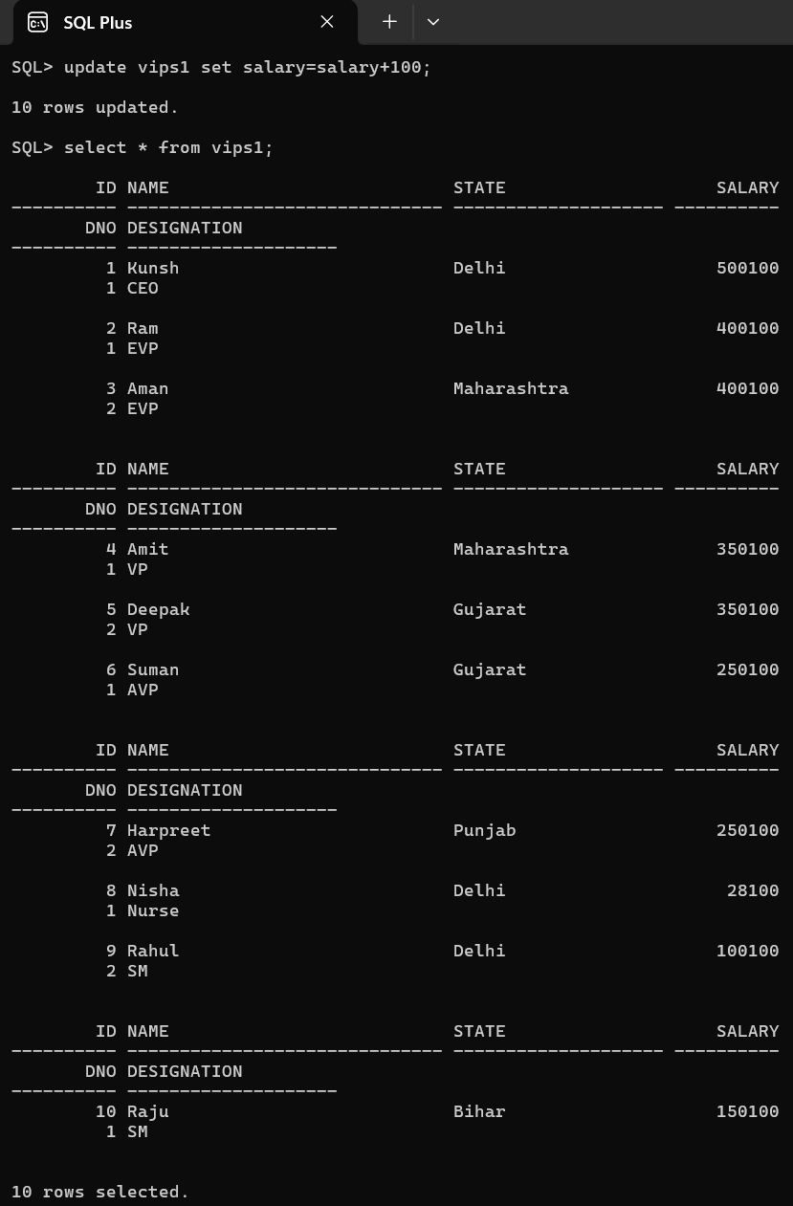Update the salary of each employee by 100.
4. 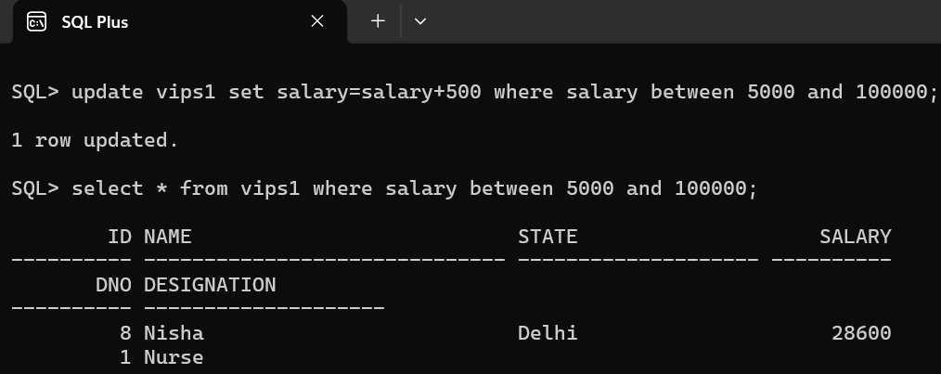Update the salary of the employee by 500 with salary between 5000 and 1,00,000.
5. 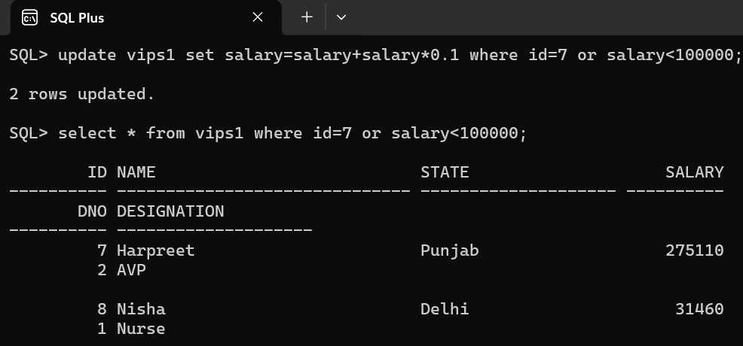Update the salary of the employees by 10% whose ID is 7 or salary is less than 1,00,000.
6. 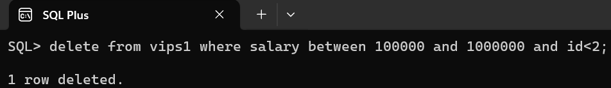Delete the employee with salary between 1,00,000 and 1,00,00,000 and ID less than 2.

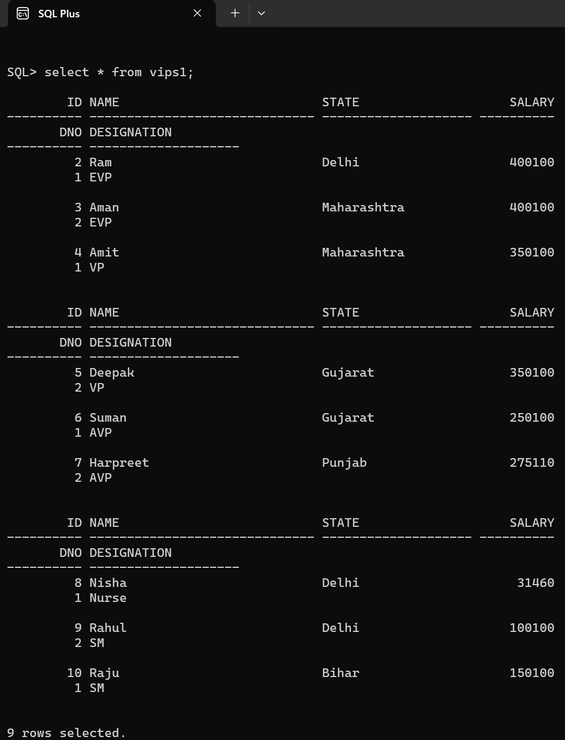

1. 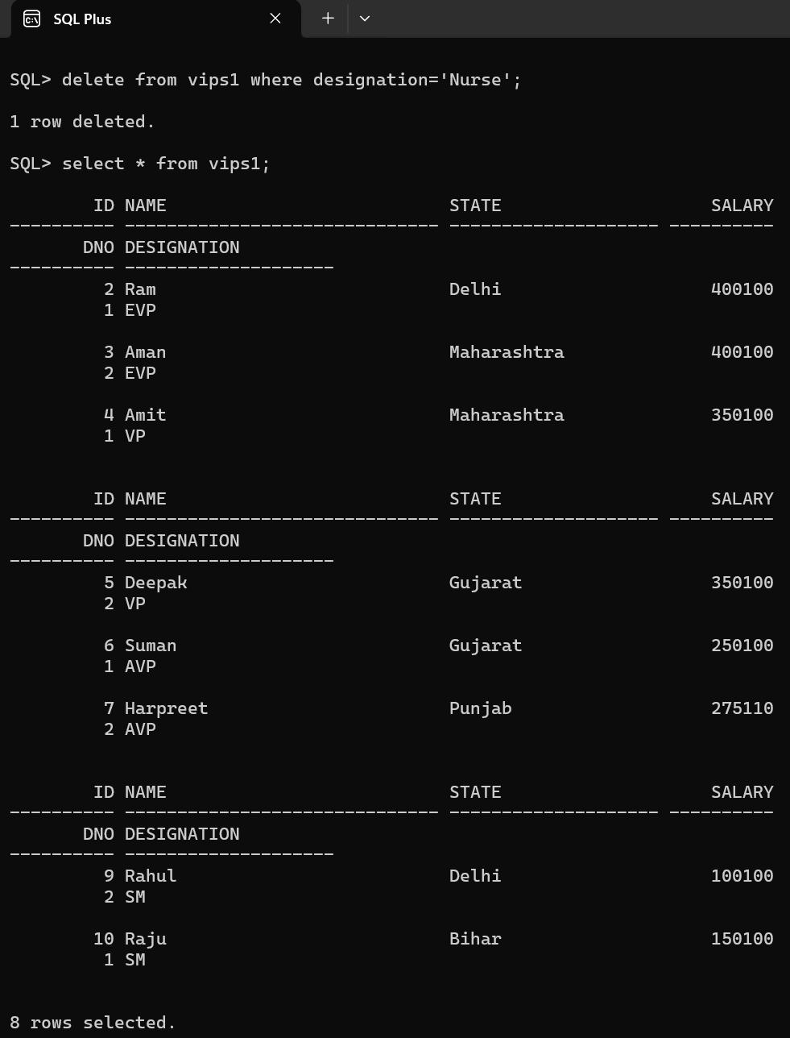Delete the employee whose designation is Nurse.
2. 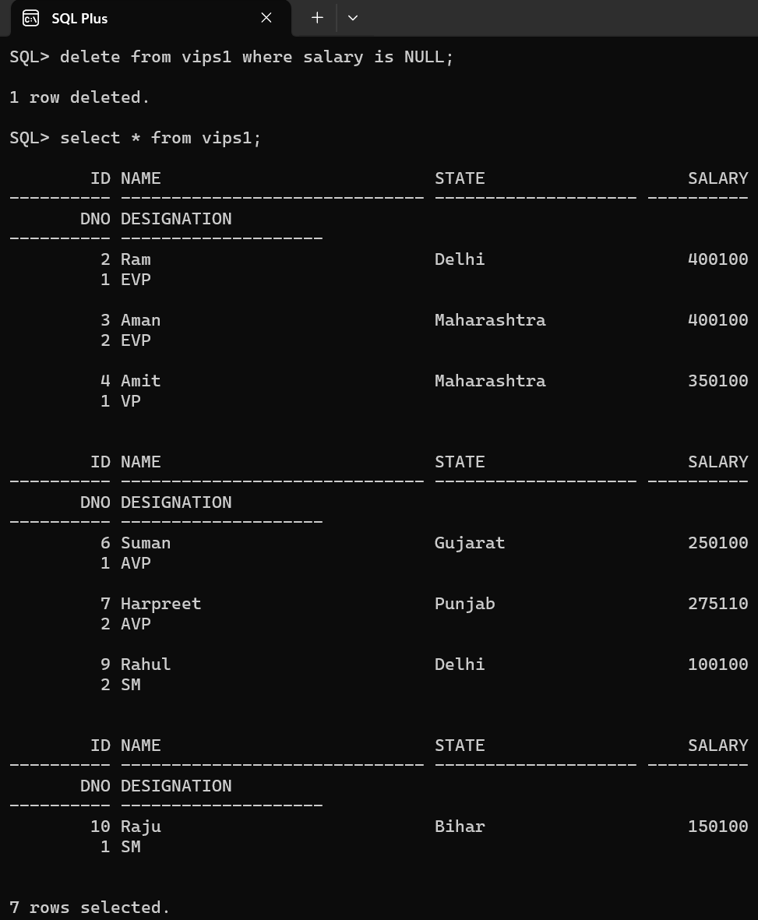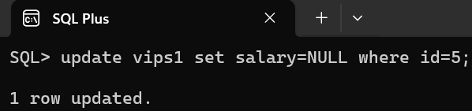Delete the employee with no salary.

**Learning Outcome:**

**EXPERIMENT 3**

**Problem statement:** Implement basic queries to Create, Insert, Update, Delete and Select Statements for two different scenarios (For instance: Bank, College etc.)

**Theory:**

**SQL Commands: - (For Bank Scenario)**

1. Create the 5 tables given below: -
   1. Acc (acc_no, name, phone)
   2. Trans (*acc_no*, C_D, amount)
   3. Loan (*acc_no*, interest, time, type)
   4. FD (*acc_no*, amount, interest, time)
   5. 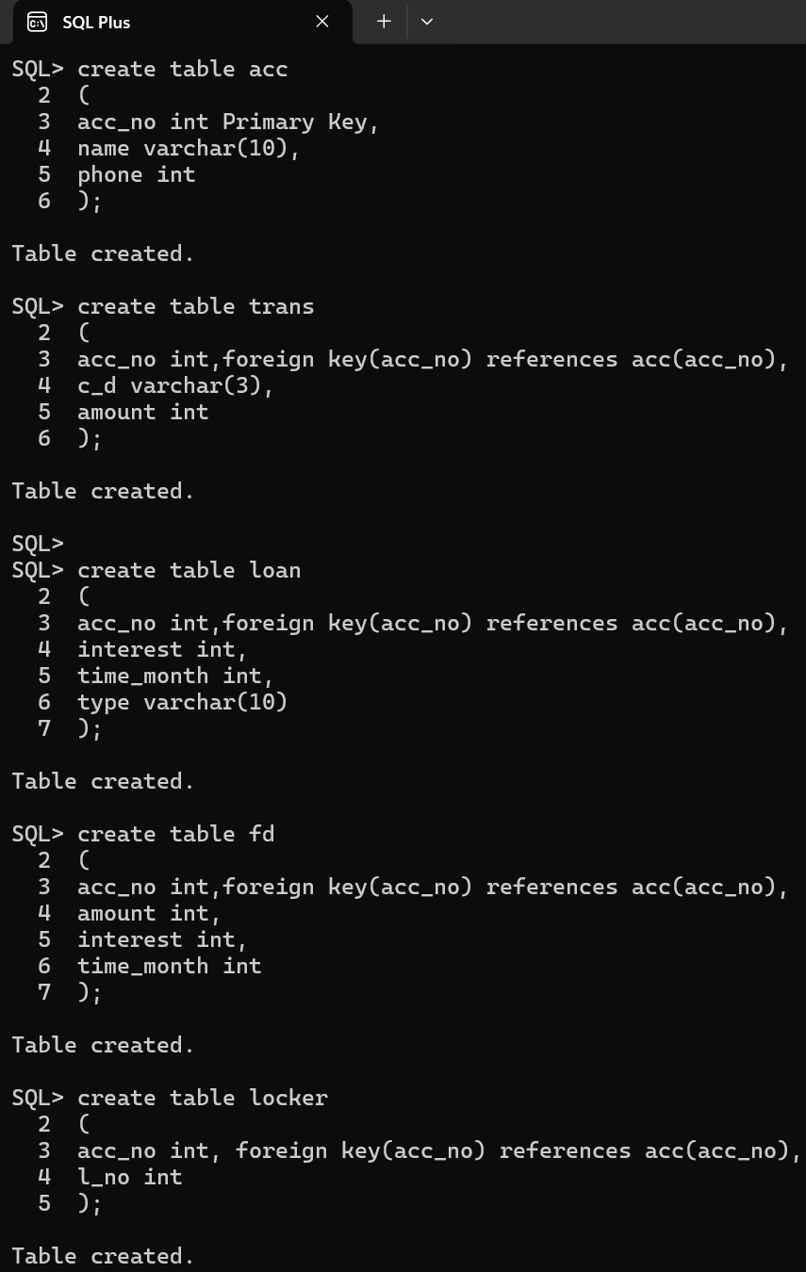Locker (*acc_no*, l_no)
2. 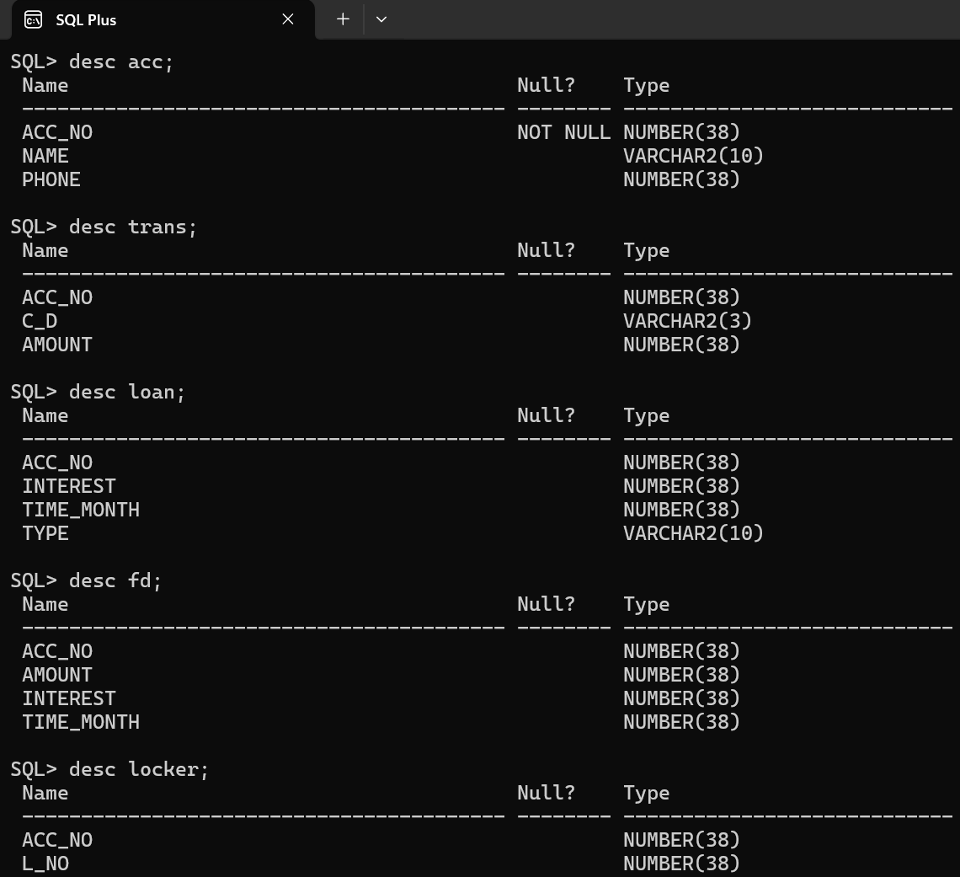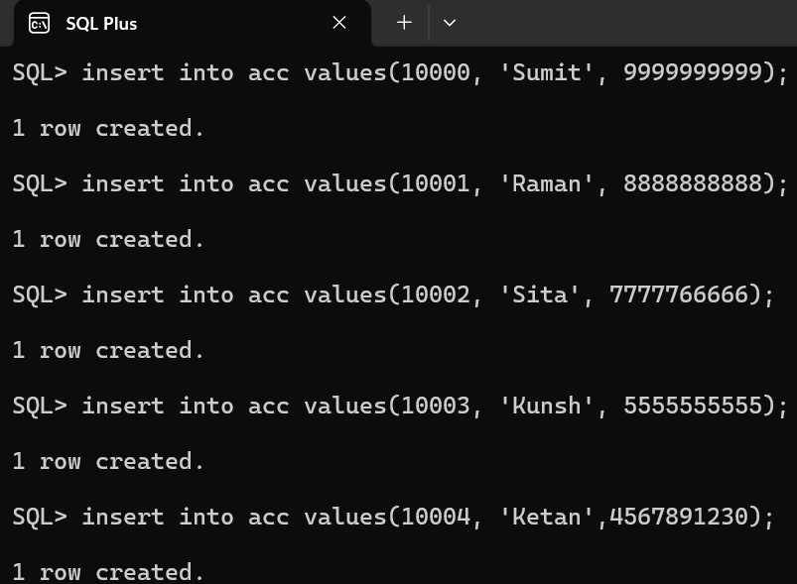Insert values in each table and show contents.

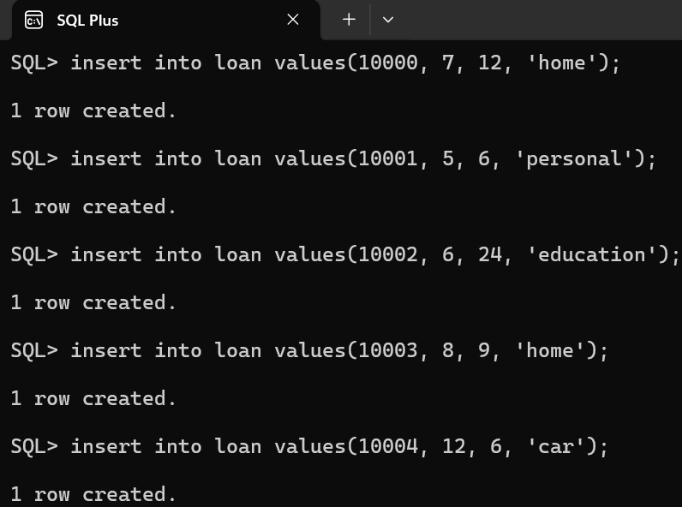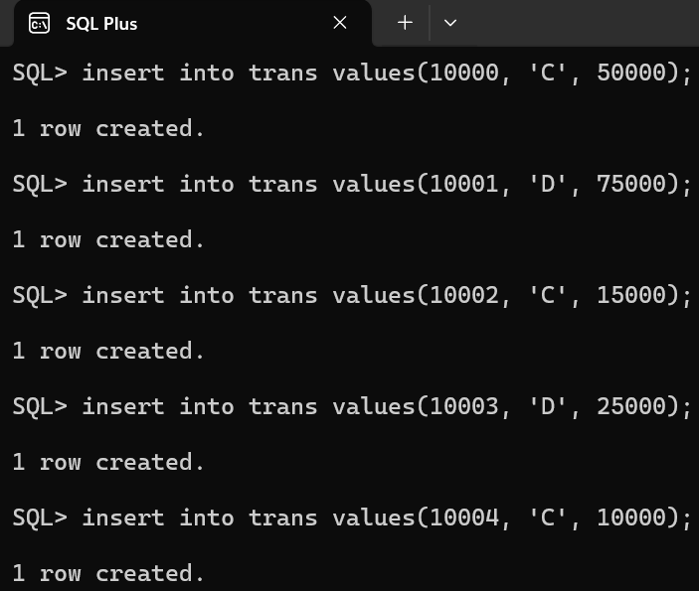

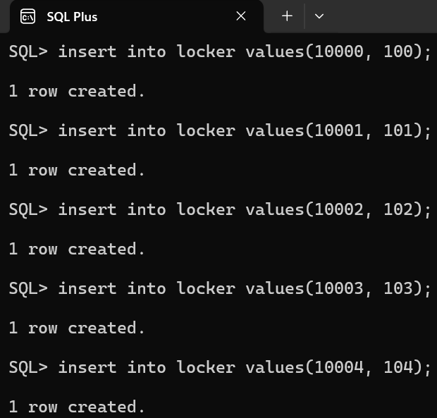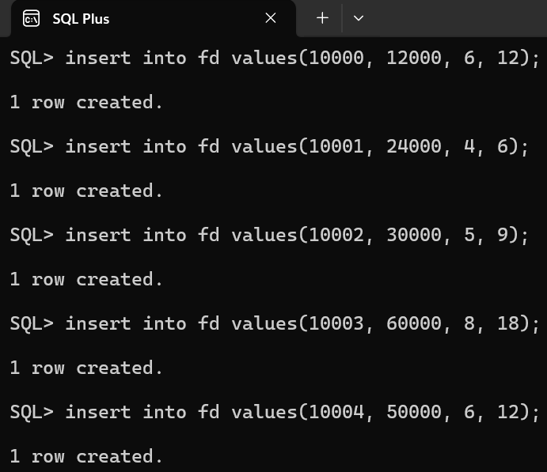

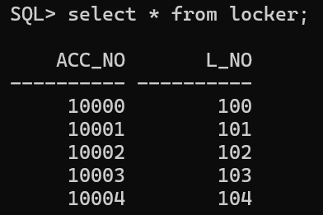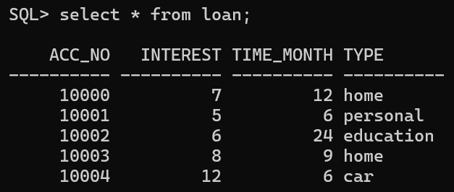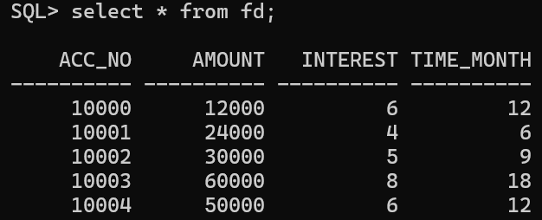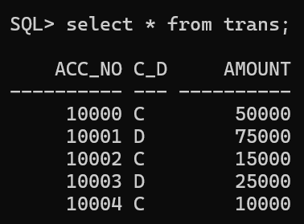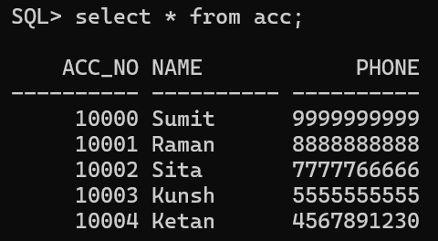

1. 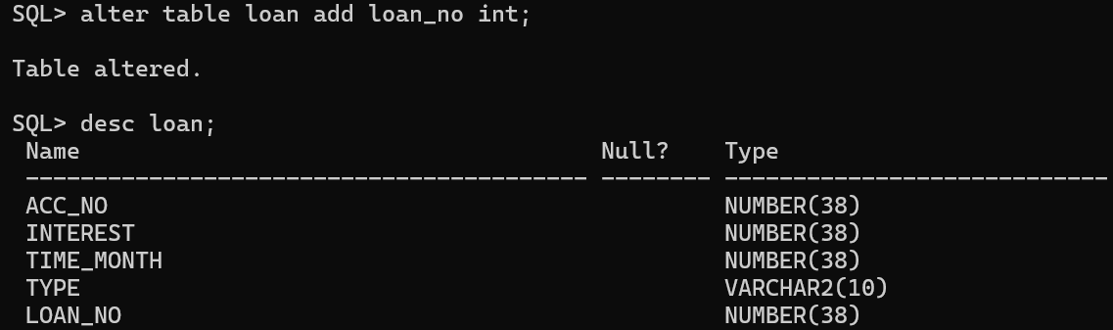Add a column loan_no in loan table and update values for this column.
2. 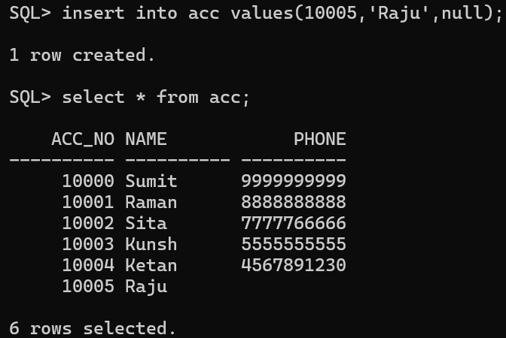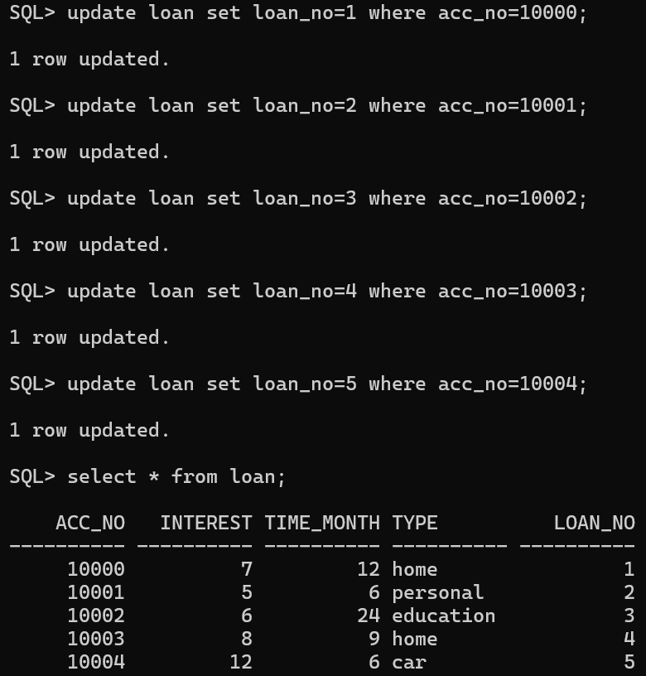 Insert a row in account table without phone number.
3. 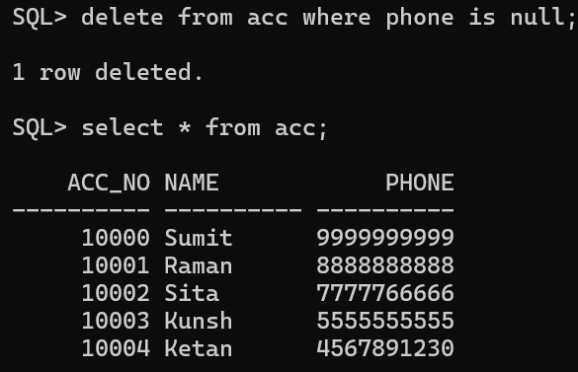Delete account with no phone number.

**SQL Commands: - (For College Scenario)**

1. Create the below mentioned tables with proper constraints: -
   1. Faculty (fid, name, *dno*, sal, address, phone, dob, exp)
   2. Dept (dno, dname, budget)
   3. Student (sid, name, *dno*, phone, dob, address, sem)
   4. Society (sc_id, name)
   5. Std_soc (*sid, sc_id*)
   6. Course (cid, cname)
   7. Fac_course (*fid, cid*)

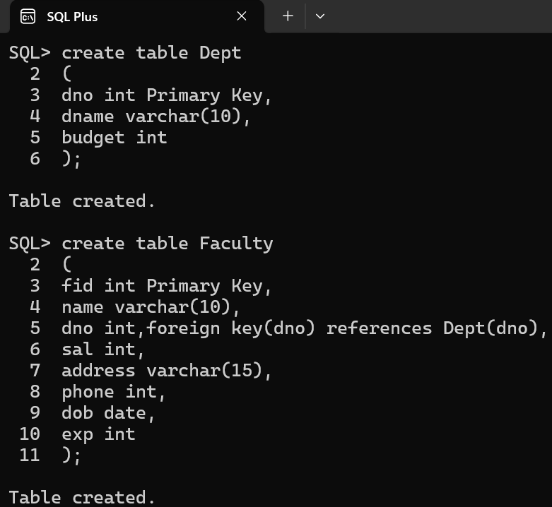

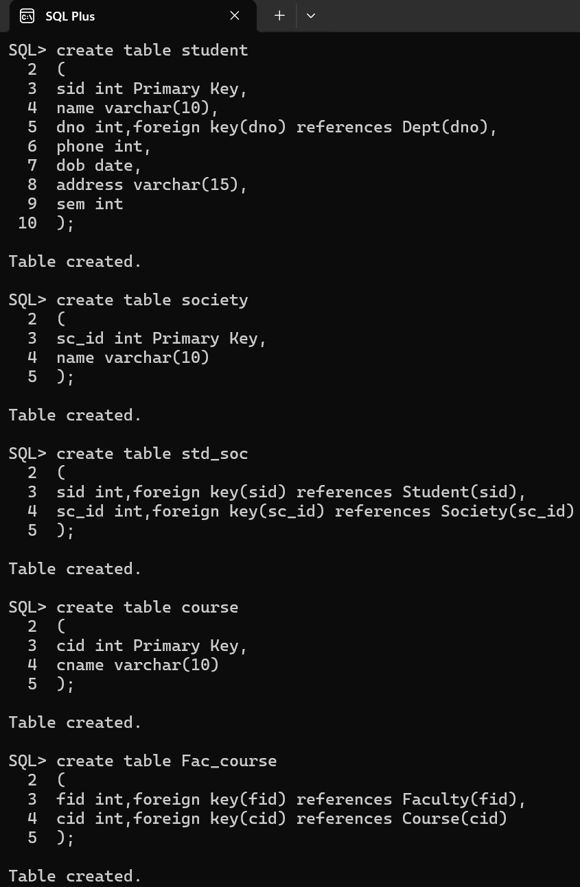

1. 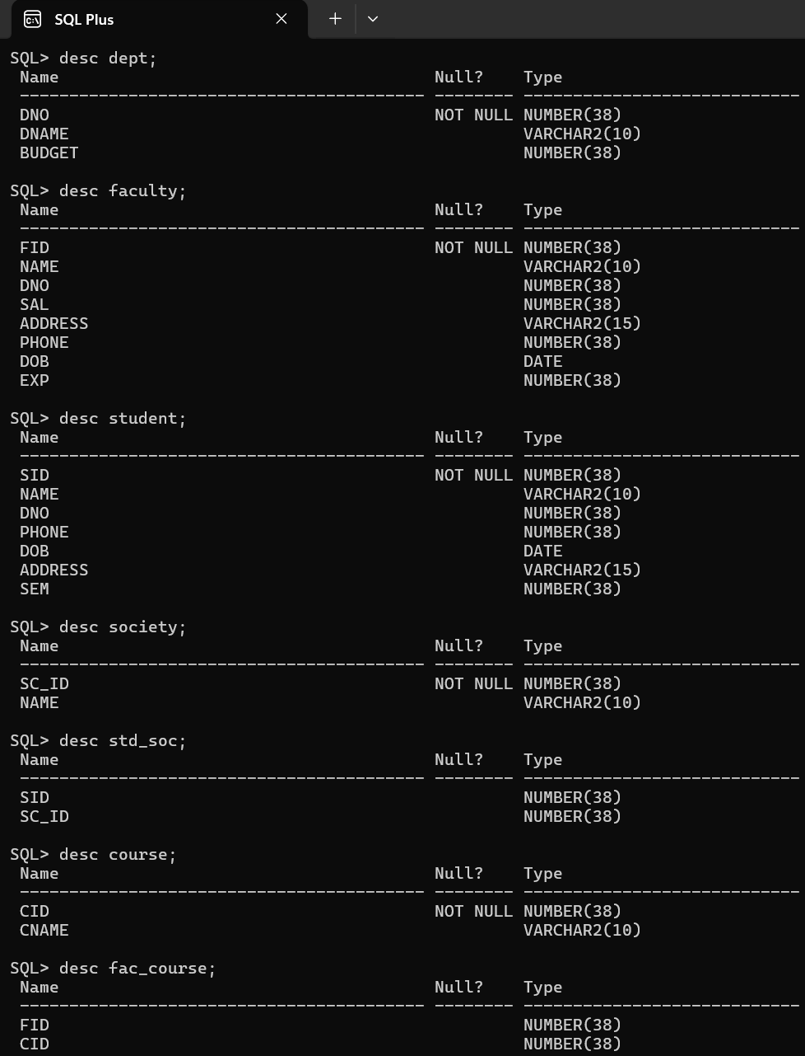Insert rows in each table (at least 5 records).

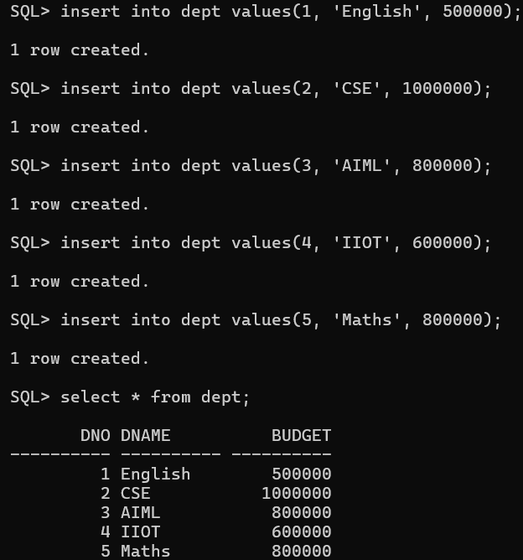

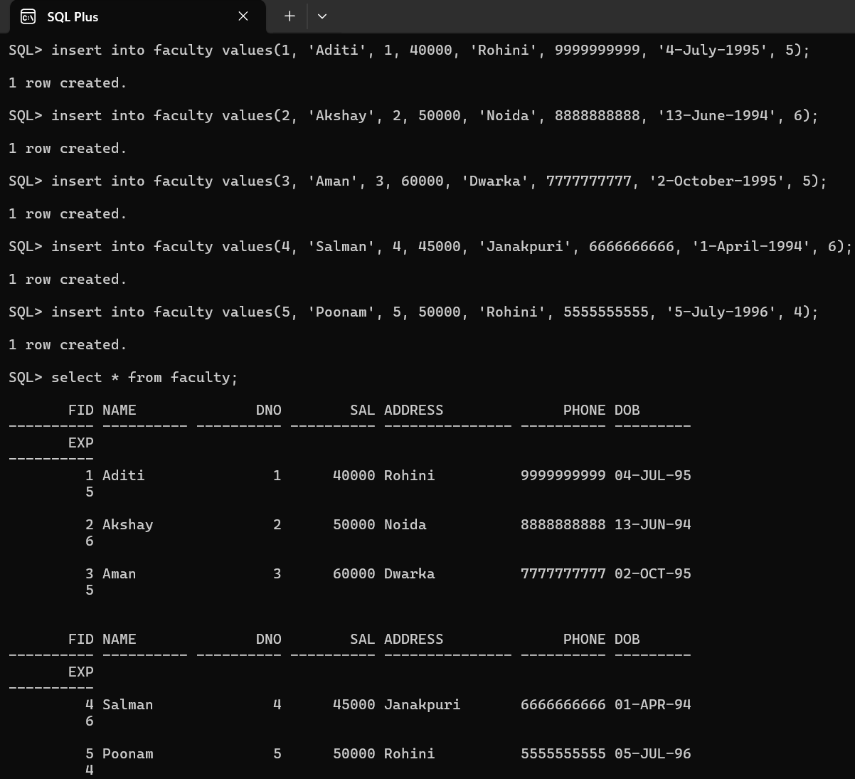

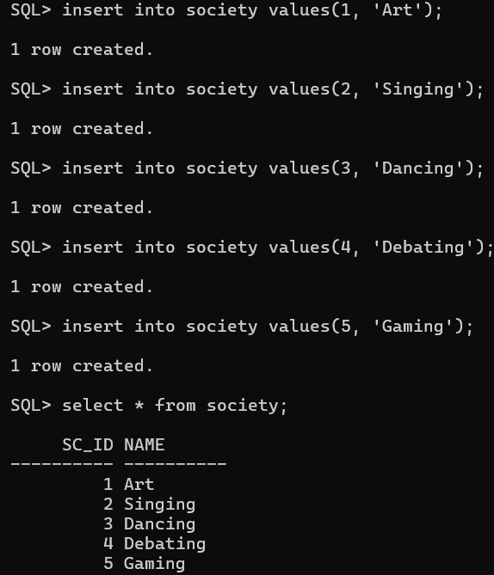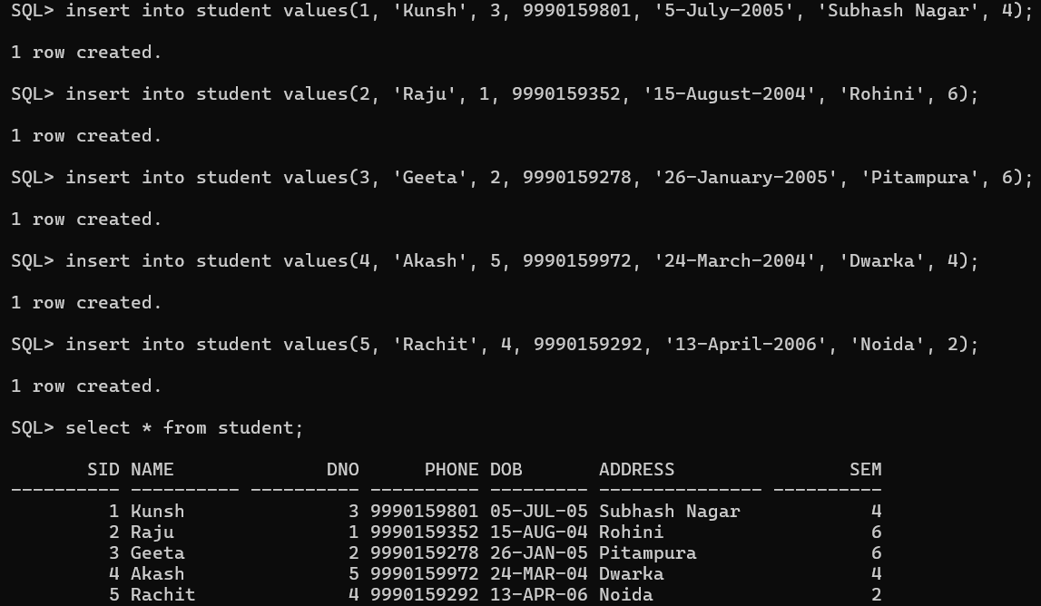

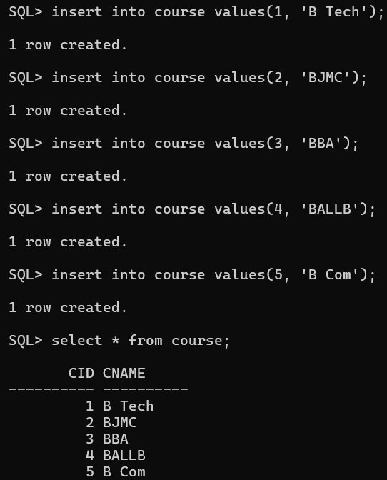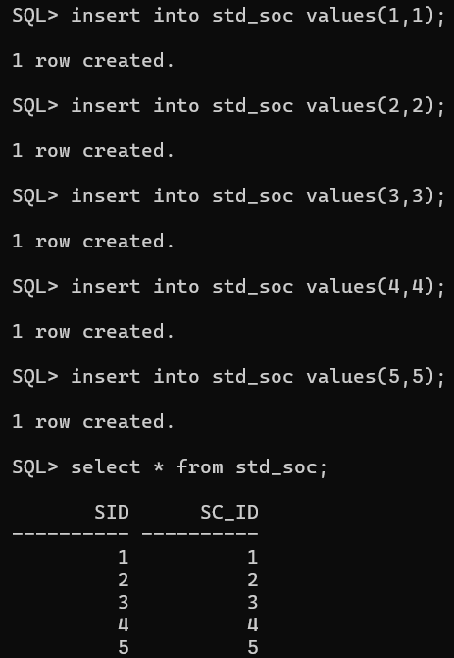

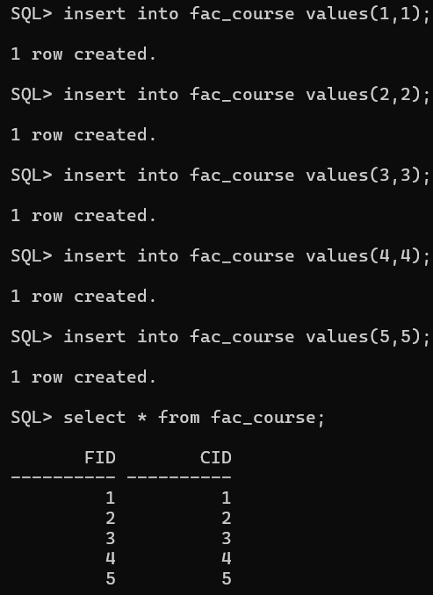

1. 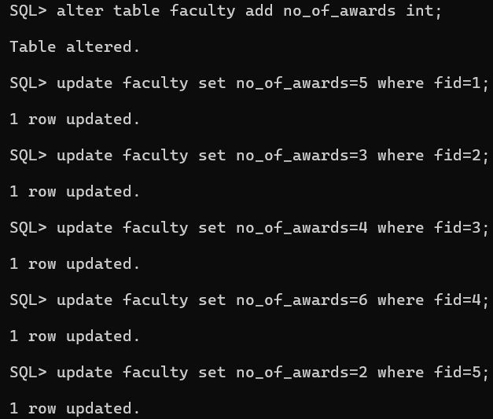Add a column no_of_awards to faculty table and update the values in the column
2. 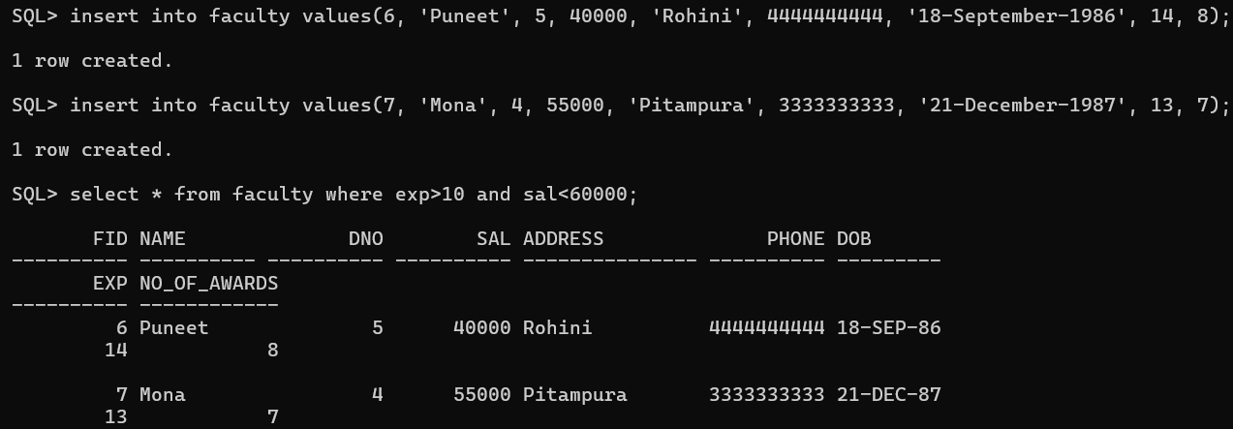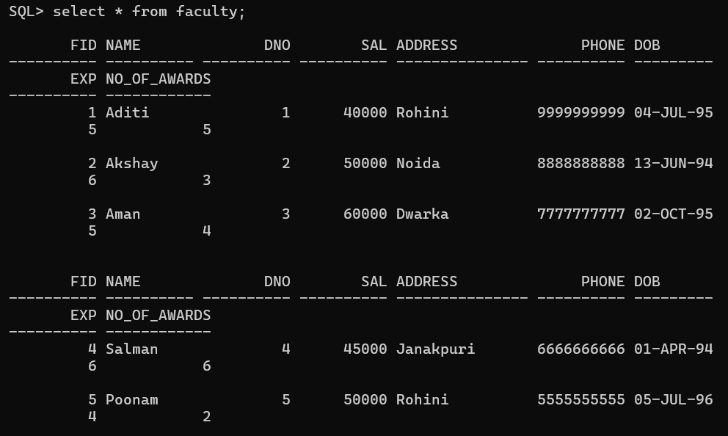Retrieve the faculties with exp greater than 10 years and sal<60000.
3. 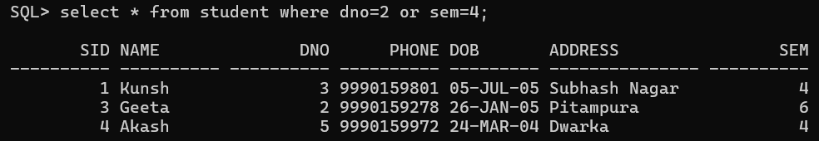 Retrieve the students enrolled in dno 2 or sem 4.
4. 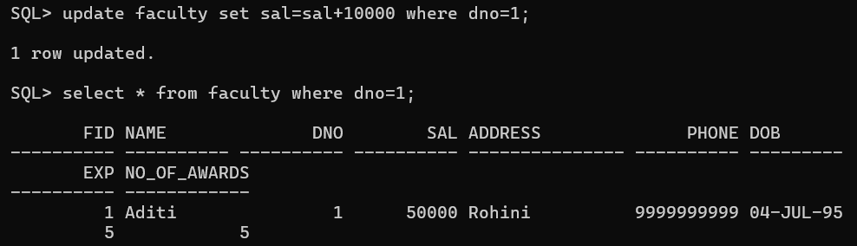Increase the faculties salary whose dno is 1.
5. 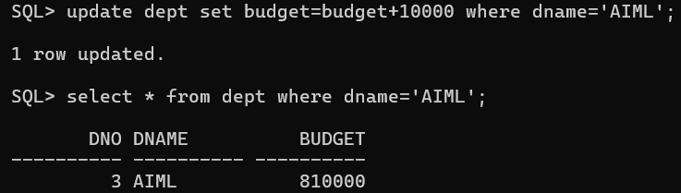 Increase the budget of AIML Department by 10000
6. 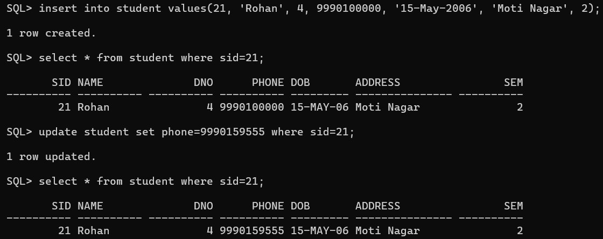Update the phone no. of student id 21.
7. 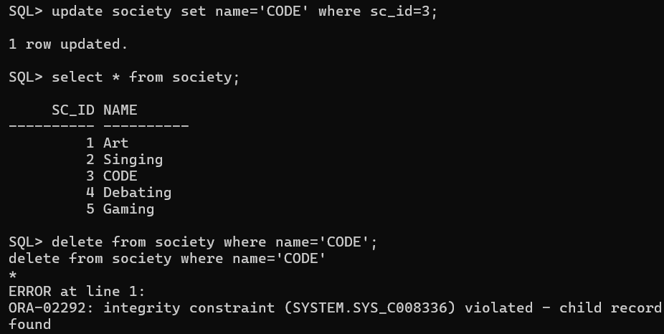Delete the society CODE (see if it allows (provided there are students enrolled))
8. Delete the student with no phone no.

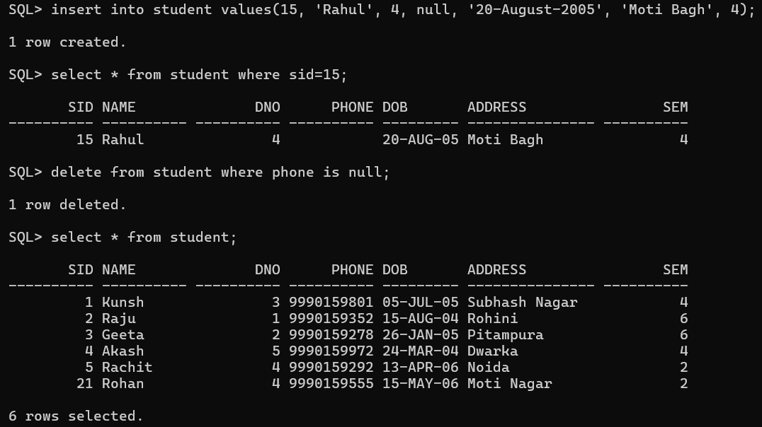**Learning Outcome:**

**EXPERIMENT 4**

**Problem statement:** Implement queries including various functions- mathematical, string, date etc.

**Theory:**

**SQL Commands:**

1. **Mathematical Functions:**
   1. SQRT()
   2. SIN() / COS()/ TAN()
   3. ABS()
   4. CEIL()
   5. FLOOR()
   6. 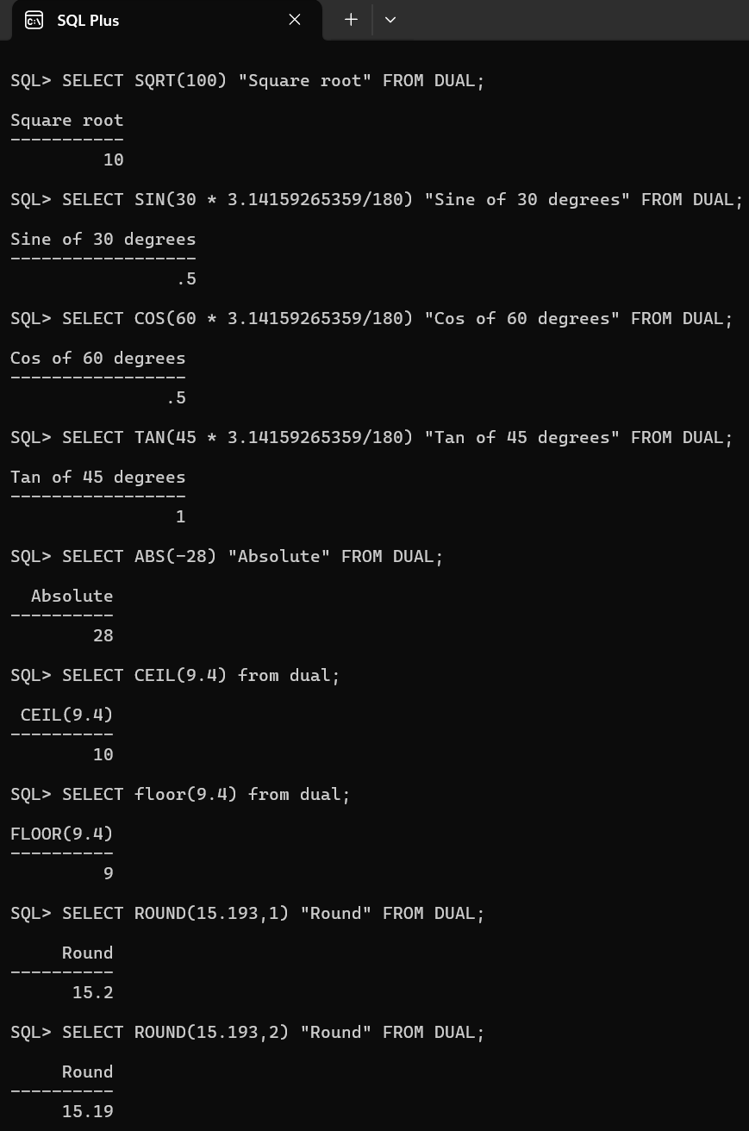ROUND()
2. **String Functions:**
   1. ASCII()
   2. CHR()
   3. LENGTH()
   4. CONCAT()
   5. LOWER() / UPPER()
   6. 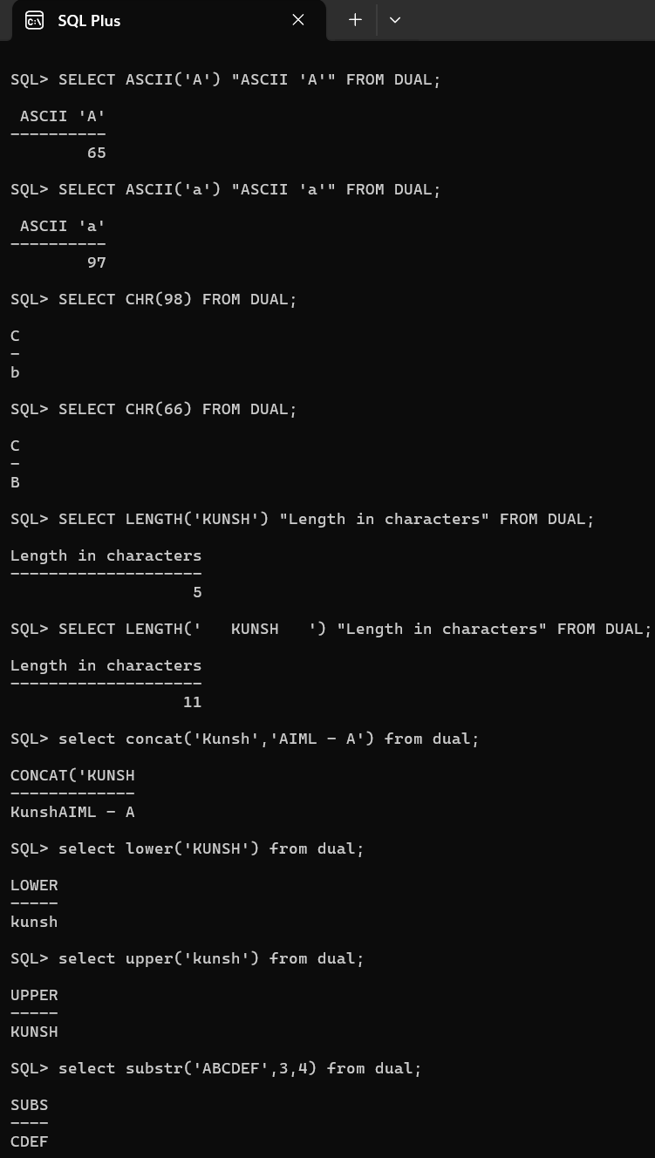SUBSTR()
3. **Date Functions:**
   1. CURRENT_DATE()
   2. CURRENT_TIMESTAMP()
   3. MONTHS_BETWEEN()
   4. SYSDATE()
   5. LAST_DAY()
   6. 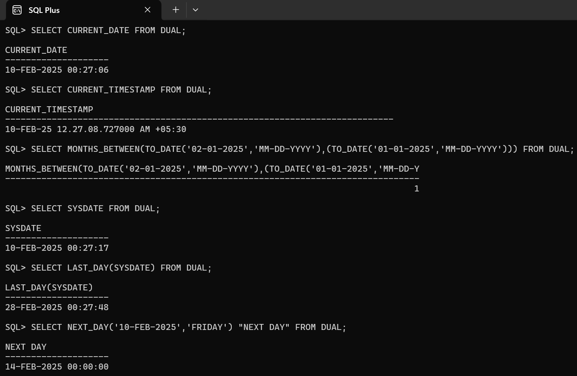NEXT_DAY()
4. **Aggregate Functions:**
   1. SUM()
   2. AVG()
   3. MIN()
   4. MAX()
   5. 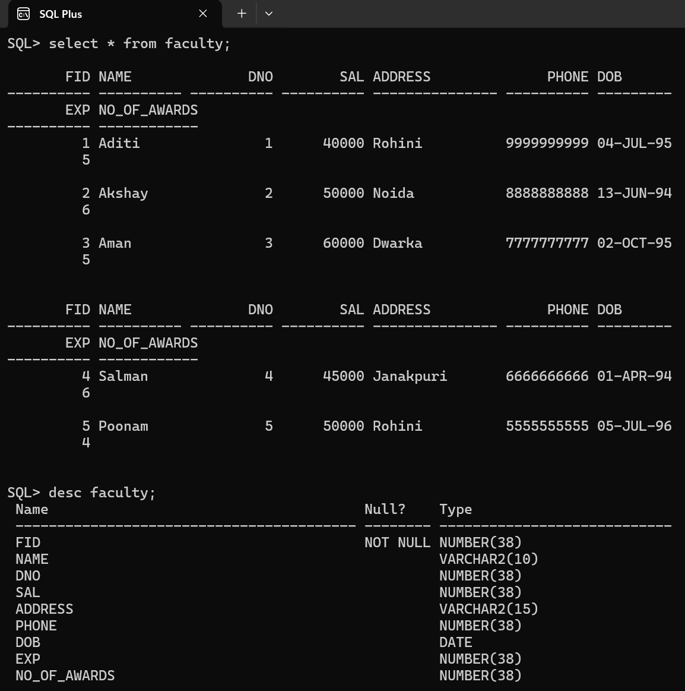COUNT(*)

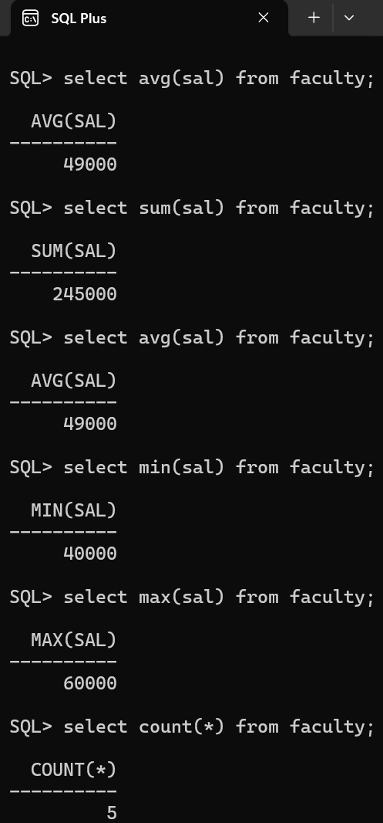

**Learning Outcome:**

**EXPERIMENT 5**

**Problem statement:** Implement queries including Sorting, Grouping and Subqueries- like any, all, exists, not exists.

**Theory:**

**SQL Commands:**

1. Create the below mentioned tables with proper constraints: -
   1. Faculty (fid, name, *dno*, sal, address, phone, dob, exp)
   2. 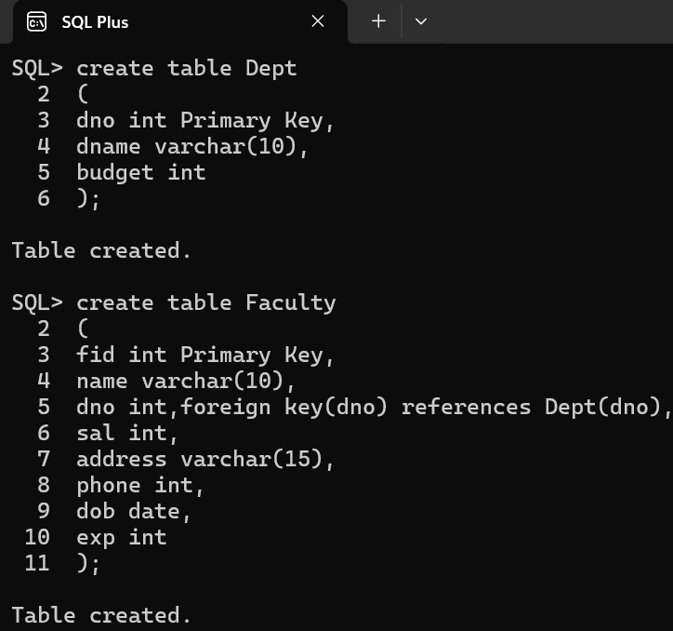Dept (dno, dname, budget)

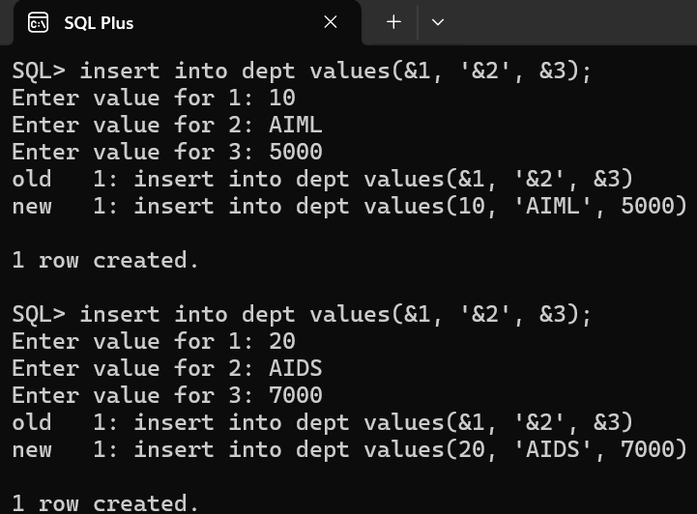

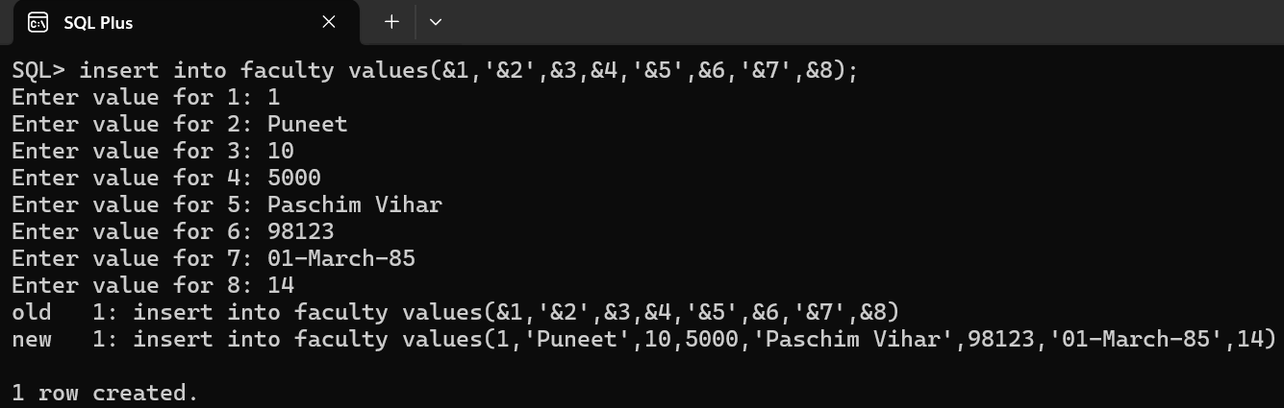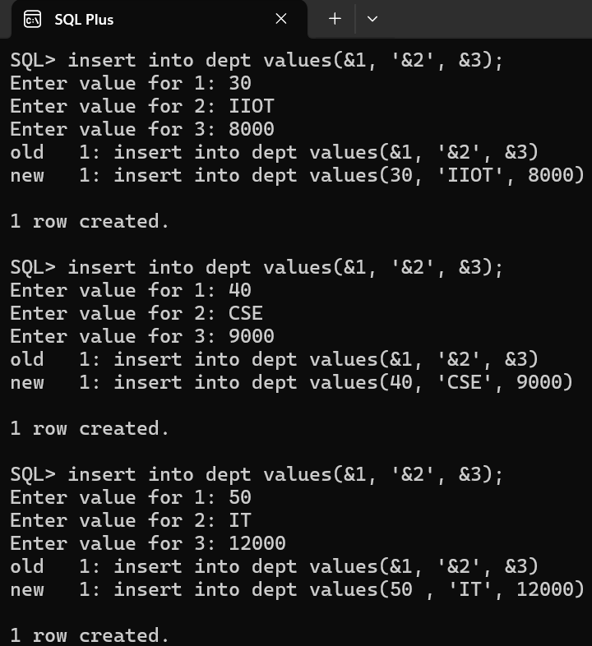

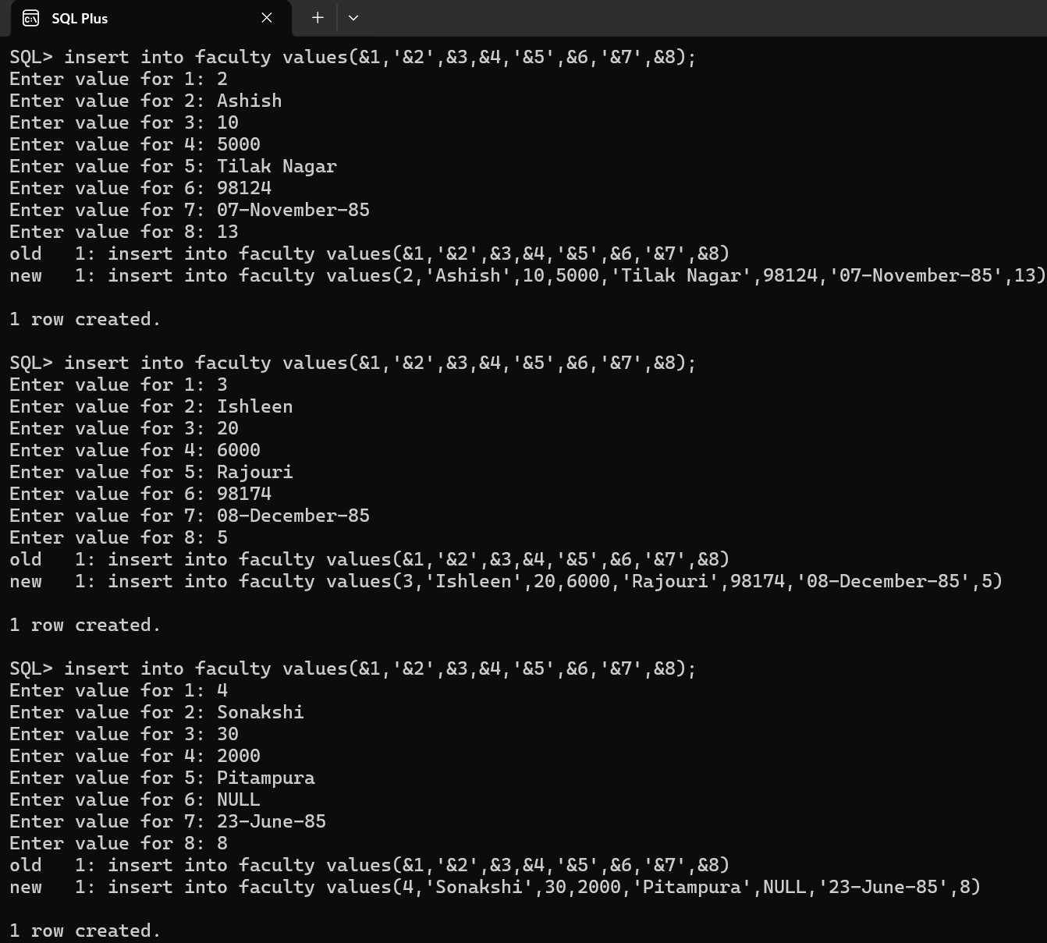

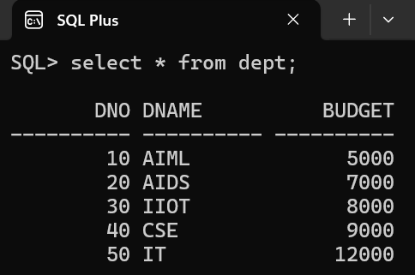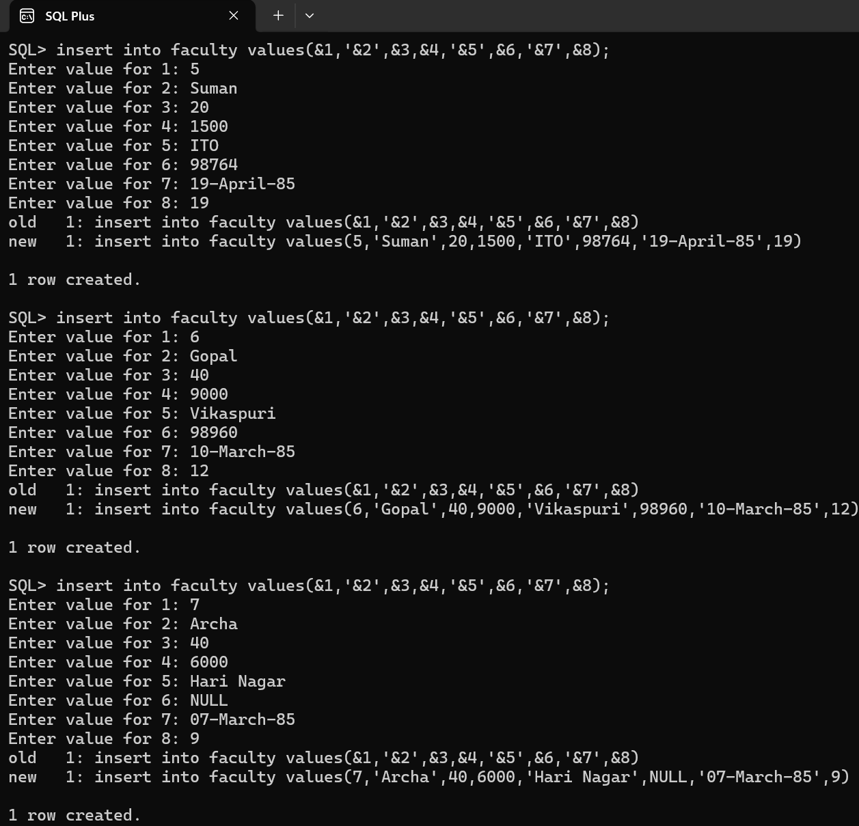

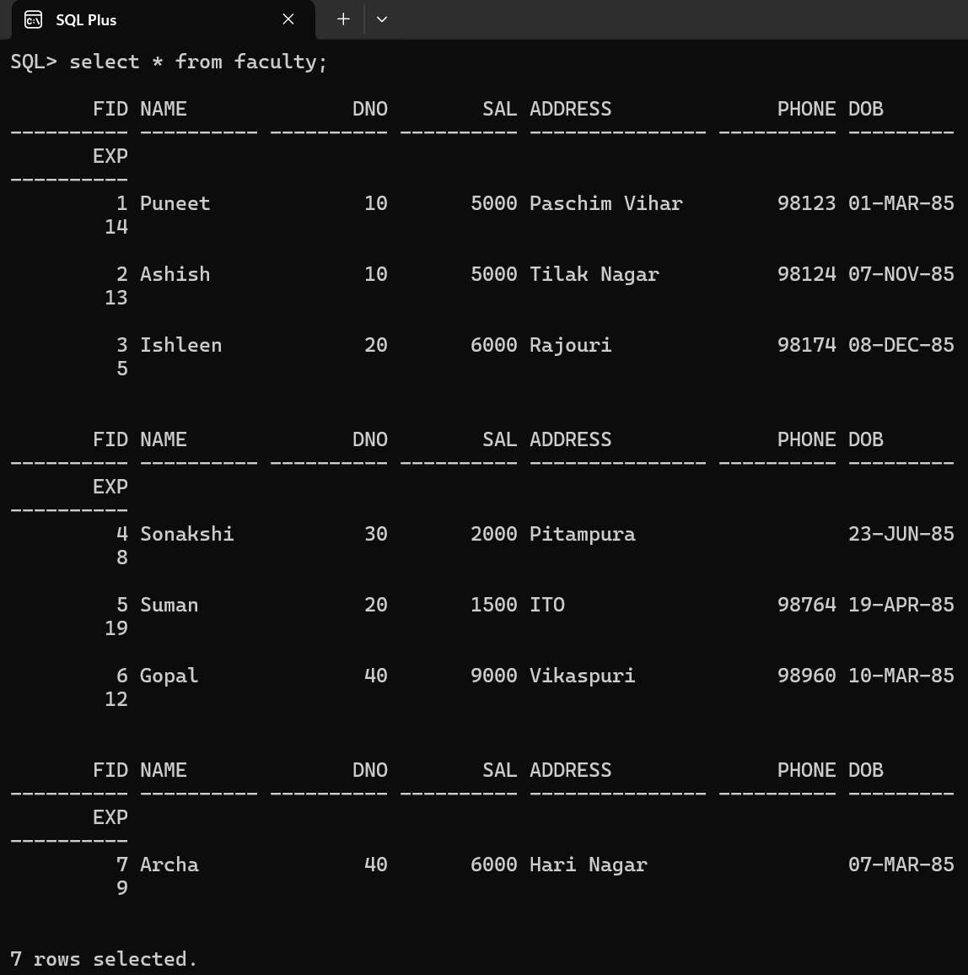

1. 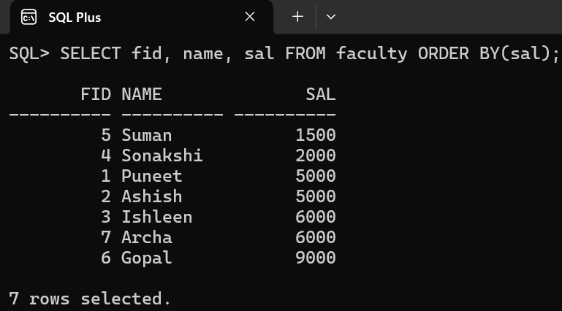Retrieve the ID, Name and Salary of Faculty in increasing order of Salary.
2. 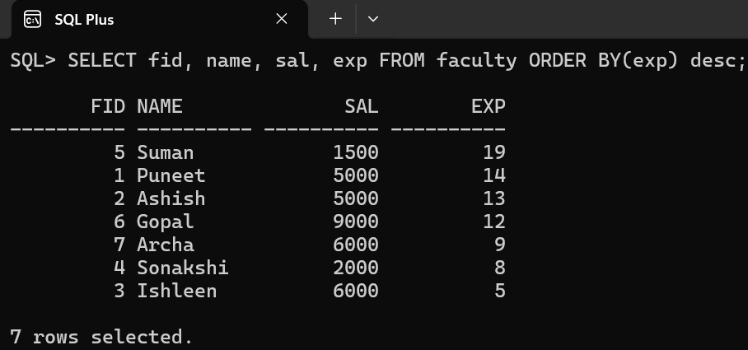Retrieve the ID, Name, Salary and Experience of Faculty in decreasing order of Experience.
3. 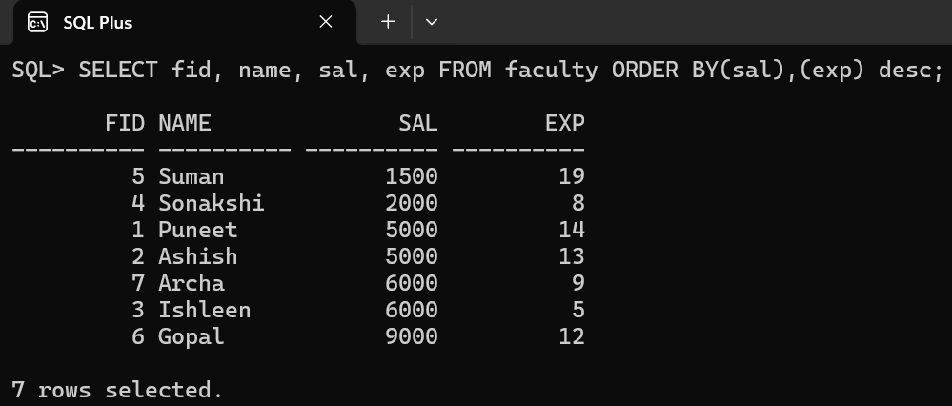Retrieve the ID, Name, Salary and Experience of Faculty in increasing order of Salary and Decreasing order of Experience.
4. 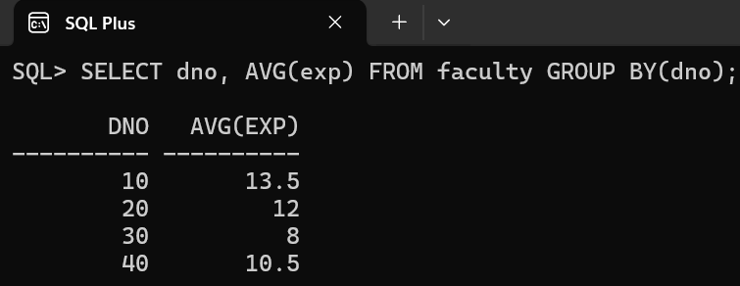Show the average experience department wise
5. 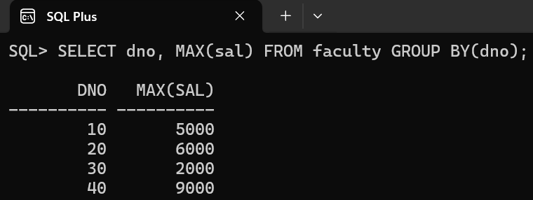Retrieve the maximum salary department wise.
6. 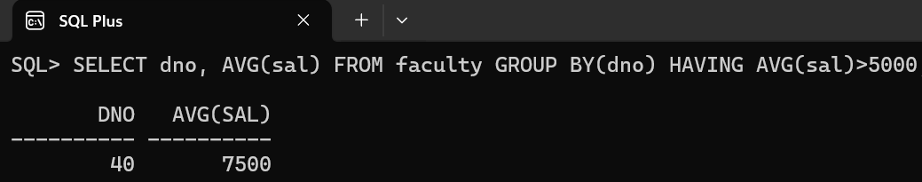Retrieve the average salary department wise having average salary greater than 5000.
7. 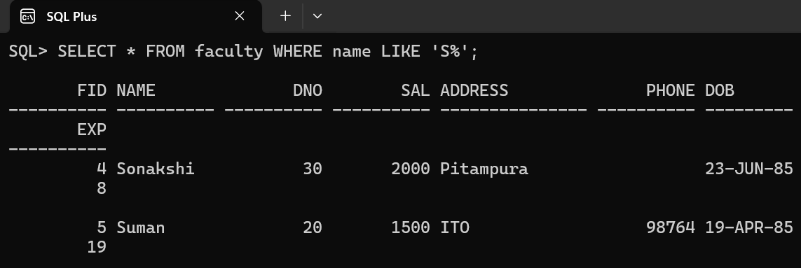Retrieve faculties details where name (table should have names accordingly): -
8. Starting with 'S'
9. 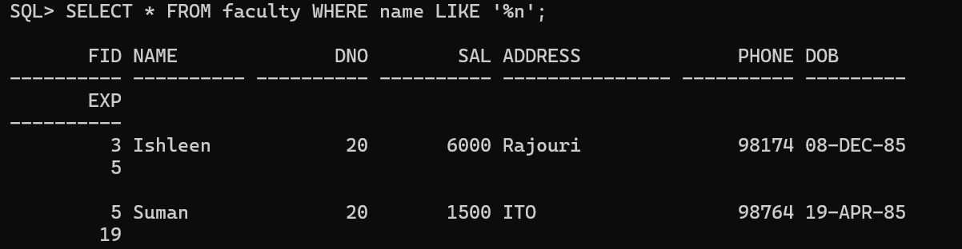Ending with 'n'
10. 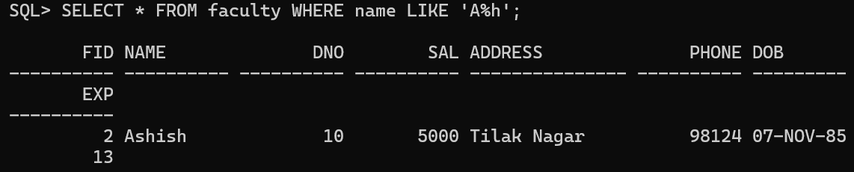Starting with 'a' and ending with 'h'
11. 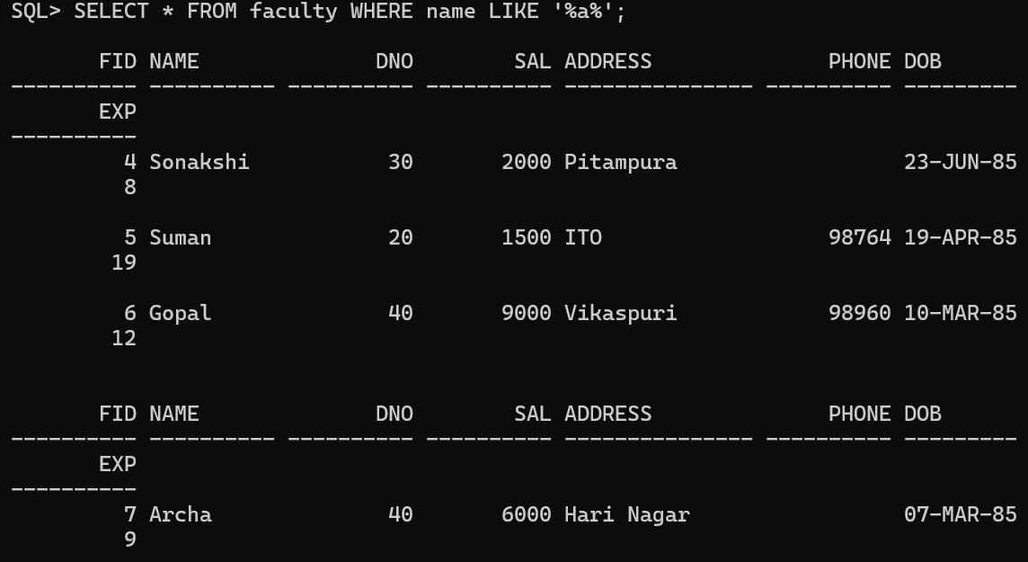Must contain 'a'
12. 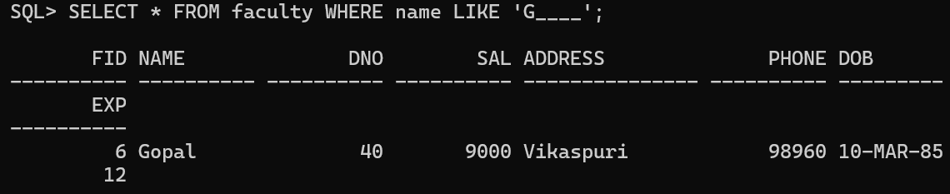Should have 5 letters only starting with 'g'
13. 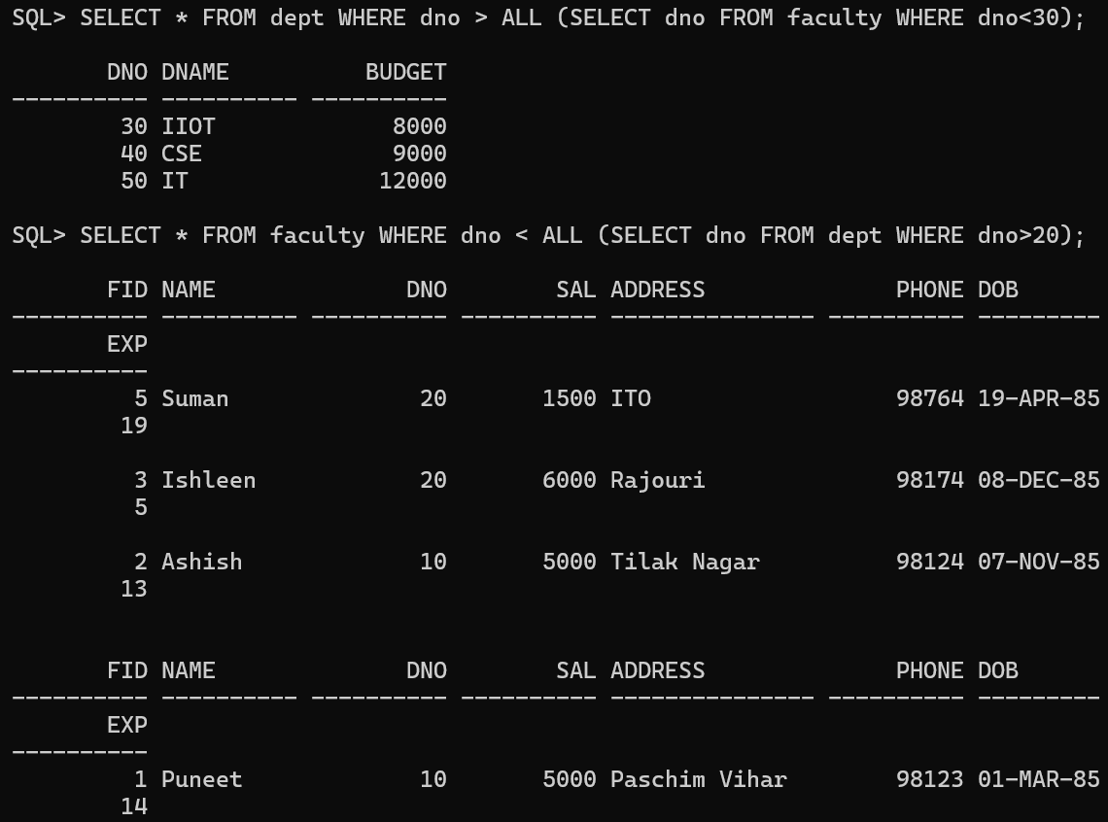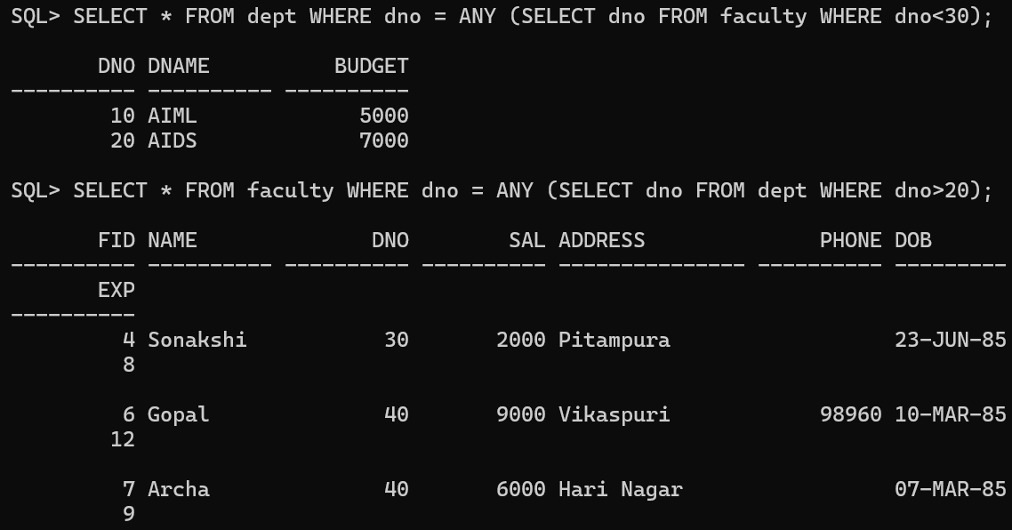Show the use of ANY/ALL clauses.
14. 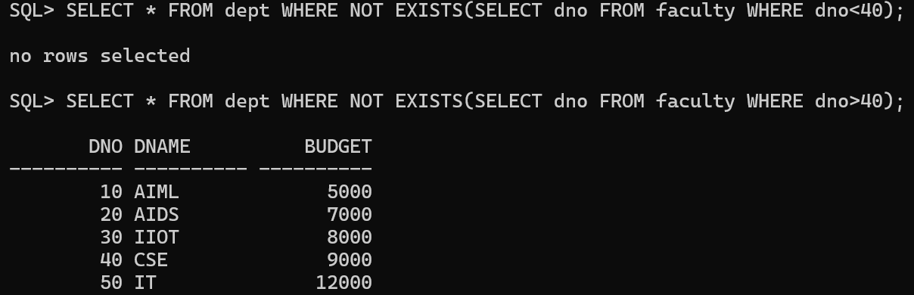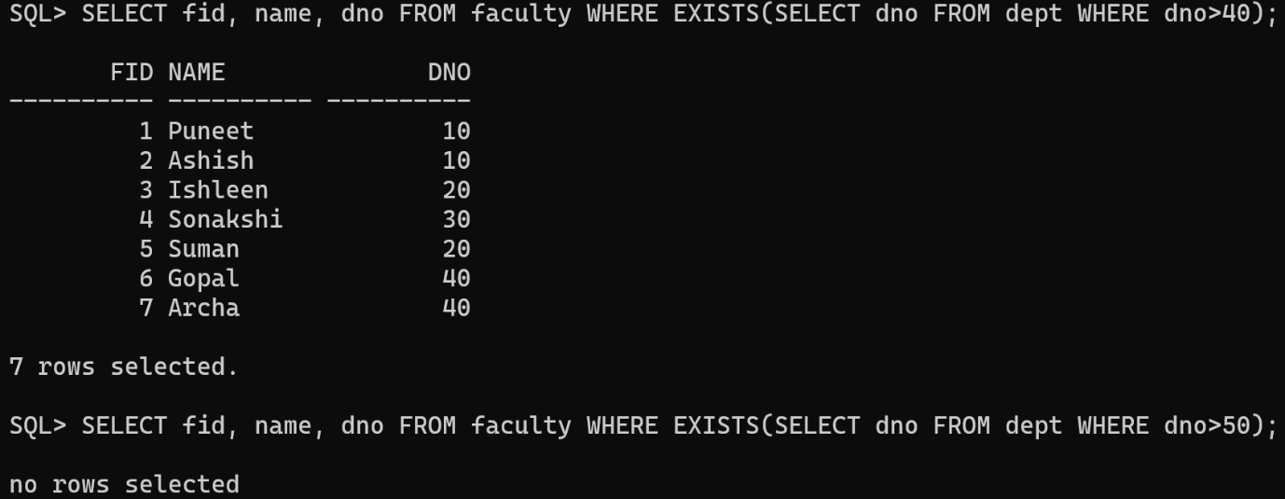Show the use of EXISTS/NOT EXISTS clauses
15. 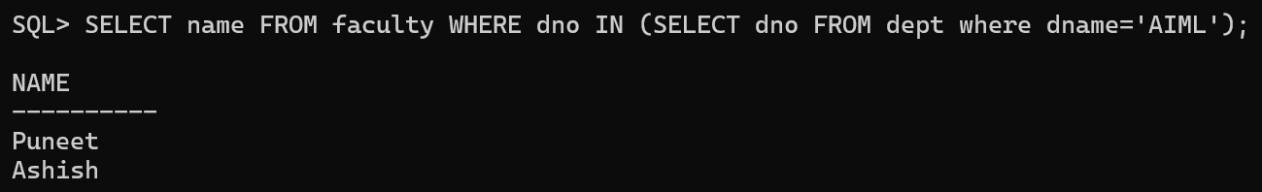Find the names of Faculty who work in department AIML (using subquery)

**Learning Outcome:**

**EXPERIMENT 6**

**Problem statement:** Implement queries including various Set operations (Union, Intersection, Except etc.).

**Theory:**

**SQL Commands:**

1. Create a table named section with the following columns and add appropriate values to it:
   1. 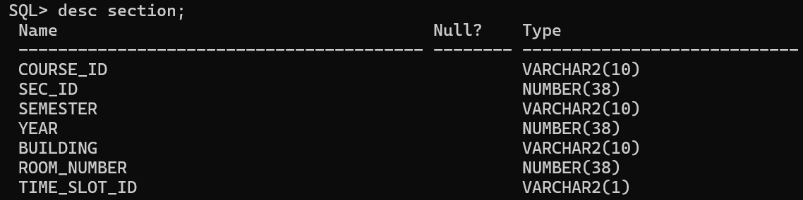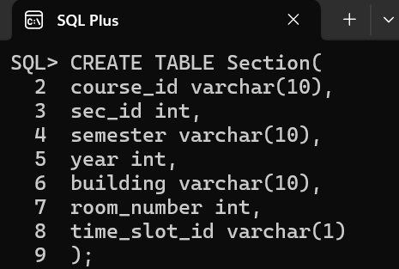Section (course_id, sec_id, semester, year, building, room_number, time_slot_id)

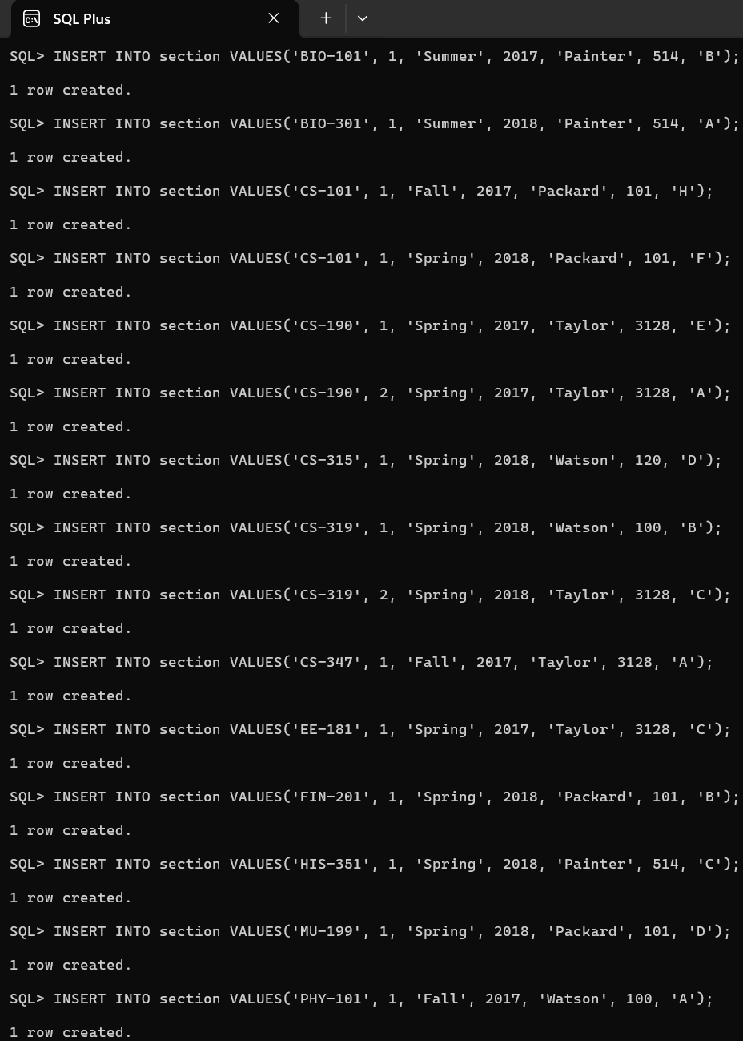

1. 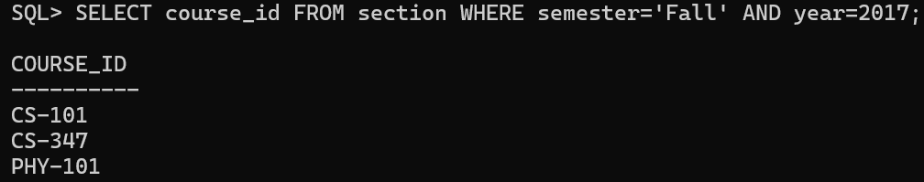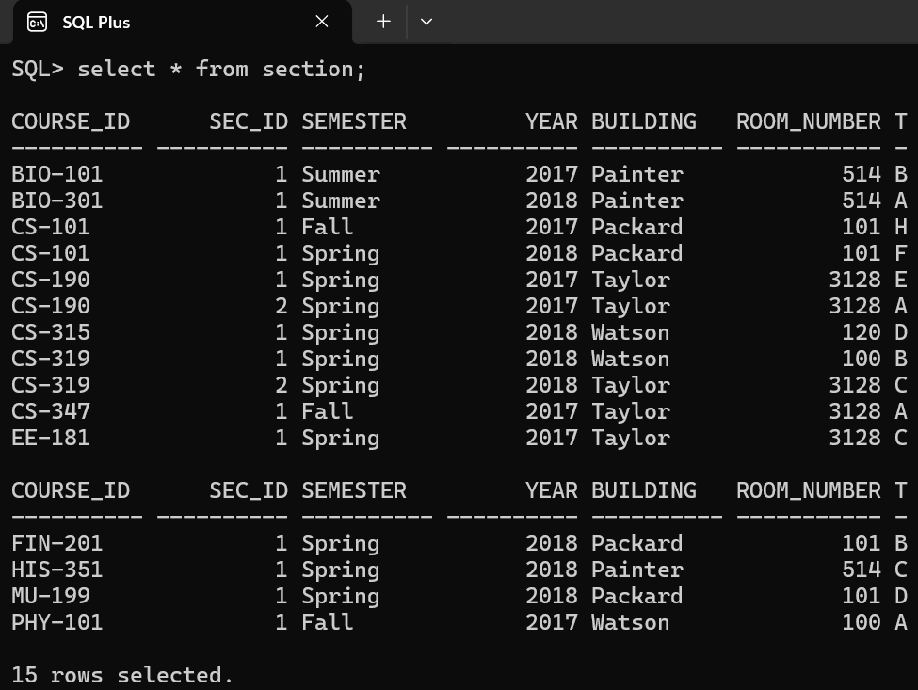Find courses that ran in Fall 2017.
2. 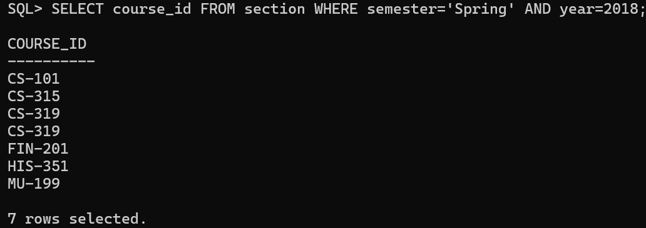Find the courses that ran in Spring 2018.
3. 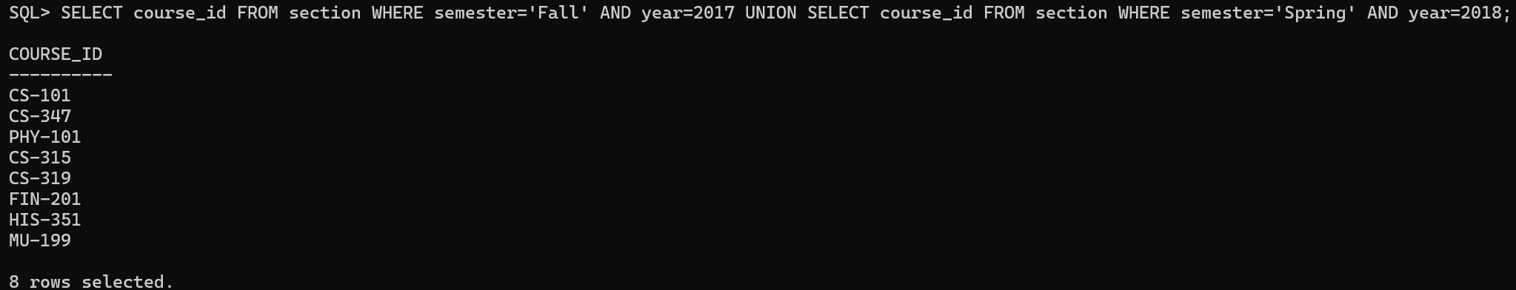Find courses that ran in Fall 2017 or in Spring 2018.
4. Find courses that ran in Fall 2017 and in Spring 2018.
5. Find courses that ran in Fall 2017 but not in Spring 2018.
6. 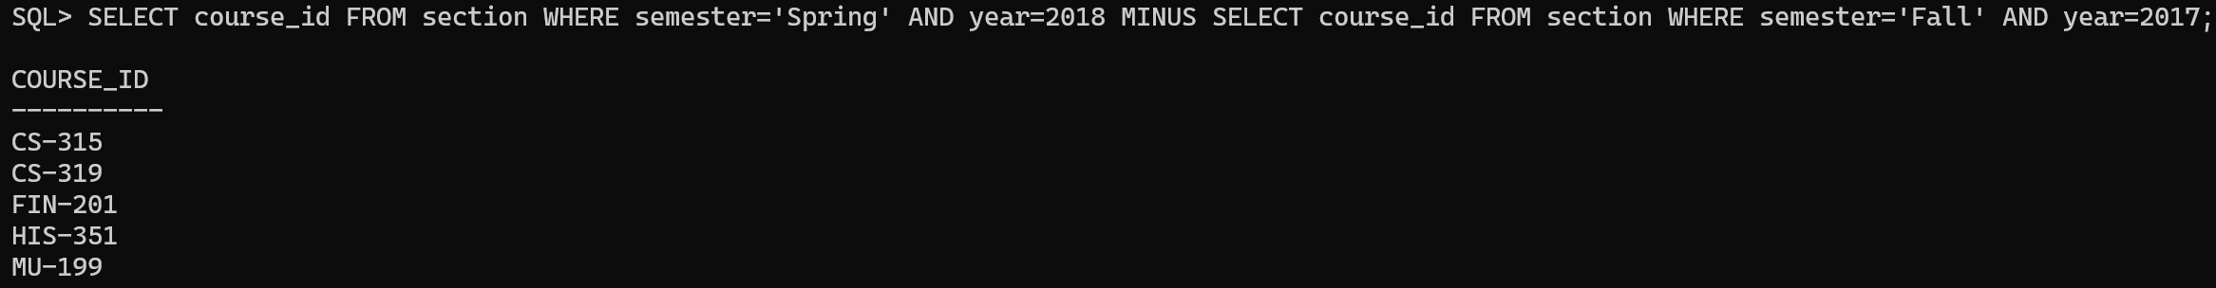Find courses that ran in Spring 2018 but not in Fall 2017.
7. Create 2 different tables with same number of columns and make use of Union, Union all, Intersect and Except.
   1. Building (id, name)
   2. Construction (id, name)

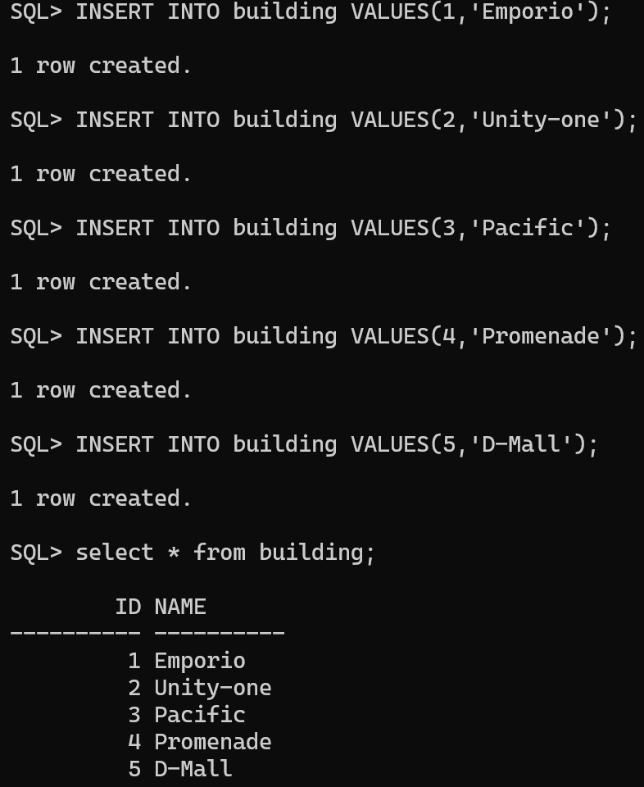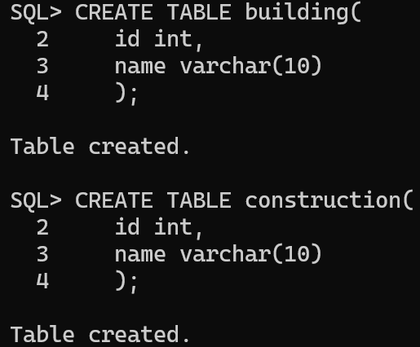

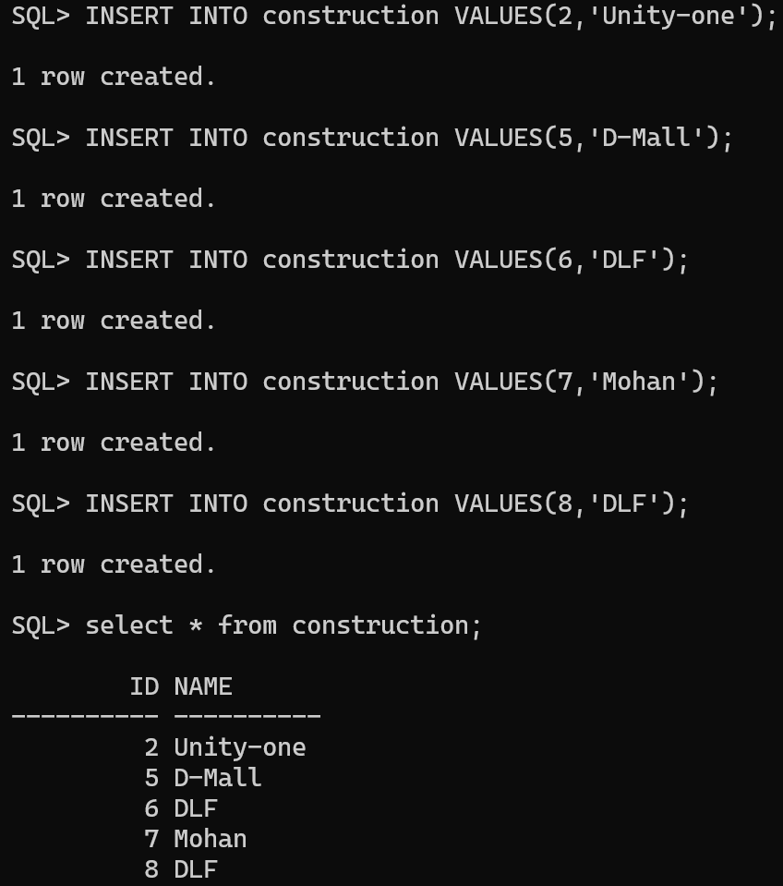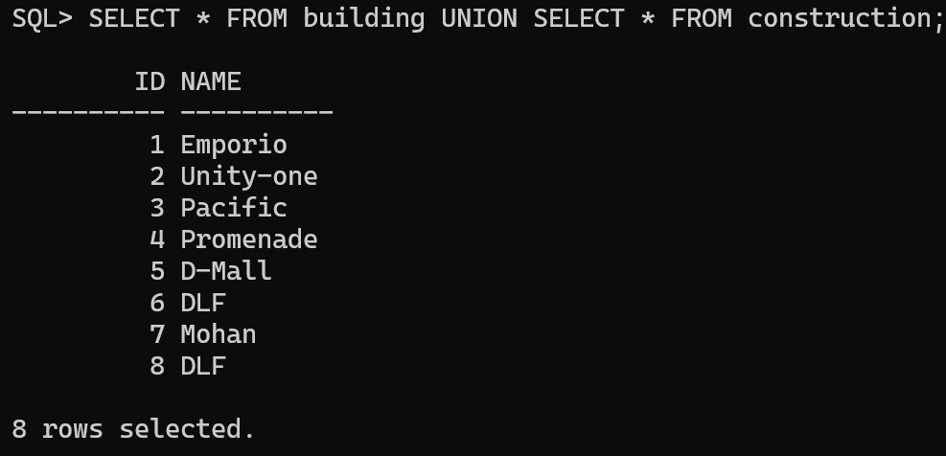

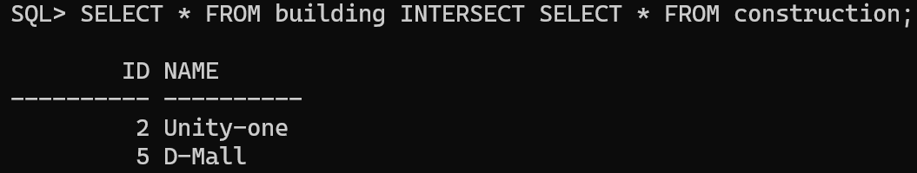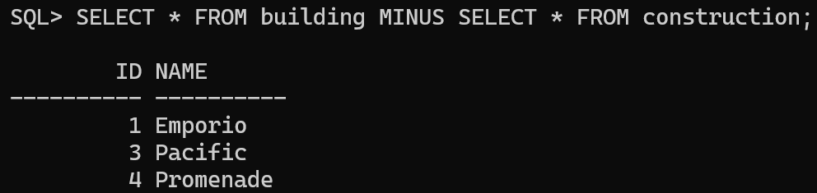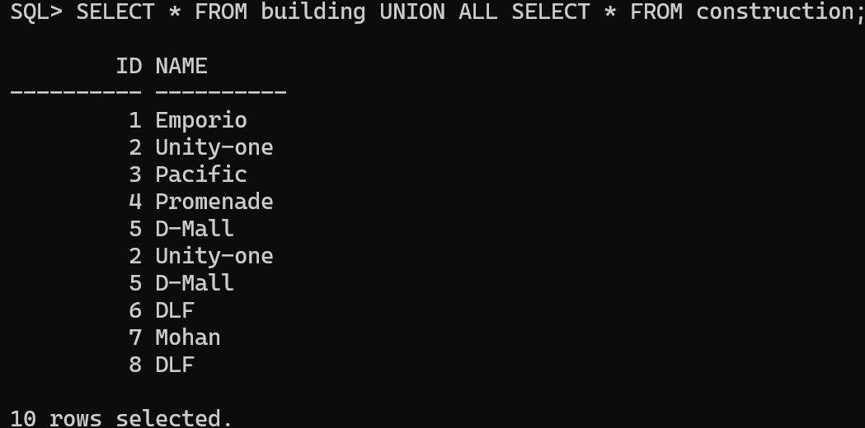**Learning Outcome:**

**EXPERIMENT 7**

**Problem statement:** Implement various JOIN operations- (Inner, Outer).

**Theory:**

**SQL Commands:**

1. Create the following tables
   1. Employee – (empid, empname, *deptid)*
   2. 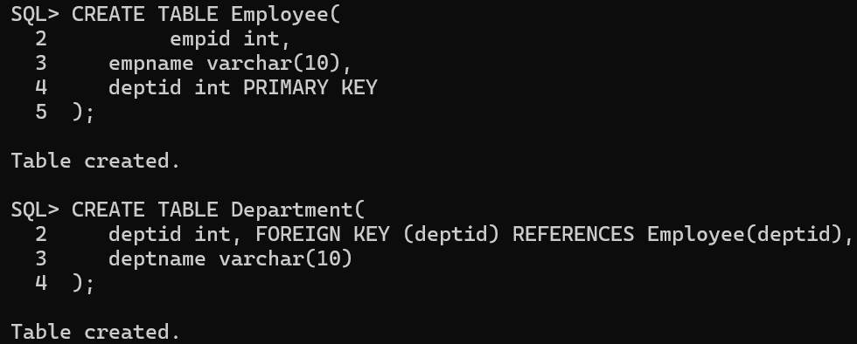Department – (*deptid*, deptname)
2. 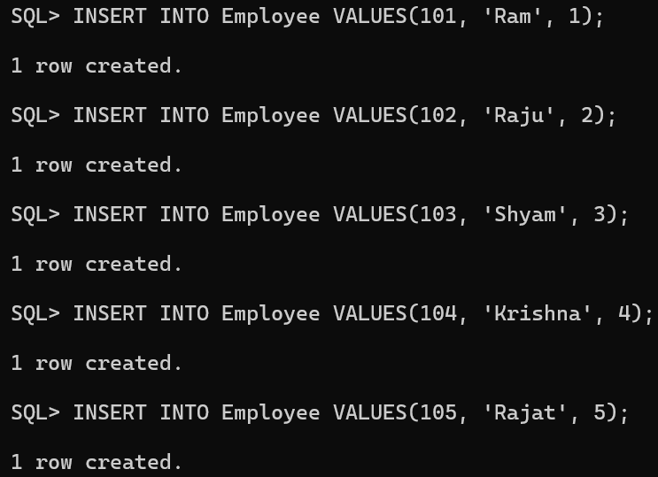Insert values in the above tables.

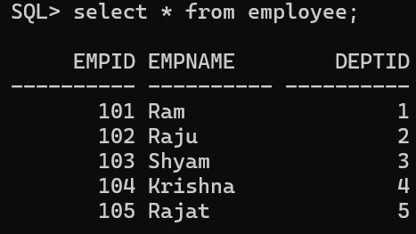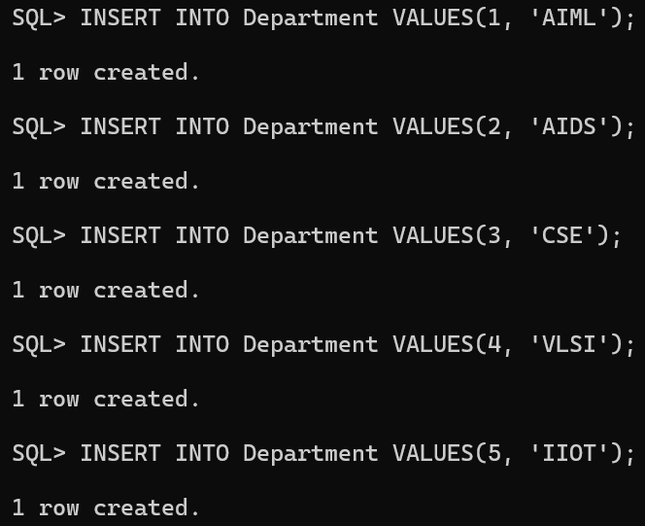

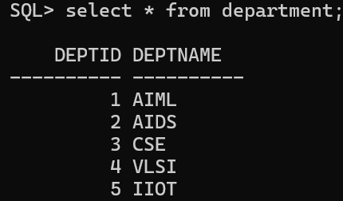

1. 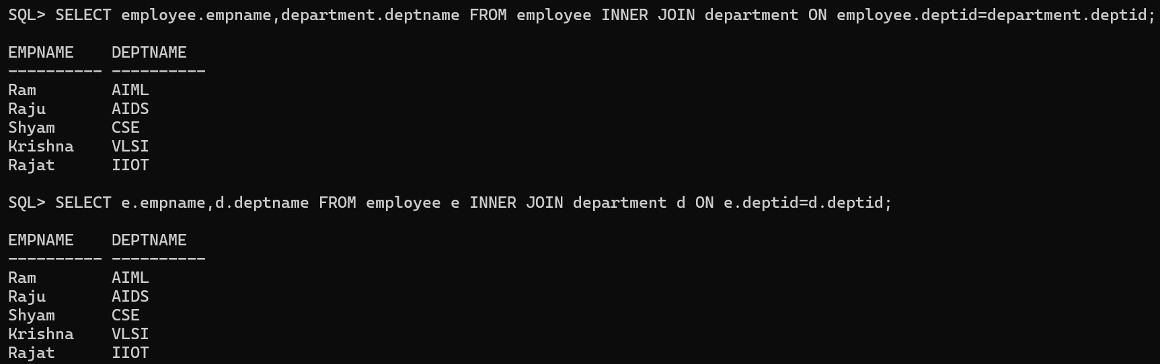Implement INNER JOIN on the tables.
2. 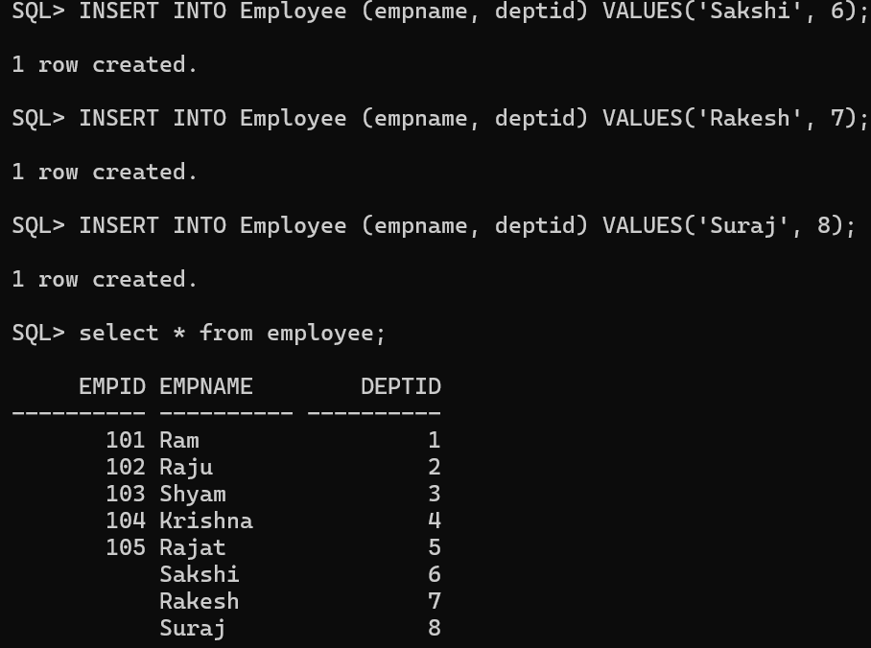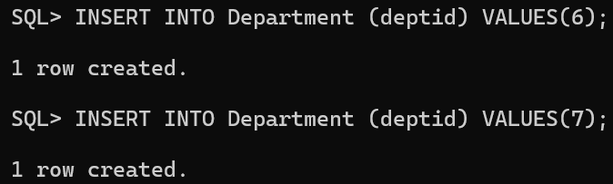Implement LEFT JOIN (OUTER JOIN) on the tables.

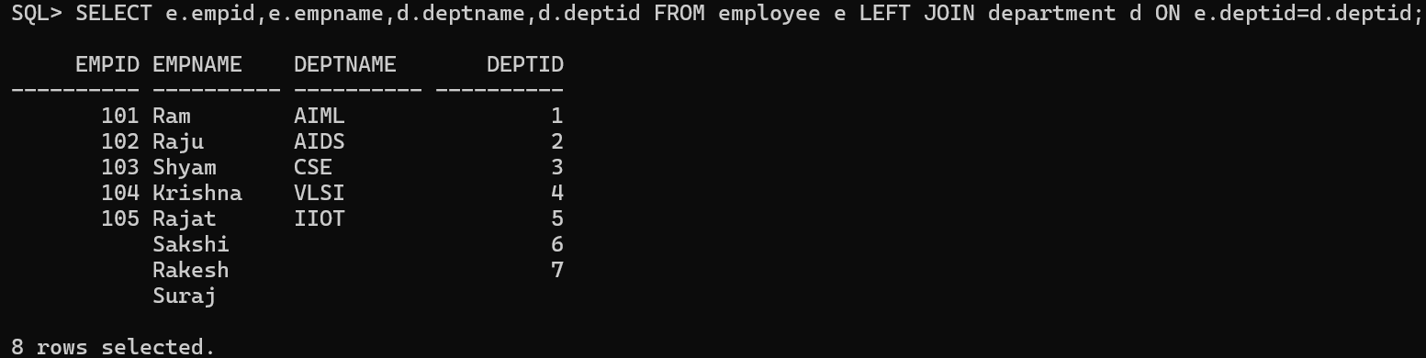 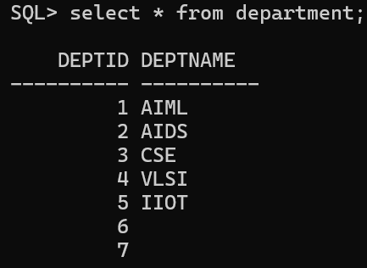

1. 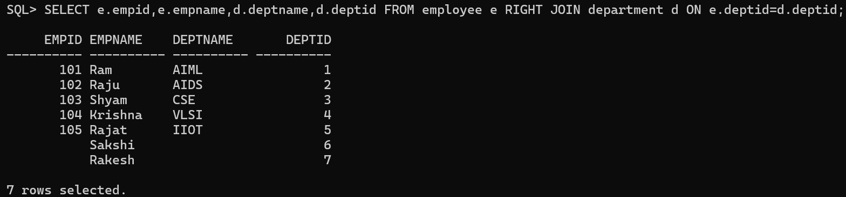Implement RIGHT JOIN (OUTER JOIN) on the tables.
2. 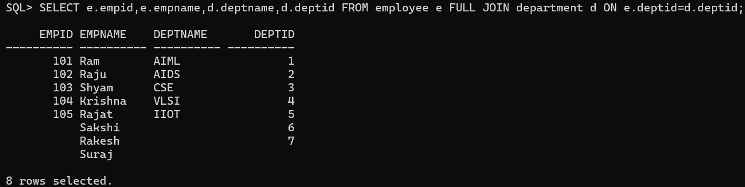Implement FULL JOIN (OUTER JOIN) on the tables.
3. 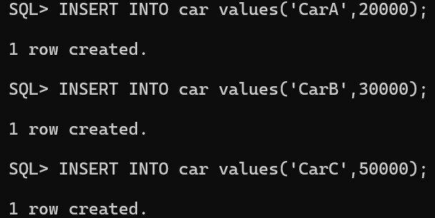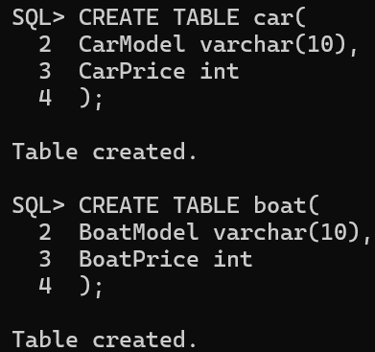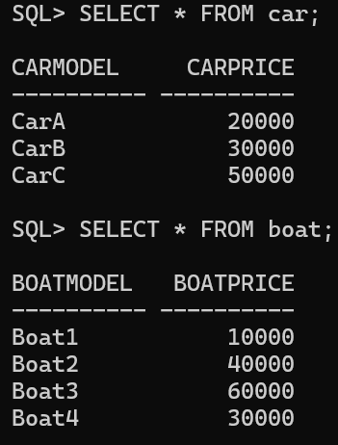Implement THETA and EQUI Join (INNER JOIN).

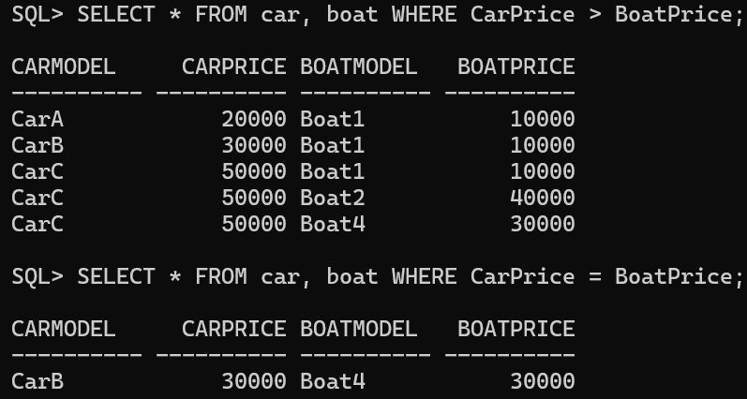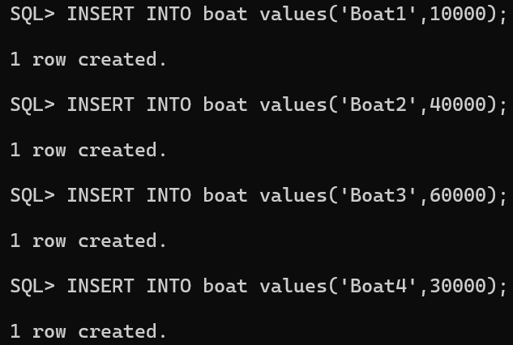**Learning Outcome:**

**EXPERIMENT 8**

**Problem statement:** Write a PL/SQL program using FOR loop to insert ten rows into a database table.

**Theory:**

**SQL Commands:**

1. 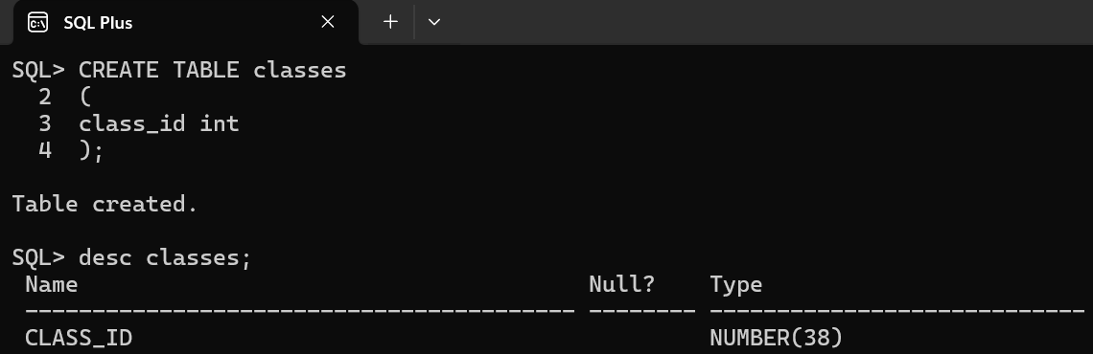Create table classes with only one column (class_id int) to display 10 classes.
2. 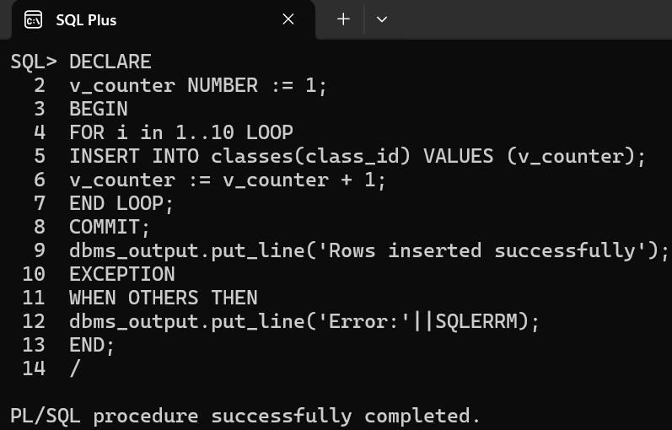Create the PL/SQL command to DECLARE a variable v_counter starting from 1 and in BEGIN make a FOR LOOP to run from 1 – 10, incrementing value of v_counter each time. Add these values to the table each time the for loop iterates.
3. Print the full table.

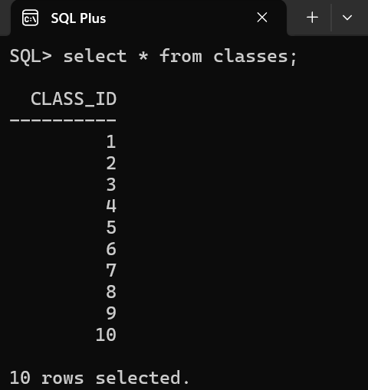

**Learning Outcome:**

**EXPERIMENT 9**

**Problem statement:** Given the table EMPLOYEE (Emp No, Name, Salary, Designation, DeptID), write a cursor to select the five highest-paid employees from the table.

**Theory:**

**SQL Commands:**

1. 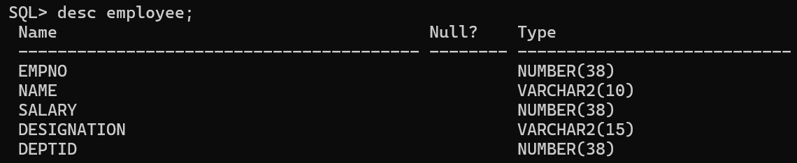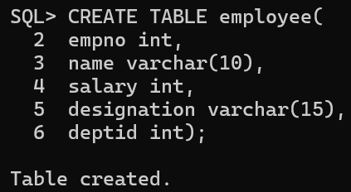Create table employee with columns (empno int, name varchar (10), salary int, designation varchar (10), deptid int).
2. 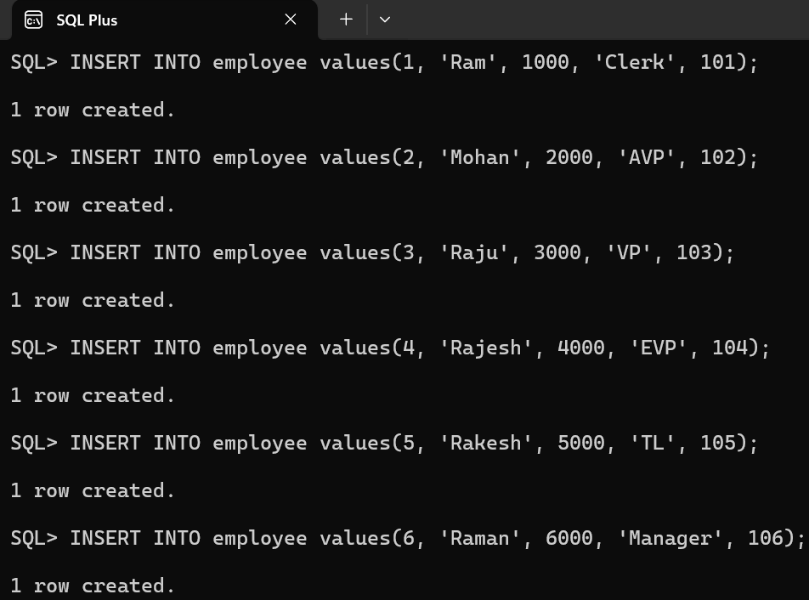Insert appropriate values into the above table with employee number, names, salary, designation, and department ID.
3. 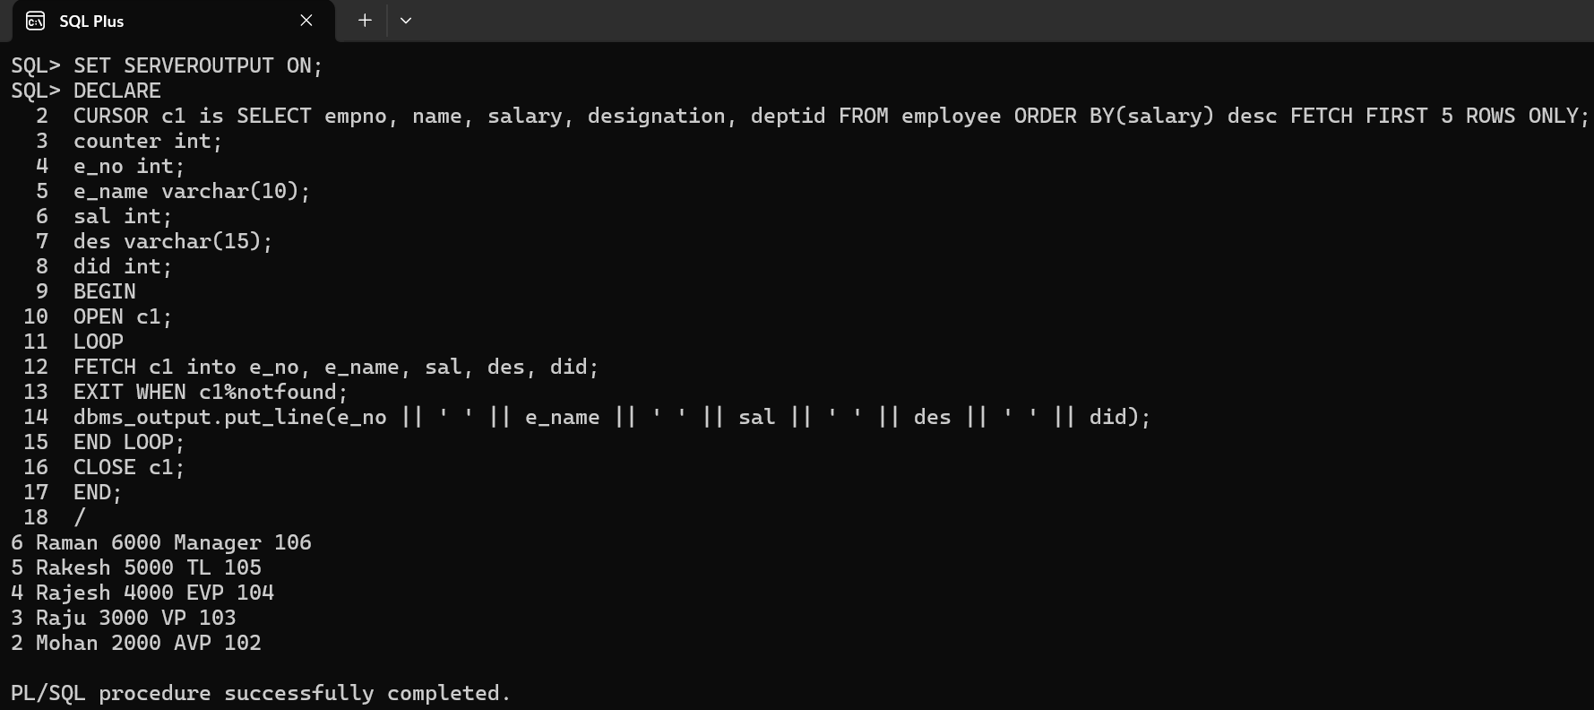Create the required cursor to select only the 5 highest paid employees from the table.

**Learning Outcome:**

**EXPERIMENT 10**

**Problem statement:** Illustrate how you can embed PL/SQL in a high-level host language such as C/Java And demonstrates how a banking debit transaction might be done.

**Theory:**

**SQL Commands: -**

1. 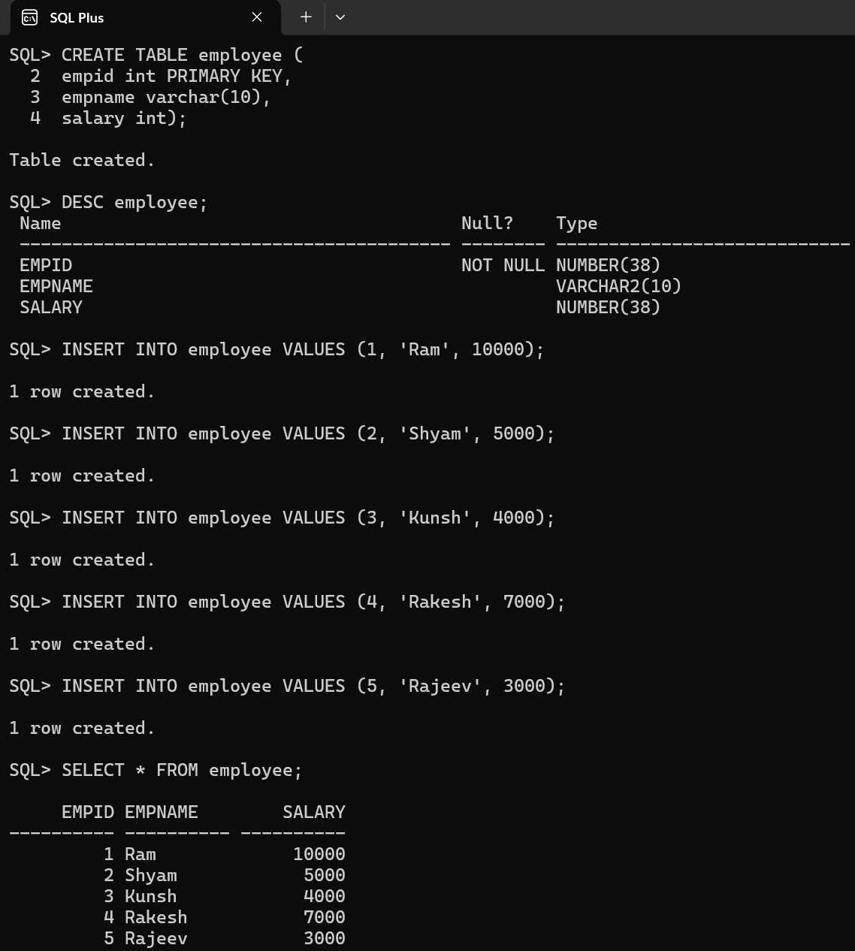Create a table in SQL Plus and add values to it and display the table.
2. 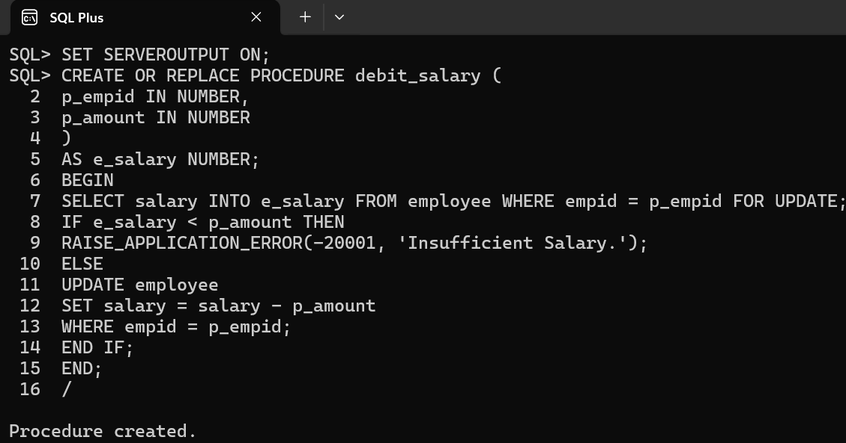Create a procedure to implement when the connectivity is done via java.
3. 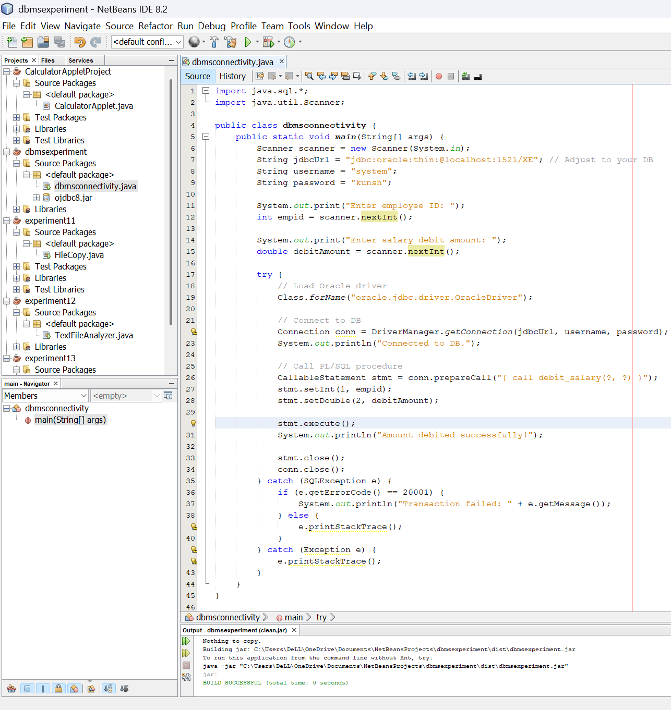Write the connectivity code in any IDE for Java.
4. Open command prompt and navigate to the folder containing the .class file, .java file and ojdbc.jar file for the connectivity.

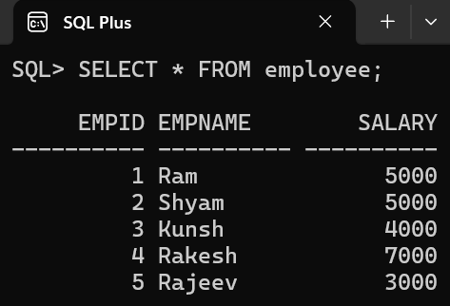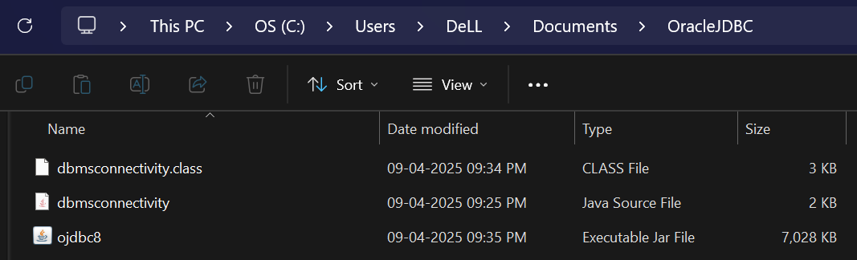

1. Print the table again in SQL to confirm the debit of salary.

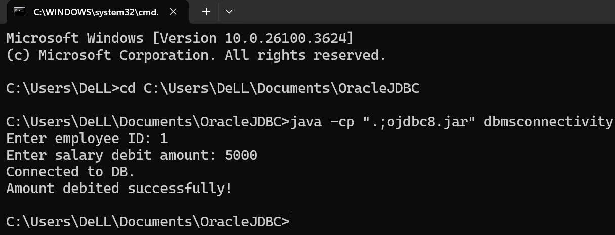

**Learning Outcome:**

**Beyond Curriculum**

**EXPERIMENT 1**

**Problem statement:** Write the steps to install and implement NOSQL databases-MongoDB**.**

**Theory:**

**Installation Screenshots:**

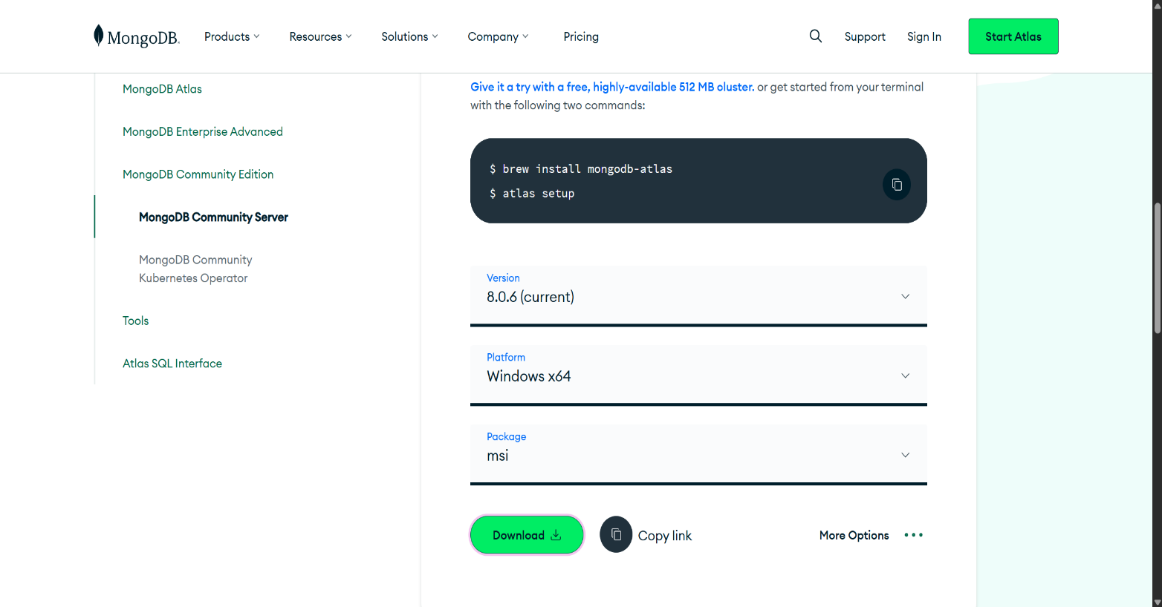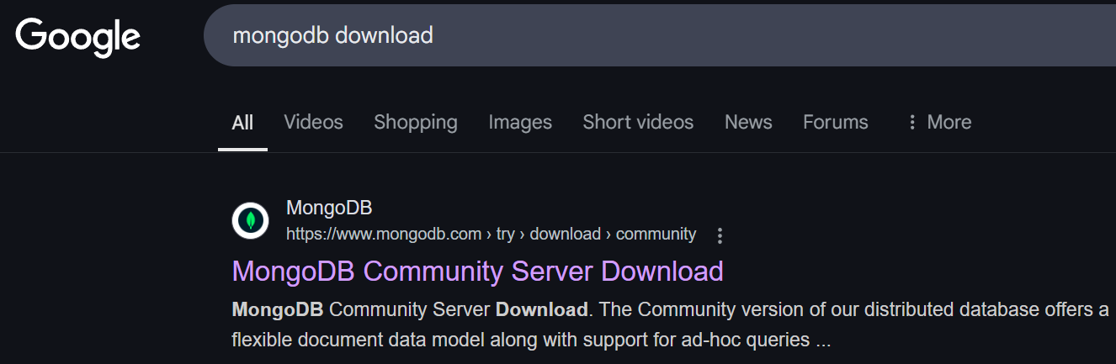

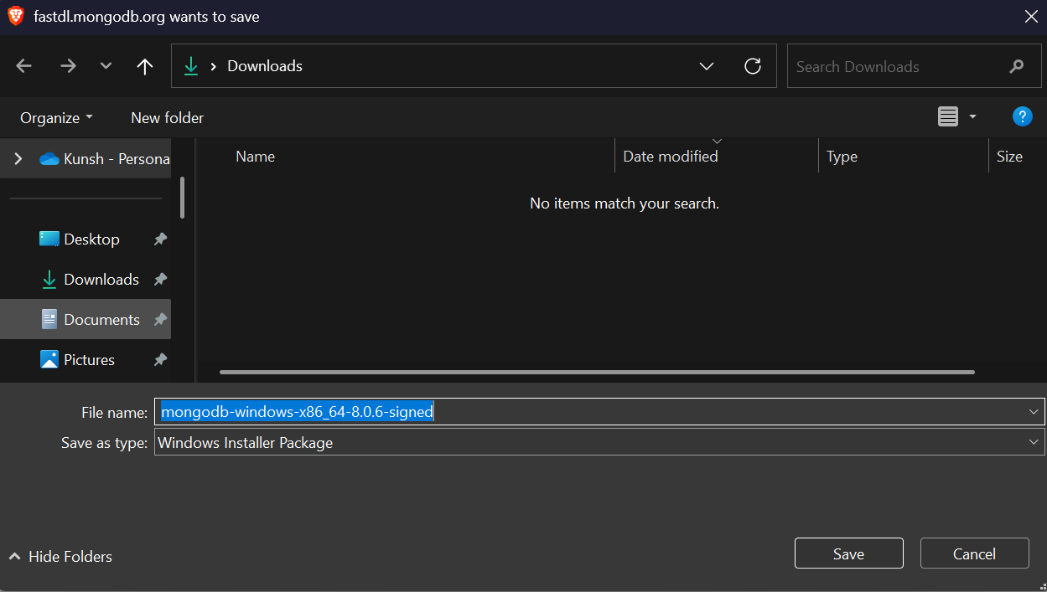

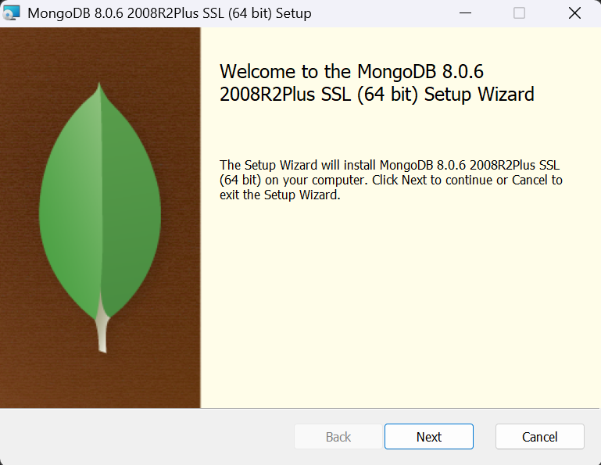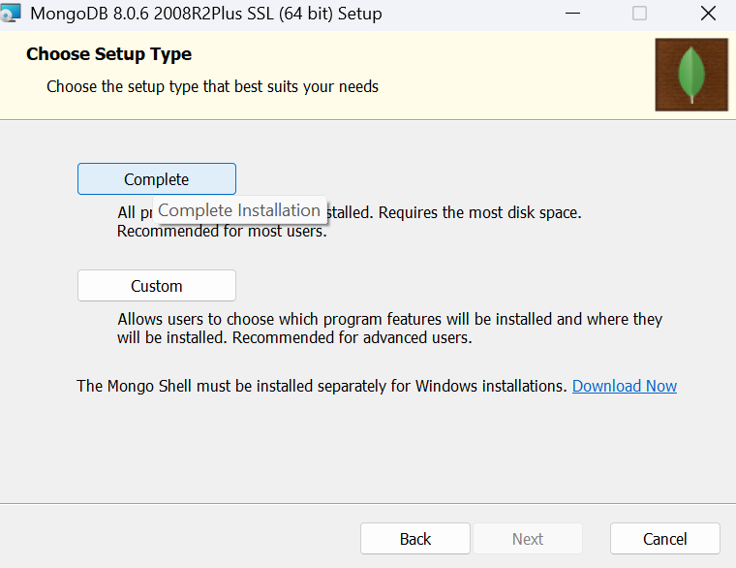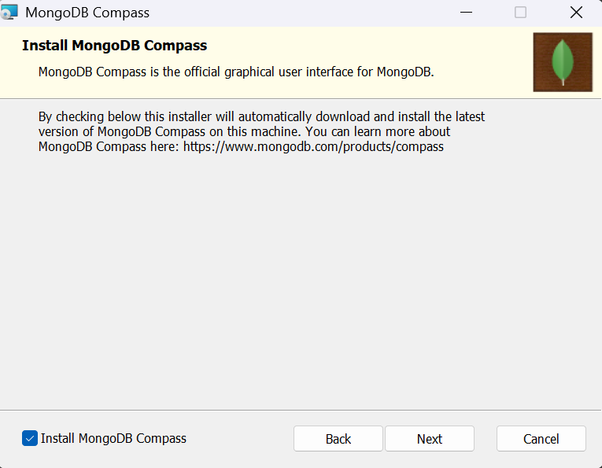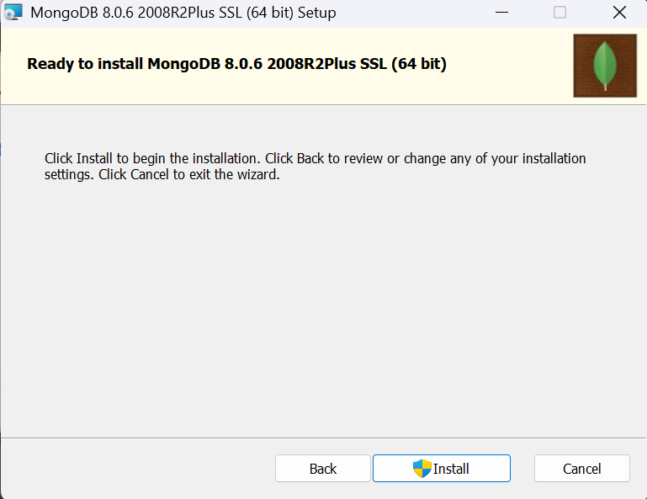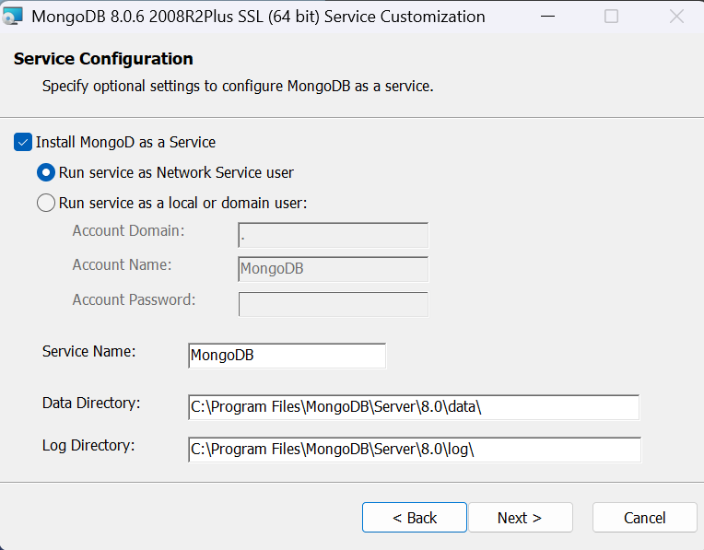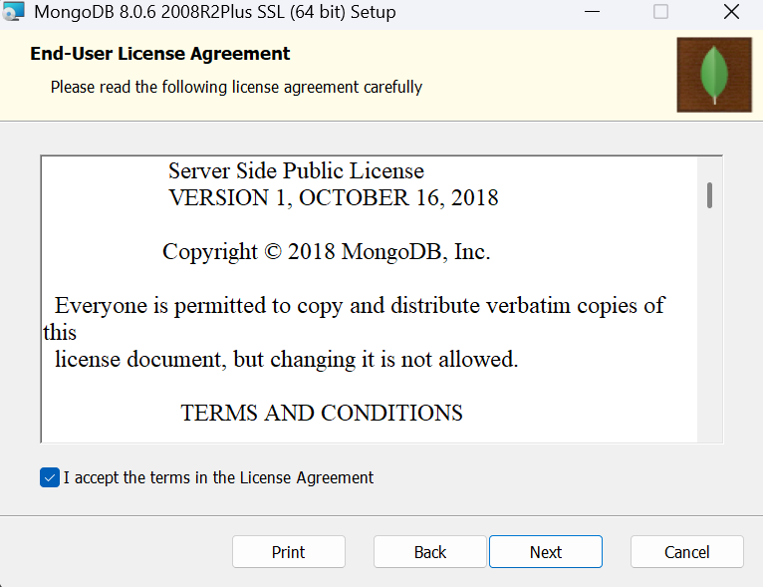

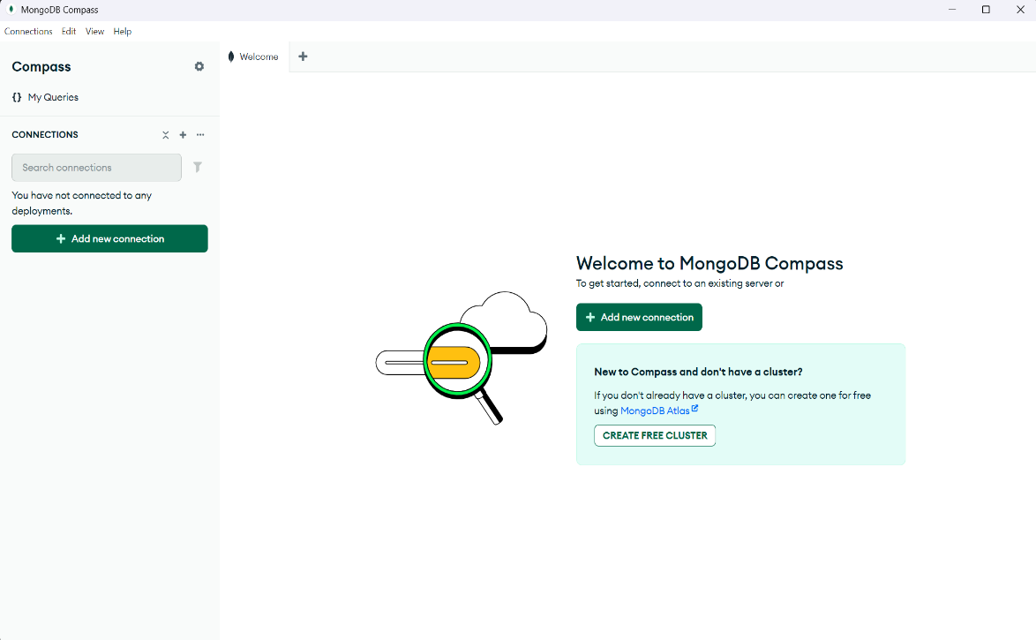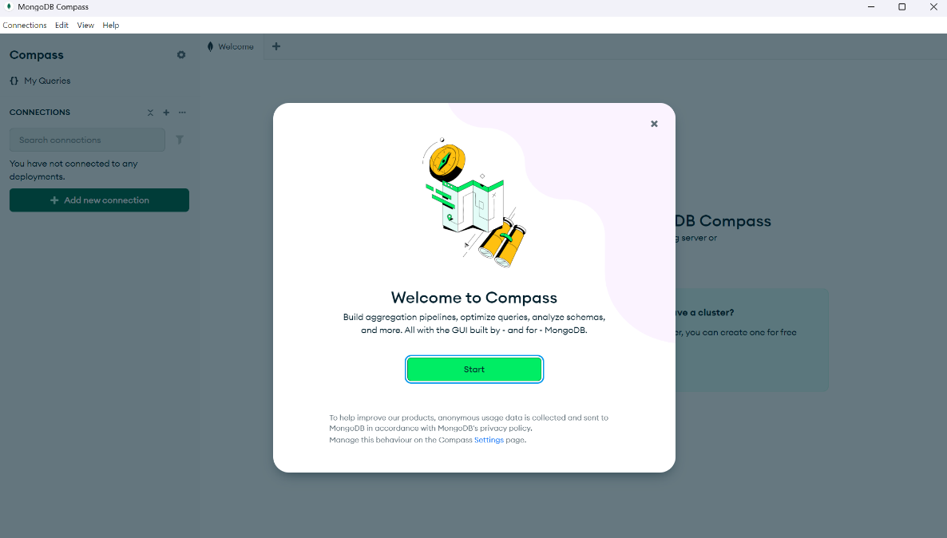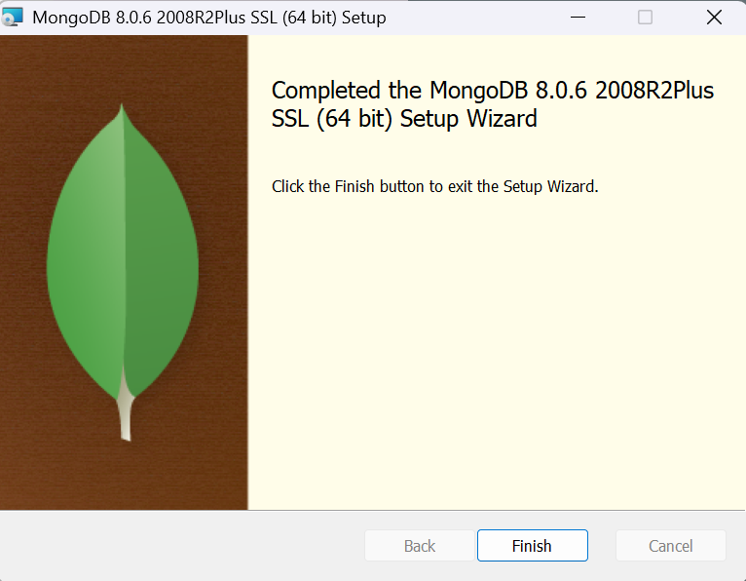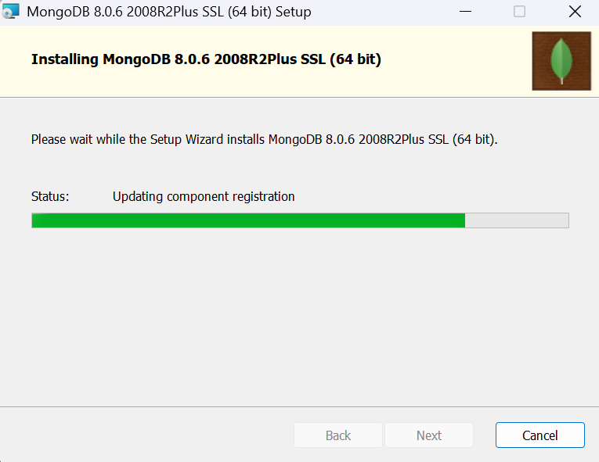

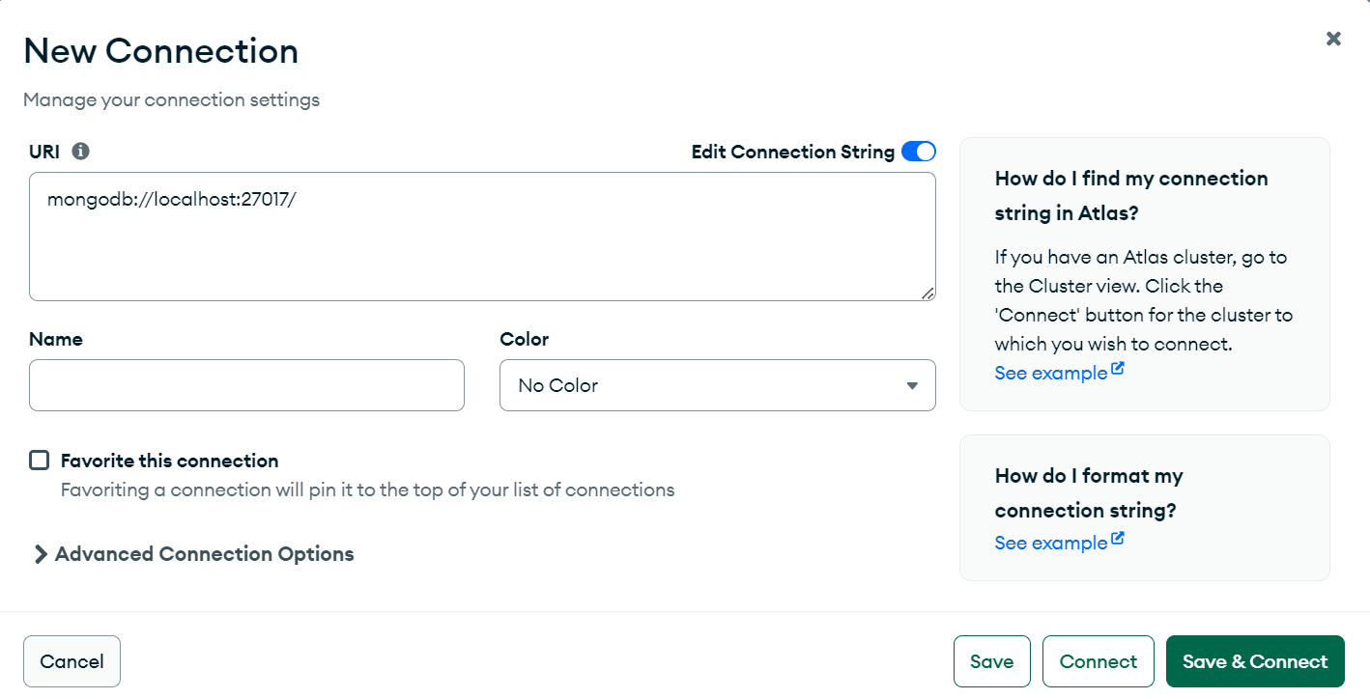

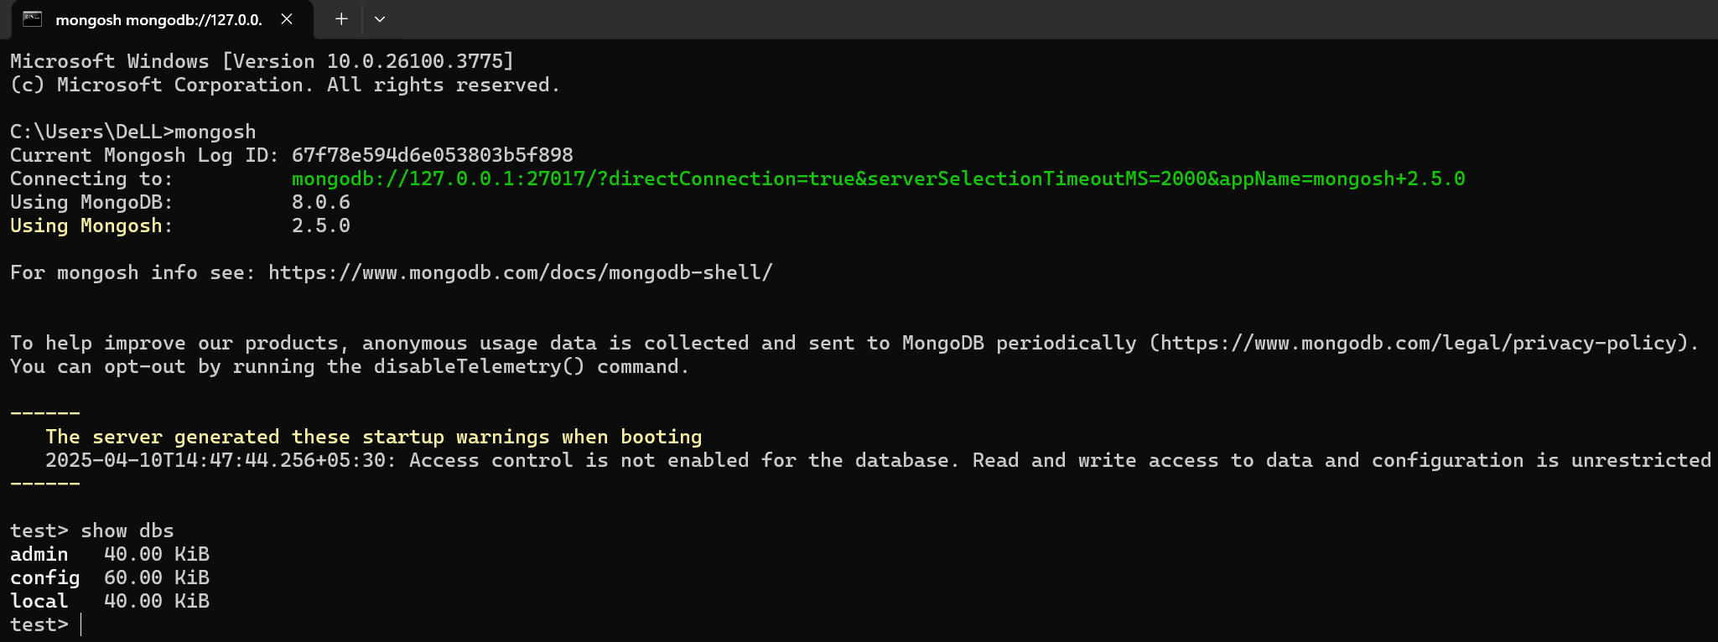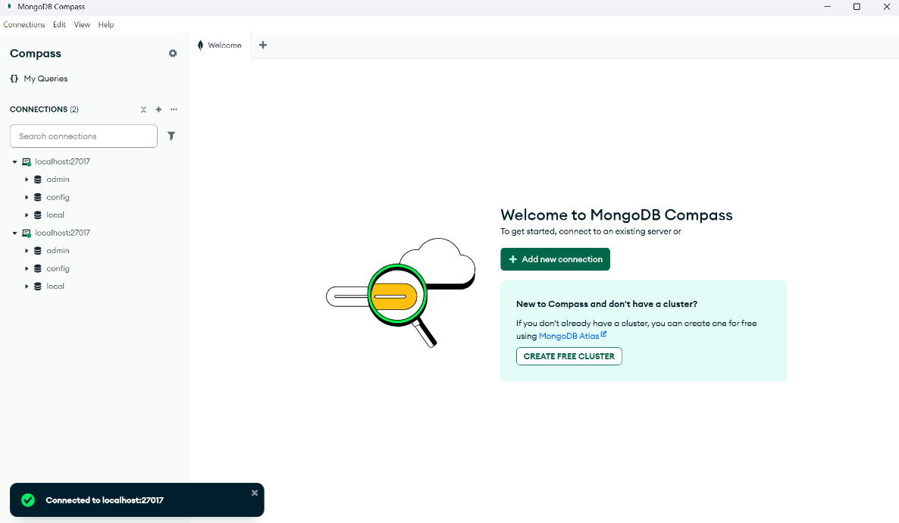

**Learning Outcome:**

**Beyond Curriculum**

**EXPERIMENT 2**

**Problem statement:** Study and implement basic commands of MongoDB

**Theory:**

**MongoDB Compass: -**

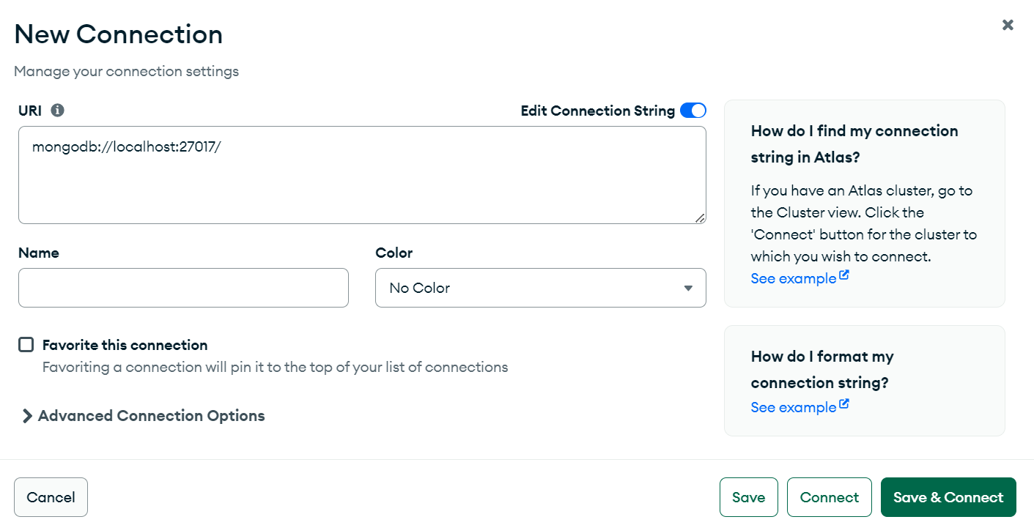(a) Connect to the runtime: -localhost:27017.

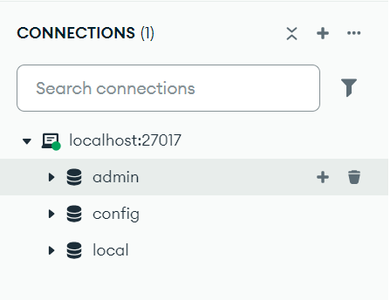

(b) We see three existing databases named – admin, config and local. Create a new database with name college and in it a collection named students.

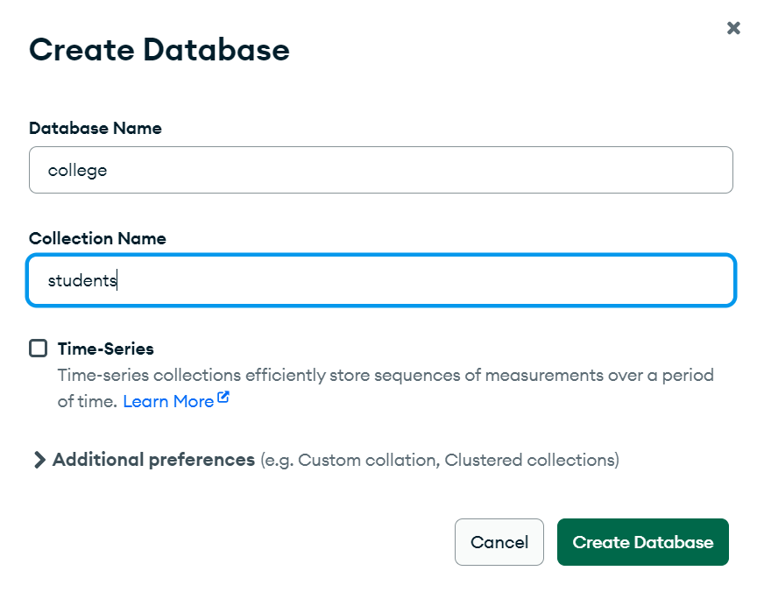

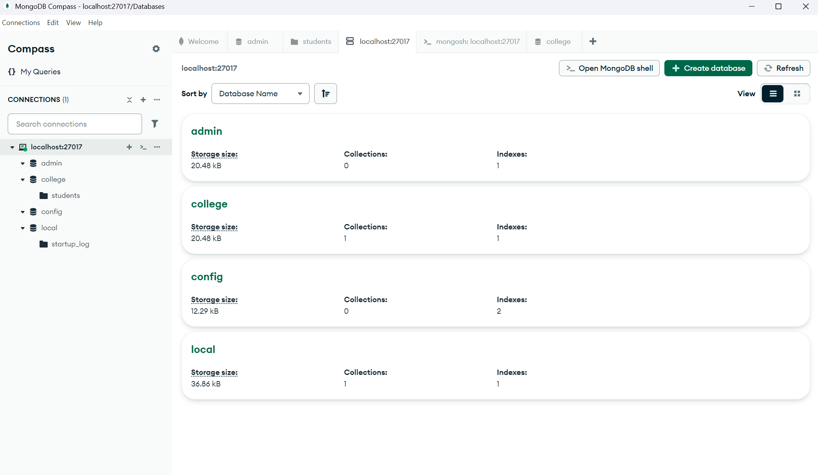(c) View all the databases in compass’s GUI by clicking on the connections name i.e. localhost:27017

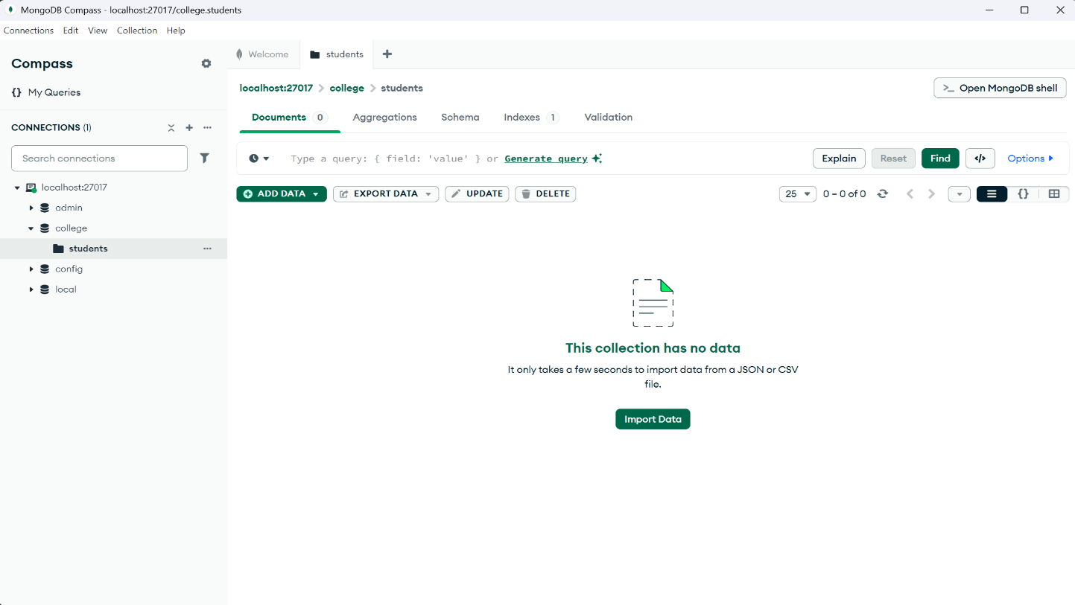(d) On visiting the college database and the collection student we enter the documents tab which is empty by default.

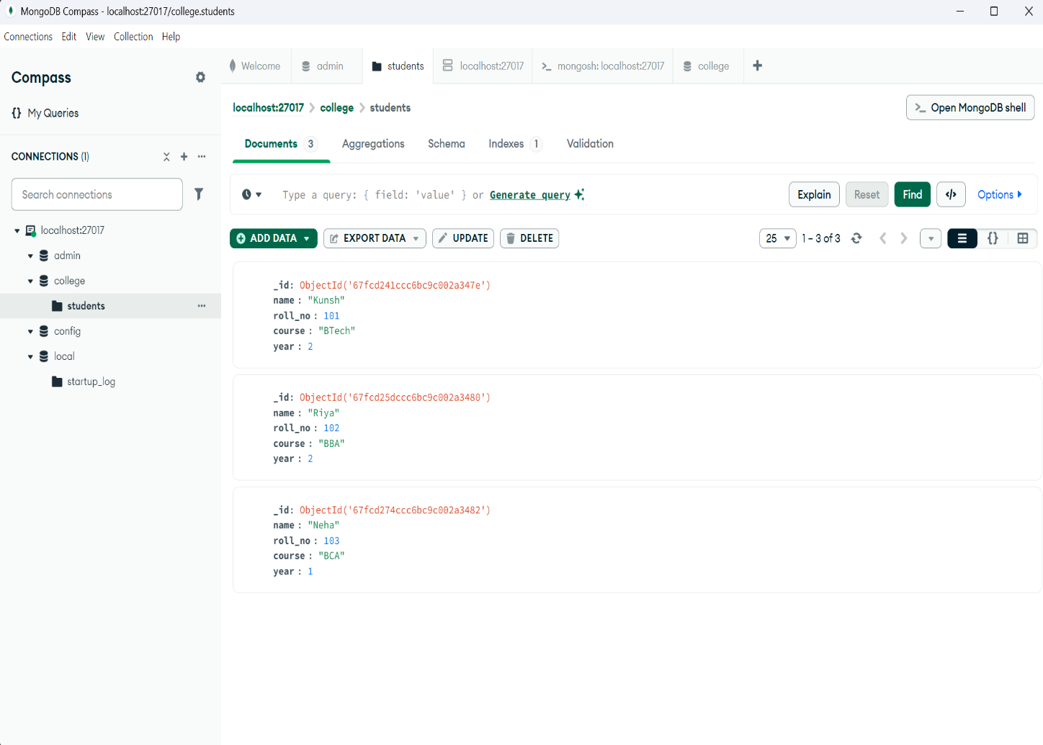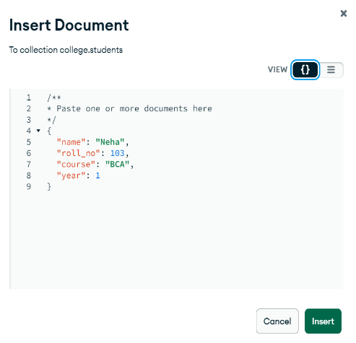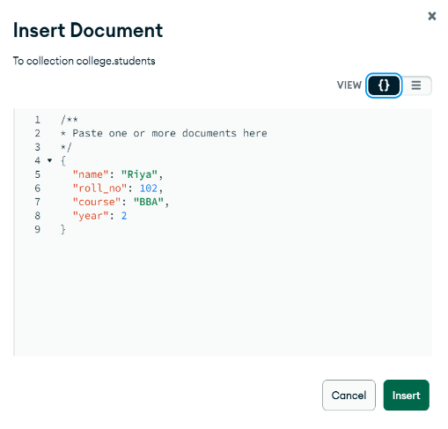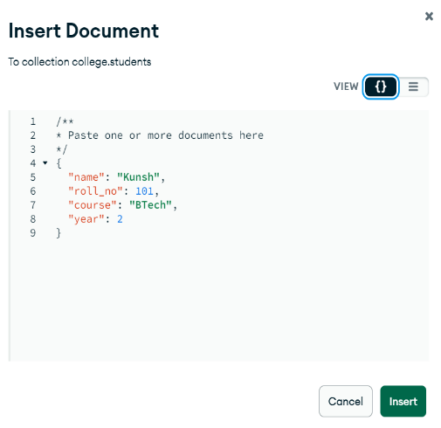(e) Insert values in the documents tab by clicking on add data 🡪 insert document and keep changing the value you want to insert there and click insert after each update to add that value.

(f) After inserting the values, we can click on the button in the top right of the MongoDB Compass GUI – >_ Open MongoDB shell. After clicking, a navy-blue colour screen appears where we may type and execute some basic queries related to the data that we just inserted.

**Commands in MongoDB shell: -**

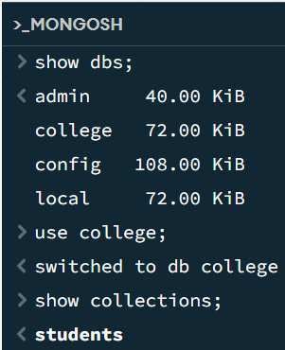

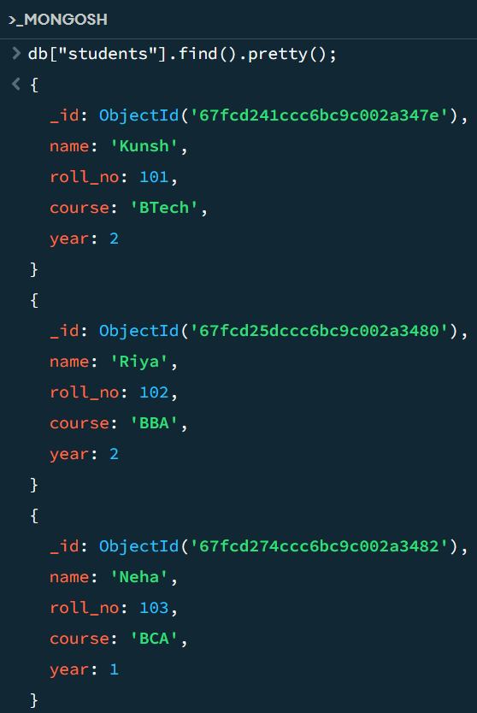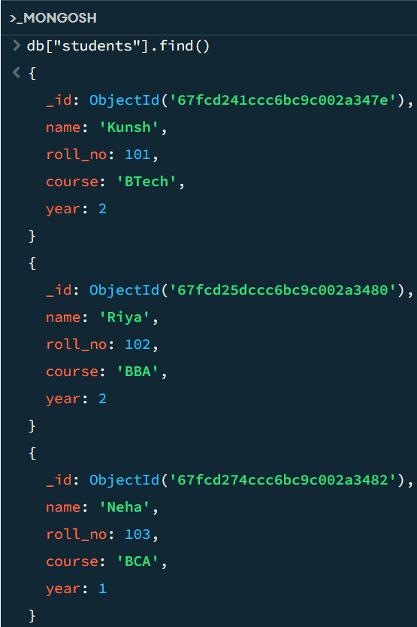

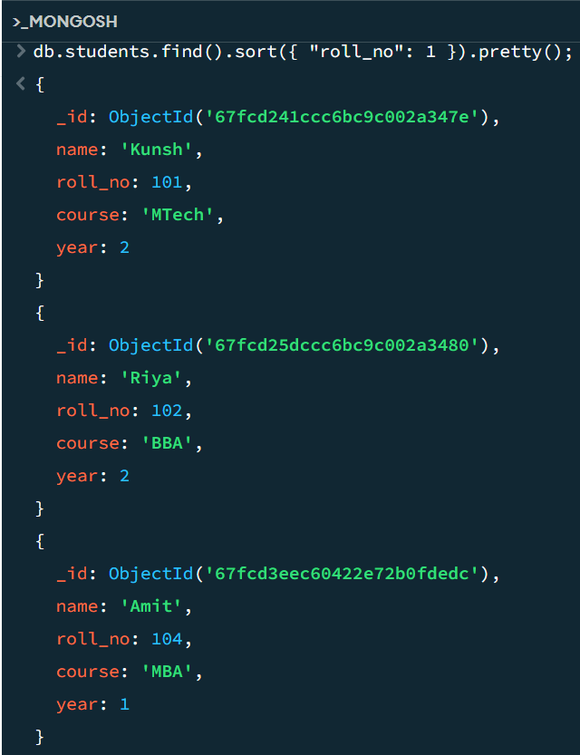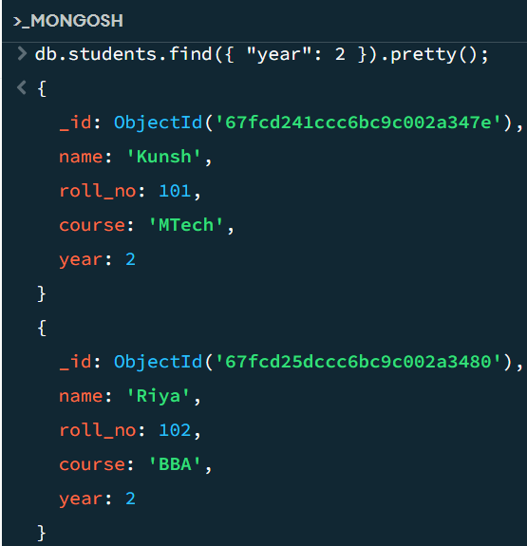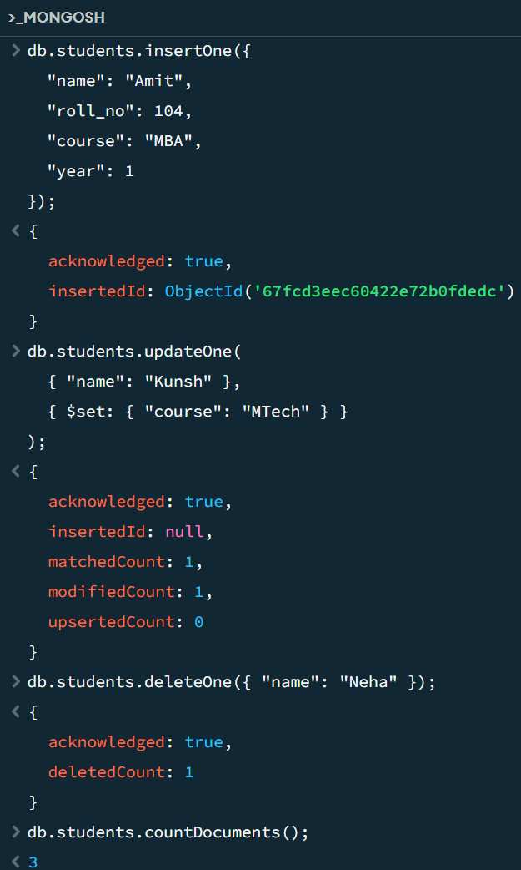

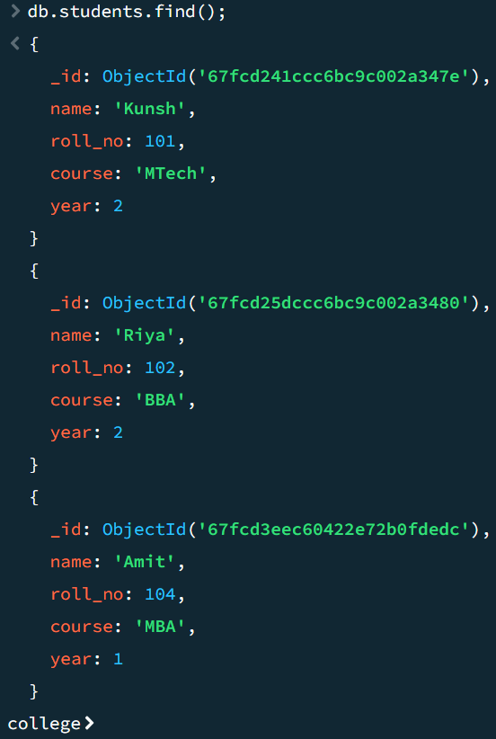

**Learning Outcome: -**